
Capstone Project Report
Report 4 – Software Design Document

– Ho Chi Minh City, October 2026 –

Table of Contents
I. Record of Changes 15
II. Software Design Document 16
1. System Design 16
1.1 System Architecture 16
1.2 Package Diagram 18
1.2.1 Backend Package Diagram 18
1.2.2 Auth Service Package Diagram 19
1.2.3 User Service Package Diagram 21
1.2.4 Order Service Package Diagram 22
1.2.5 Locker Service Package Diagram 24
1.2.6 Payment Service Package Diagram 25
1.2.7 Notification Service Package Diagram 27
1.2.8 IoT Service Package Diagram 28
1.2.9 Store Service Package Diagram 30
1.2.10 Loyalty Service Package Diagram 31
1.2.11 Assistant Service Package Diagram 33
1.2.12 Admin Web Application Package Diagram 34
1.2.13 Mobile Application Package Diagram 35
1.2.14 Mobile Feature Module Package Diagram 36
1.2.15 IoT Locker Controller Package Diagram 37
2. Database Design 38
2.1 auth_db (auth-service) 38
2.2 user_db (user-service) 39
2.3 store_db (store-service) 40
2.4 locker_db (locker-service) 41
2.5 order_db (order-service) 43
2.6 payment_db (payment-service) 46
2.7 notification_db (notification-service) 47
2.8 iot_db (iot-service) 48
2.9 loyalty_db (loyalty-service) 50
2.10 assistant_db (assistant-service) 51
3. Detailed Design 51
3.1 Authentication 52
3.1.1 Class Diagram 52
3.1.2 Sign in with Password 53
3.1.3 Sign in with Phone Number (Firebase OTP) 54
3.1.4 Administrator Sign in with 2FA 55
3.1.5 Refresh Token and Sign out 56
3.1.6 Class Specification 56
3.2 Kiosk Login by QR 57
3.2.1 Class Diagram 58
3.2.2 Kiosk Login by QR 59
3.2.3 Class Specification 59
3.3 Profile and User Management 60
3.3.1 Class Diagram 60
3.3.2 Update Profile Avatar 61
3.3.3 Administrator Creates and Deactivates a User 62
3.3.4 Class Specification 62
3.4 Store Management and Nearby Stores 63
3.4.1 Class Diagram 64
3.4.2 Find Nearby Stores 65
3.4.3 Class Specification 65
3.5 Locker and Box Management 66
3.5.1 Class Diagram 67
3.5.2 Create Locker and Box Grid 68
3.5.3 View Locker Layout 68
3.5.4 Class Specification 69
3.6 Send Parcel 69
3.6.1 Class Diagram 70
3.6.2 Create Send Order 71
3.6.3 Class Specification 71
3.7 VietQR Payment (SePay) 72
3.7.1 Class Diagram 73
3.7.2 Checkout with VietQR 74
3.7.3 SePay Webhook Completes the Payment 75
3.7.4 Class Specification 75
3.8 Drop and Pick Up Parcel at the Kiosk 76
3.8.1 Class Diagram 77
3.8.2 Open Box with PIN at the Kiosk 77
3.8.3 Confirm Parcel Drop 78
3.8.4 Class Specification 78
3.9 Rent Locker, Extend and End Rental 79
3.9.1 Class Diagram 79
3.9.2 Create Rental Order 80
3.9.3 Extend Rental 80
3.9.4 End Rental at the Kiosk 81
3.9.5 Class Specification 81
3.10 Delegate Pickup and Reset PIN 82
3.10.1 Class Diagram 82
3.10.2 Delegate Pickup 83
3.10.3 Reset PIN 83
3.10.4 Class Specification 84
3.11 Rate Order, Complaint and Feedback Handling 84
3.11.1 Class Diagram 85
3.11.2 Rate an Order 85
3.11.3 Administrator Replies to Feedback 86
3.11.4 Class Specification 86
3.12 Wallet Top-up and Withdrawal 87
3.12.1 Class Diagram 88
3.12.2 Top Up Wallet 88
3.12.3 Withdraw to Bank and Admin Approval 89
3.12.4 Class Specification 89
3.13 Refund Requests 90
3.13.1 Class Diagram 91
3.13.2 Request and Approve a Refund 92
3.13.3 Class Specification 92
3.14 Promotions, Vouchers and Loyalty Points 93
3.14.1 Class Diagram 93
3.14.2 Exchange Points for a Voucher 94
3.14.3 Earn Points when an Order Completes 94
3.14.4 Class Specification 95
3.15 Drone Delivery Booking 96
3.15.1 Class Diagram 96
3.15.2 Book a Drone Delivery 97
3.15.3 Class Specification 97
3.16 Drone Home Pickup 98
3.16.1 Class Diagram 99
3.16.2 Offer, Accept and Confirm a Home Pickup 100
3.16.3 Class Specification 100
3.17 Drone Dispatch, Loading and Launch 101
3.17.1 Class Diagram 102
3.17.2 Accept Drone Order and Confirm Loading 103
3.17.3 Launch the Drone 103
3.17.4 Class Specification 104
3.18 Drone Flight Tracking and Stage Progress 104
3.18.1 Class Diagram 105
3.18.2 Advance Flight Stage and Live Position 105
3.18.3 Class Specification 105
3.19 Drone Parcel Drop Incident 106
3.19.1 Class Diagram 107
3.19.2 Report a Dropped Parcel 108
3.19.3 Recovery, Proposal and Customer Decision 108
3.19.4 Class Specification 109
3.20 Locker Incident Ticket 109
3.20.1 Class Diagram 110
3.20.2 Customer Reports a Box Fault 110
3.20.3 Technician Claims and Resolves a Ticket 111
3.20.4 Class Specification 111
3.21 Periodic Inspection 112
3.21.1 Class Diagram 113
3.21.2 Plan and Perform a Periodic Inspection 114
3.21.3 Class Specification 114
3.22 Locker Controller Provisioning and Cabinet Control 115
3.22.1 Class Diagram 115
3.22.2 Assign a Controller to a Locker 116
3.22.3 Remote Open Box from the Admin Web 116
3.22.4 Class Specification 116
3.23 Bluetooth Open Test 117
3.23.1 Class Diagram 118
3.23.2 Open a Box by Bluetooth 118
3.23.3 Class Specification 119
3.24 Notifications and Realtime Updates 119
3.24.1 Class Diagram 120
3.24.2 Deliver a Domain Event to Users 120
3.24.3 Class Specification 121
3.25 AI Assistant (RAG) 121
3.25.1 Class Diagram 122
3.25.2 Ask the AI Assistant 122
3.25.3 Upload and Index a Knowledge Document 123
3.25.4 Class Specification 123
3.26 Business Settings 124
3.26.1 Class Diagram 125
3.26.2 Administrator Changes a Business Rule 125
3.26.3 Class Specification 126
3.27 Admin Dashboard and Revenue Reports 126
3.27.1 Class Diagram 127
3.27.2 View Revenue Summary 127
3.27.3 Class Specification 128
3.28 System Scheduled Jobs 128
3.28.1 Class Diagram 129
3.28.2 Expire Overdue Orders 130
3.28.3 Class Specification 130

List of Figures
Figure 1.1: System architecture of Lock.R 16
Figure 1.2.1: Backend package diagram (modules) 18
Figure 1.2.2: Auth Service package diagram 19
Figure 1.2.3: User Service package diagram 21
Figure 1.2.4: Order Service package diagram 22
Figure 1.2.5: Locker Service package diagram 24
Figure 1.2.6: Payment Service package diagram 25
Figure 1.2.7: Notification Service package diagram 27
Figure 1.2.8: IoT Service package diagram 28
Figure 1.2.9: Store Service package diagram 30
Figure 1.2.10: Loyalty Service package diagram 31
Figure 1.2.11: Assistant Service package diagram 33
Figure 1.2.12: Admin web application package diagram 34
Figure 1.2.13: Mobile application package diagram 35
Figure 1.2.14: Package structure inside one mobile feature module 36
Figure 1.2.15: IoT locker controller package diagram 37
Figure 2.1: Database diagram of auth_db 38
Figure 2.2: Database diagram of user_db 39
Figure 2.3: Database diagram of store_db 40
Figure 2.4: Database diagram of locker_db 41
Figure 2.5: Database diagram of order_db 43
Figure 2.6: Database diagram of payment_db 46
Figure 2.7: Database diagram of notification_db 47
Figure 2.8: Database diagram of iot_db 48
Figure 2.9: Database diagram of loyalty_db 50
Figure 2.10: Database diagram of assistant_db 51
Figure 3.1.1: Class diagram - Authentication 52
Figure 3.1.2: Sequence diagram - Sign in with Password 53
Figure 3.1.3: Sequence diagram - Sign in with Phone Number (Firebase OTP) 54
Figure 3.1.4: Sequence diagram - Administrator Sign in with 2FA 55
Figure 3.1.5: Sequence diagram - Refresh Token and Sign out 56
Figure 3.2.1: Class diagram - Kiosk Login by QR 58
Figure 3.2.2: Sequence diagram - Kiosk Login by QR 59
Figure 3.3.1: Class diagram - Profile and User Management 60
Figure 3.3.2: Sequence diagram - Update Profile Avatar 61
Figure 3.3.3: Sequence diagram - Administrator Creates and Deactivates a User 62
Figure 3.4.1: Class diagram - Store Management and Nearby Stores 64
Figure 3.4.2: Sequence diagram - Find Nearby Stores 65
Figure 3.5.1: Class diagram - Locker and Box Management 67
Figure 3.5.2: Sequence diagram - Create Locker and Box Grid 68
Figure 3.5.3: Sequence diagram - View Locker Layout 68
Figure 3.6.1: Class diagram - Send Parcel 70
Figure 3.6.2: Sequence diagram - Create Send Order 71
Figure 3.7.1: Class diagram - VietQR Payment (SePay) 73
Figure 3.7.2: Sequence diagram - Checkout with VietQR 74
Figure 3.7.3: Sequence diagram - SePay Webhook Completes the Payment 75
Figure 3.8.1: Class diagram - Drop and Pick Up Parcel at the Kiosk 77
Figure 3.8.2: Sequence diagram - Open Box with PIN at the Kiosk 77
Figure 3.8.3: Sequence diagram - Confirm Parcel Drop 78
Figure 3.9.1: Class diagram - Rent Locker, Extend and End Rental 79
Figure 3.9.2: Sequence diagram - Create Rental Order 80
Figure 3.9.3: Sequence diagram - Extend Rental 80
Figure 3.9.4: Sequence diagram - End Rental at the Kiosk 81
Figure 3.10.1: Class diagram - Delegate Pickup and Reset PIN 82
Figure 3.10.2: Sequence diagram - Delegate Pickup 83
Figure 3.10.3: Sequence diagram - Reset PIN 83
Figure 3.11.1: Class diagram - Rate Order, Complaint and Feedback Handling 85
Figure 3.11.2: Sequence diagram - Rate an Order 85
Figure 3.11.3: Sequence diagram - Administrator Replies to Feedback 86
Figure 3.12.1: Class diagram - Wallet Top-up and Withdrawal 88
Figure 3.12.2: Sequence diagram - Top Up Wallet 88
Figure 3.12.3: Sequence diagram - Withdraw to Bank and Admin Approval 89
Figure 3.13.1: Class diagram - Refund Requests 91
Figure 3.13.2: Sequence diagram - Request and Approve a Refund 92
Figure 3.14.1: Class diagram - Promotions, Vouchers and Loyalty Points 93
Figure 3.14.2: Sequence diagram - Exchange Points for a Voucher 94
Figure 3.14.3: Sequence diagram - Earn Points when an Order Completes 94
Figure 3.15.1: Class diagram - Drone Delivery Booking 96
Figure 3.15.2: Sequence diagram - Book a Drone Delivery 97
Figure 3.16.1: Class diagram - Drone Home Pickup 99
Figure 3.16.2: Sequence diagram - Offer, Accept and Confirm a Home Pickup 100
Figure 3.17.1: Class diagram - Drone Dispatch, Loading and Launch 102
Figure 3.17.2: Sequence diagram - Accept Drone Order and Confirm Loading 103
Figure 3.17.3: Sequence diagram - Launch the Drone 103
Figure 3.18.1: Class diagram - Drone Flight Tracking and Stage Progress 105
Figure 3.18.2: Sequence diagram - Advance Flight Stage and Live Position 105
Figure 3.19.1: Class diagram - Drone Parcel Drop Incident 107
Figure 3.19.2: Sequence diagram - Report a Dropped Parcel 108
Figure 3.19.3: Sequence diagram - Recovery, Proposal and Customer Decision 108
Figure 3.20.1: Class diagram - Locker Incident Ticket 110
Figure 3.20.2: Sequence diagram - Customer Reports a Box Fault 110
Figure 3.20.3: Sequence diagram - Technician Claims and Resolves a Ticket 111
Figure 3.21.1: Class diagram - Periodic Inspection 113
Figure 3.21.2: Sequence diagram - Plan and Perform a Periodic Inspection 114
Figure 3.22.1: Class diagram - Locker Controller Provisioning and Cabinet Control 115
Figure 3.22.2: Sequence diagram - Assign a Controller to a Locker 116
Figure 3.22.3: Sequence diagram - Remote Open Box from the Admin Web 116
Figure 3.23.1: Class diagram - Bluetooth Open Test 118
Figure 3.23.2: Sequence diagram - Open a Box by Bluetooth 118
Figure 3.24.1: Class diagram - Notifications and Realtime Updates 120
Figure 3.24.2: Sequence diagram - Deliver a Domain Event to Users 120
Figure 3.25.1: Class diagram - AI Assistant (RAG) 122
Figure 3.25.2: Sequence diagram - Ask the AI Assistant 122
Figure 3.25.3: Sequence diagram - Upload and Index a Knowledge Document 123
Figure 3.26.1: Class diagram - Business Settings 125
Figure 3.26.2: Sequence diagram - Administrator Changes a Business Rule 125
Figure 3.27.1: Class diagram - Admin Dashboard and Revenue Reports 127
Figure 3.27.2: Sequence diagram - View Revenue Summary 127
Figure 3.28.1: Class diagram - System Scheduled Jobs 129
Figure 3.28.2: Sequence diagram - Expire Overdue Orders 130

List of Tables
Table 1.1: Components of the system architecture 16
Table 1.2.1: Backend modules and common-lib packages 18
Table 1.2.2: Packages of auth-service 20
Table 1.2.3: Packages of user-service 21
Table 1.2.4: Packages of order-service 22
Table 1.2.5: Packages of locker-service 24
Table 1.2.6: Packages of payment-service 26
Table 1.2.7: Packages of notification-service 27
Table 1.2.8: Packages of iot-service 29
Table 1.2.9: Packages of store-service 30
Table 1.2.10: Packages of loyalty-service 31
Table 1.2.11: Packages of assistant-service 33
Table 1.2.12: Packages of the admin web application 34
Table 1.2.13: Packages of the mobile application 35
Table 1.2.14: Layers of a mobile feature module 37
Table 1.2.15: Packages of the IoT locker controller 37
Table 2.1: Table descriptions of auth_db 39
Table 2.2: Table descriptions of user_db 40
Table 2.3: Table descriptions of store_db 40
Table 2.4: Table descriptions of locker_db 41
Table 2.5: Table descriptions of order_db 43
Table 2.6: Table descriptions of payment_db 46
Table 2.7: Table descriptions of notification_db 47
Table 2.8: Table descriptions of iot_db 48
Table 2.9: Table descriptions of loyalty_db 50
Table 2.10: Table descriptions of assistant_db 51
Table 3.1.6.a: AuthController description 56
Table 3.1.6.b: AuthService description 57
Table 3.1.6.c: JwtService description 57
Table 3.1.6.d: EmailOtpService description 57
Table 3.2.3.a: KioskQrLoginController description 59
Table 3.2.3.b: KioskQrLoginService description 60
Table 3.3.4.a: UserController description 62
Table 3.3.4.b: MediaController description 63
Table 3.3.4.c: UserProfileService description 63
Table 3.4.3.a: StoreController description 65
Table 3.4.3.b: StoreService description 66
Table 3.5.4.a: LockerController description 69
Table 3.5.4.b: LockerService description 69
Table 3.6.3.a: OrderController description 71
Table 3.6.3.b: OrderService description 71
Table 3.6.3.c: OrderBenefitService description 72
Table 3.6.3.d: PaidOrderEffects description 72
Table 3.7.4.a: PaymentController description 75
Table 3.7.4.b: PaymentService description 75
Table 3.7.4.c: SepayService description 76
Table 3.7.4.d: OrderPaymentEventListener description 76
Table 3.7.4.e: PaidOrderEffects description 76
Table 3.8.4.a: IotController description 78
Table 3.8.4.b: IotService description 78
Table 3.8.4.c: LockerMqttService description 79
Table 3.9.5.a: OrderController description 81
Table 3.9.5.b: OrderService description 81
Table 3.10.4.a: OrderController description 84
Table 3.10.4.b: OrderService description 84
Table 3.10.4.c: QrTokenService description 84
Table 3.11.4.a: OrderController description 86
Table 3.11.4.b: AdminFeedbackController description 86
Table 3.11.4.c: OrderService description 87
Table 3.11.4.d: AdminFeedbackService description 87
Table 3.12.4.a: WalletController description 89
Table 3.12.4.b: PaymentController description 90
Table 3.12.4.c: WalletService description 90
Table 3.13.3.a: PaymentController description 92
Table 3.13.3.b: AdminPaymentController description 92
Table 3.13.3.c: PaymentService description 93
Table 3.14.4.a: OrderController description 95
Table 3.14.4.b: VoucherExchangeService description 95
Table 3.14.4.c: LoyaltyController description 95
Table 3.14.4.d: LoyaltyService description 95
Table 3.14.4.e: OrderCompletedPointsListener description 96
Table 3.15.3.a: OrderController description 97
Table 3.15.3.b: DroneOrderBookingService description 98
Table 3.15.3.c: DroneSourceLockerSelector description 98
Table 3.15.3.d: DroneWeatherService description 98
Table 3.16.3.a: OrderController description 100
Table 3.16.3.b: DronePickupService description 101
Table 3.17.4.a: OrderController description 104
Table 3.17.4.b: DroneOrderMaintenanceService description 104
Table 3.18.3.a: OrderController description 105
Table 3.18.3.b: DroneMissionProgressService description 106
Table 3.18.3.c: DroneTelemetryMqttListener description 106
Table 3.18.3.d: DroneTelemetryService description 106
Table 3.19.4.a: DroneParcelIncidentController description 109
Table 3.19.4.b: DroneParcelIncidentService description 109
Table 3.20.4.a: OrderController description 111
Table 3.20.4.b: LockerController description 111
Table 3.20.4.c: OrderService description 112
Table 3.20.4.d: LockerService description 112
Table 3.21.3.a: LockerController description 114
Table 3.21.3.b: LockerService description 114
Table 3.21.3.c: LockerScheduler description 115
Table 3.22.4.a: GatewayController description 116
Table 3.22.4.b: CabinetControlController description 117
Table 3.22.4.c: GatewayProvisioningService description 117
Table 3.22.4.d: CabinetControlService description 117
Table 3.23.3.a: BleTestController description 119
Table 3.23.3.b: BleTestService description 119
Table 3.24.3.a: NotificationController description 121
Table 3.24.3.b: NotificationEventListener description 121
Table 3.24.3.c: NotificationService description 121
Table 3.25.4.a: AssistantController description 123
Table 3.25.4.b: KnowledgeAdminController description 123
Table 3.25.4.c: AssistantService description 124
Table 3.25.4.d: KnowledgeService description 124
Table 3.25.4.e: KnowledgeIndexer description 124
Table 3.26.3.a: BusinessSettingsController description 126
Table 3.26.3.b: BusinessSettings description 126
Table 3.27.3.a: AdminRevenueController description 128
Table 3.27.3.b: RevenueReportService description 128
Table 3.28.3.a: OrderScheduler description 130
Table 3.28.3.b: OrderController description 130

I. Record of Changes
Date | A* M, D | In charge | Change Description
28/10/2026 | A |  | Initial Software Design Document: system architecture, package diagrams of the backend services, admin web, mobile app and IoT controller, database design of the 10 service databases, class diagrams, sequence diagrams and class specifications of 28 features.

*A - Added M - Modified D - Deleted

II. Software Design Document

1. System Design

1.1 System Architecture
Lock.R is built as a set of Spring Boot microservices behind one API gateway. Every client (mobile app, admin web and the kiosk on each locker) talks to the backend over HTTPS REST and receives realtime updates over STOMP / WebSocket. Each service owns its PostgreSQL database; services call each other synchronously with OpenFeign (internal endpoints) and asynchronously through the RabbitMQ topic exchange laundry.events. Physical lockers are driven by a Raspberry Pi that exchanges commands and events with iot-service over MQTT. The whole backend runs with Docker Compose on one Azure VM behind Nginx; the web front-ends are deployed on Cloudflare Workers.
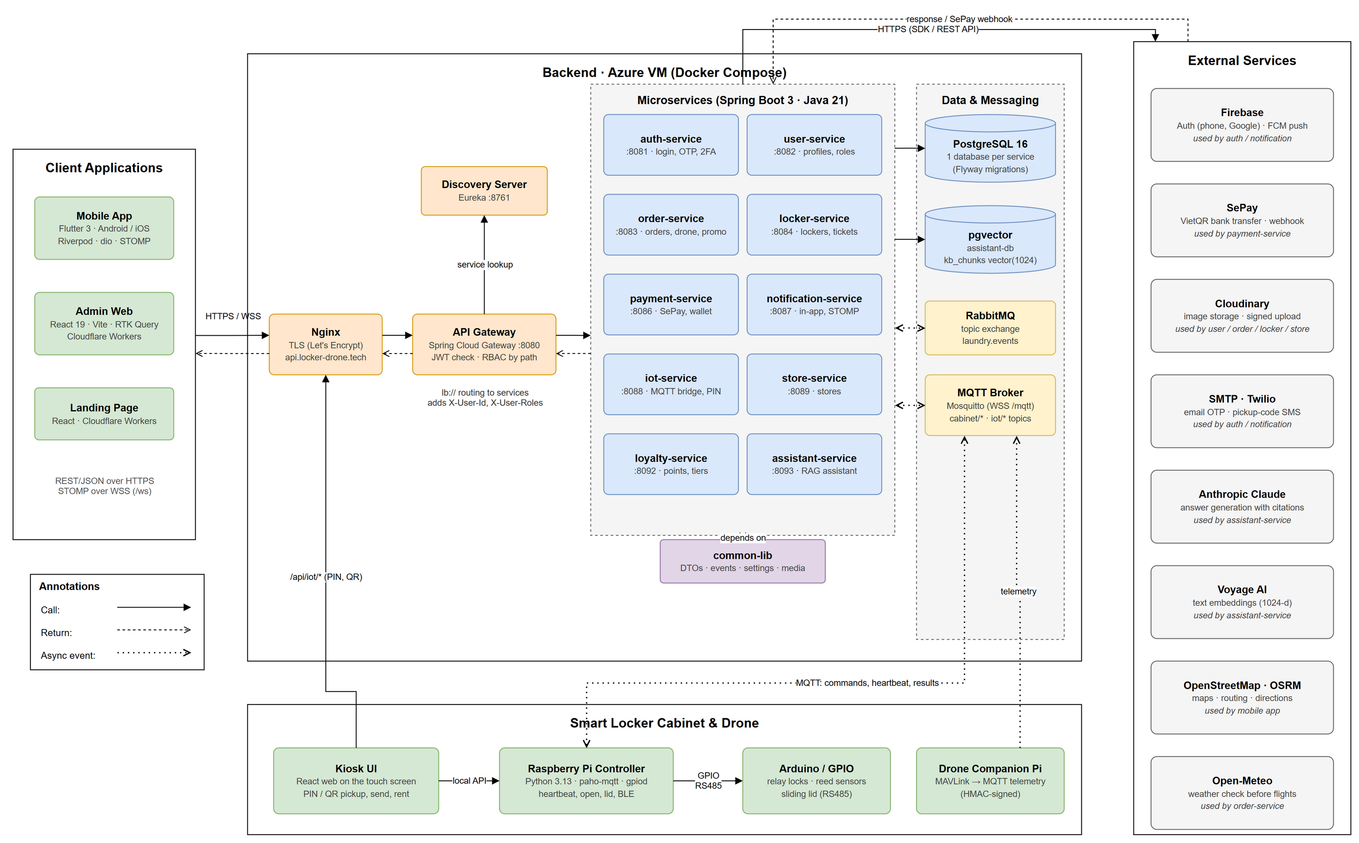
Figure 1.1: System architecture of Lock.R
The table below explains each component of the architecture diagram.
Table 1.1: Components of the system architecture
No | Component | Description
01 | Mobile App | Flutter application for customers, receivers, locker technicians and drone technicians (Android and iOS). Uses dio for REST, STOMP for realtime events, Firebase Auth for phone / Google sign-in and FCM for push.
02 | Admin Web | React 19 + Vite + RTK Query single-page app for administrators: dashboard, users, stores, lockers, cabinet control, maintenance, drones, orders, payments, refunds, promotions, loyalty, settings and knowledge base.
03 | Kiosk UI | React web app shown on the touch screen of each locker. Customers pick up with PIN / QR, sign in by QR, send and rent; it calls /api/iot/* and the local API of the Pi.
04 | Nginx | TLS termination (Let's Encrypt) for api.locker-drone.tech; forwards HTTP and WebSocket traffic to the API gateway and MQTT over WSS to the broker.
05 | API Gateway | Spring Cloud Gateway. Verifies the JWT, applies role-based access by path prefix, blocks /internal/**, adds X-User-Id / X-Account-Id / X-User-Roles headers and routes to services through Eureka (lb://).
06 | Discovery Server | Eureka registry where every service registers and the gateway / Feign clients resolve service instances.
07 | auth-service | Credentials, password / OTP / Firebase / kiosk-QR sign-in, admin 2FA, JWT and refresh tokens.
08 | user-service | User profiles, roles and status; admin user management; signed Cloudinary upload parameters.
09 | order-service | SEND / RENTAL / DRONE_DELIVERY orders, pricing, vouchers and points, ratings and complaints, drone missions, pickups, telemetry, incidents, revenue reports and scheduled jobs.
10 | locker-service | Lockers, boxes and layouts, tickets and repair logs, periodic inspections, technician presence, drones and drone devices.
11 | payment-service | Payments (SePay VietQR, wallet), SePay webhook, refunds, wallet ledger and withdrawals.
12 | notification-service | In-app notifications, FCM push, STOMP /ws broker, SMS / email to receivers without an account.
13 | iot-service | MQTT bridge to lockers: open / lid / setup commands, heartbeats and door states, PIN / QR verification, controller provisioning, BLE open tokens.
14 | store-service | Stores (locations hosting lockers) and nearby search.
15 | loyalty-service | Loyalty accounts, points, tiers, redemption and voucher exchange.
16 | assistant-service | RAG assistant: knowledge base indexing, vector search on pgvector, answers from Claude with citations.
17 | common-lib | Shared library: ApiResponse / PageResponse DTOs, domain events, exceptions, business settings framework, Cloudinary media, security and utilities.
18 | PostgreSQL / pgvector | One PostgreSQL 16 database per service (Flyway migrations, ddl validate); a separate pgvector database for the assistant.
19 | RabbitMQ | Topic exchange laundry.events with queues order.payment.events, loyalty.order.events and notification.events.
20 | MQTT Broker | Mosquitto broker for cabinet/{lockerId}/command/*, heartbeat, status and iot/{mac}/* topics, and drone telemetry.
21 | Raspberry Pi Controller | Python controller in each locker: drives relays, door sensors and the sliding lid through GPIO / Arduino RS485, sends heartbeats and results, verifies BLE tokens offline.
22 | External services | Firebase (Auth, FCM), SePay (VietQR + webhook), Cloudinary (images), SMTP and Twilio (OTP, pickup codes), Anthropic Claude and Voyage AI (assistant), OpenStreetMap / OSRM (maps), Open-Meteo (flight weather).

1.2 Package Diagram
The package diagrams show how the source code of each sub-system is organised. The backend is a Maven multi-module project; every business service follows the same layered structure (API, application, domain, infrastructure) and depends on common-lib.

1.2.1 Backend Package Diagram
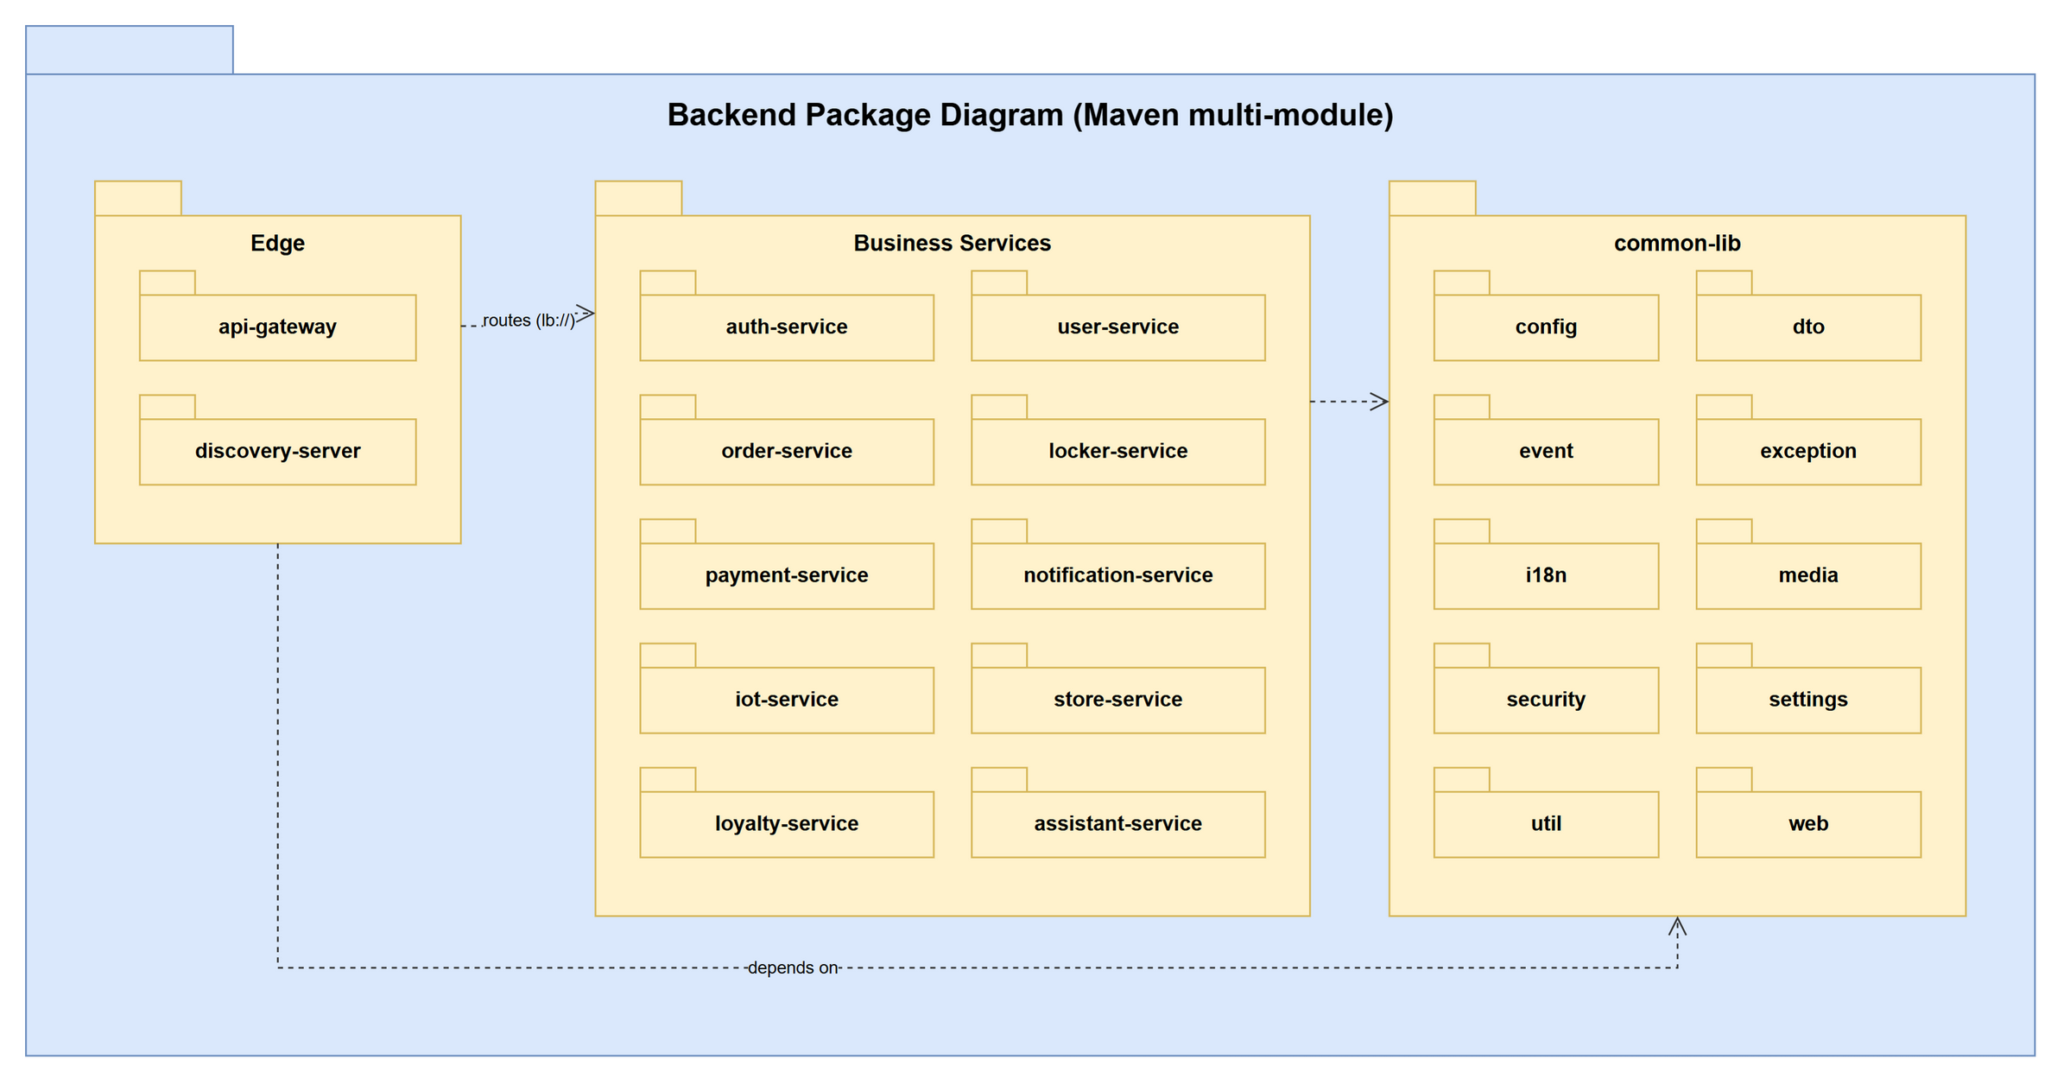
Figure 1.2.1: Backend package diagram (modules)
Table 1.2.1: Backend modules and common-lib packages
No | Package | Description
01 | api-gateway | Spring Cloud Gateway: JWT validation, RBAC by path, routing, correlation id.
02 | discovery-server | Eureka service registry.
03 | auth-service | Authentication and token issuing.
04 | user-service | User profiles, roles and media signatures.
05 | order-service | Orders, promotions, drone delivery and reports.
06 | locker-service | Lockers, boxes, tickets, inspections and drones.
07 | payment-service | Payments, refunds, wallet and withdrawals.
08 | notification-service | Notifications, push and realtime messaging.
09 | iot-service | MQTT bridge and access control of the lockers.
10 | store-service | Stores and nearby search.
11 | loyalty-service | Points, tiers and voucher exchange.
12 | assistant-service | AI assistant with retrieval-augmented generation.
13 | common-lib/config | Flyway repair configuration shared by all services.
14 | common-lib/dto | ApiResponse, ApiError, PageResponse, IdResponse and summaries (UserSummary, OrderSummary, LockerBoxSummary).
15 | common-lib/event | DomainEvent, DomainEventNames (exchange laundry.events and routing keys) and change-event helpers.
16 | common-lib/exception | BusinessException, NotFoundException and GlobalExceptionHandler (uniform error body).
17 | common-lib/i18n | MessageService for Vietnamese / English messages.
18 | common-lib/media | CloudinaryMediaStorage: signed upload parameters and verification of uploaded images.
19 | common-lib/security | UserRoles constants and SecuritySecrets checks.
20 | common-lib/settings | BusinessSettings framework: catalog, JDBC store with audit, admin / public controller.
21 | common-lib/util | AfterCommit, BusinessTime (Asia/Ho_Chi_Minh) and CodeGenerator.
22 | common-lib/web | CorrelationIdFilter for request tracing.

1.2.2 Auth Service Package Diagram
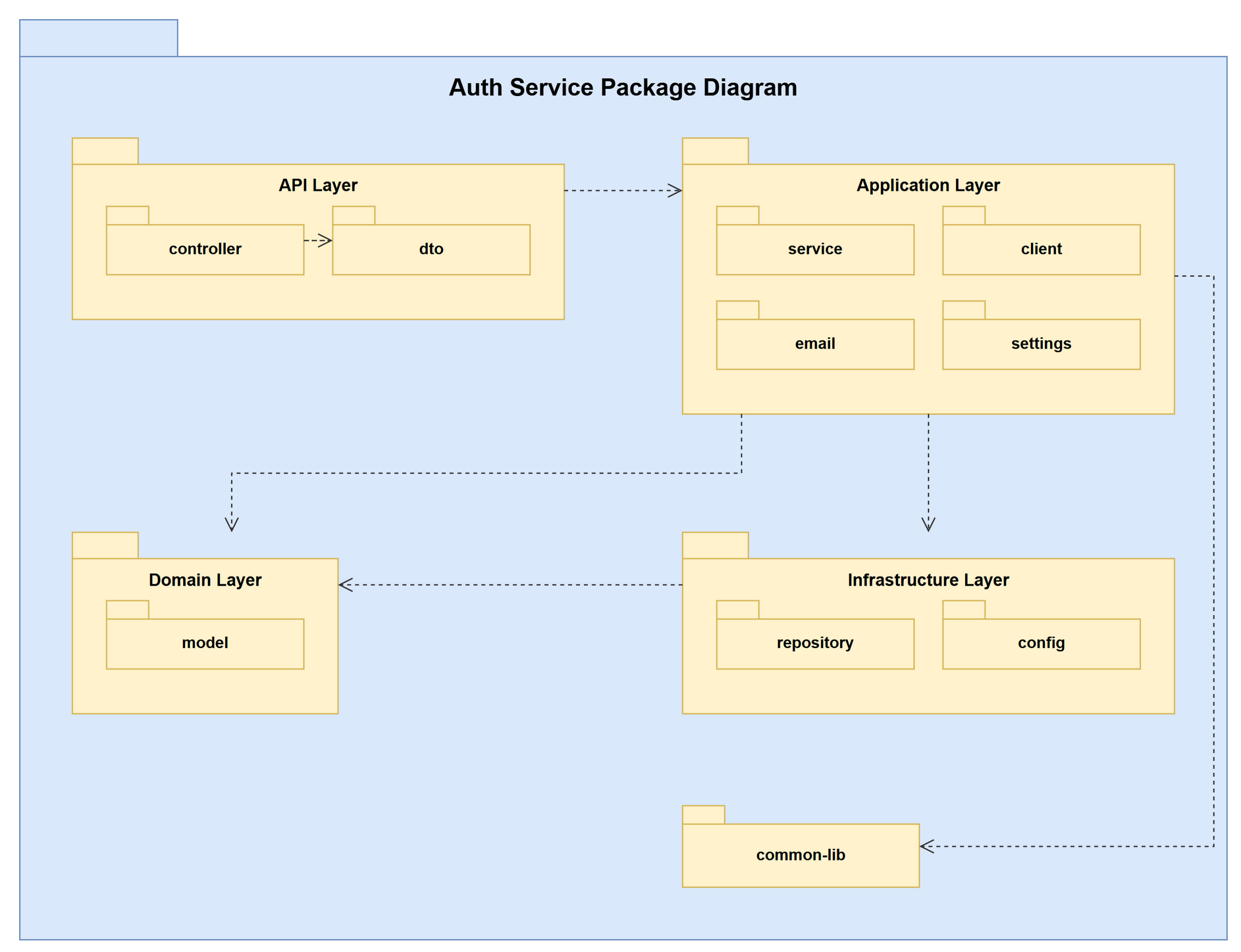
Figure 1.2.2: Auth Service package diagram
Table 1.2.2: Packages of auth-service
No | Package | Description
01 | client | OpenFeign clients that call other services through Eureka on their /internal/** endpoints. Main classes: UserClient.
02 | config | Spring configuration: RabbitMQ exchange / queues / bindings, security, Firebase, WebSocket. Main classes: AdminBootstrap, FirebaseConfig, SecurityConfig.
03 | controller | REST controllers (@RestController). Receive requests routed by the gateway, read the X-User-Id / X-User-Roles headers, validate the input and wrap results in ApiResponse. Main classes: AuthController, KioskQrLoginController.
04 | dto | Request and response records exchanged with clients and other services. Main classes: AccountIdentifiersRequest, AccountStatusRequest, AuthResponse, CreateAccountRequest, FirebaseLoginRequest, KioskQrDtos, LoginRequest, LogoutRequest … (11 classes).
05 | email | SMTP e-mail sender used for OTP codes. Main classes: EmailService, SmtpEmailService.
06 | model | JPA entities mapped to the tables of the service database, and entity listeners that publish change events. Main classes: AuthAccount, EmailOtp, RefreshToken, SocialIdentity.
07 | repository | Spring Data JPA repositories: derived queries, custom JPQL, pessimistic locks. Main classes: AuthAccountRepository, EmailOtpRepository, RefreshTokenRepository, SocialIdentityRepository.
08 | service | Business logic (@Service / @Component): use cases, business-rule checks, transactions, scheduled jobs and publishing of domain events. Main classes: AuthService, EmailOtpService, JwtService, KioskQrLoginService.
09 | settings | Rules and SettingsCatalog of the service: business settings editable on the admin web (common-lib BusinessSettings). Main classes: AuthRules, AuthSettingsCatalog.

1.2.3 User Service Package Diagram
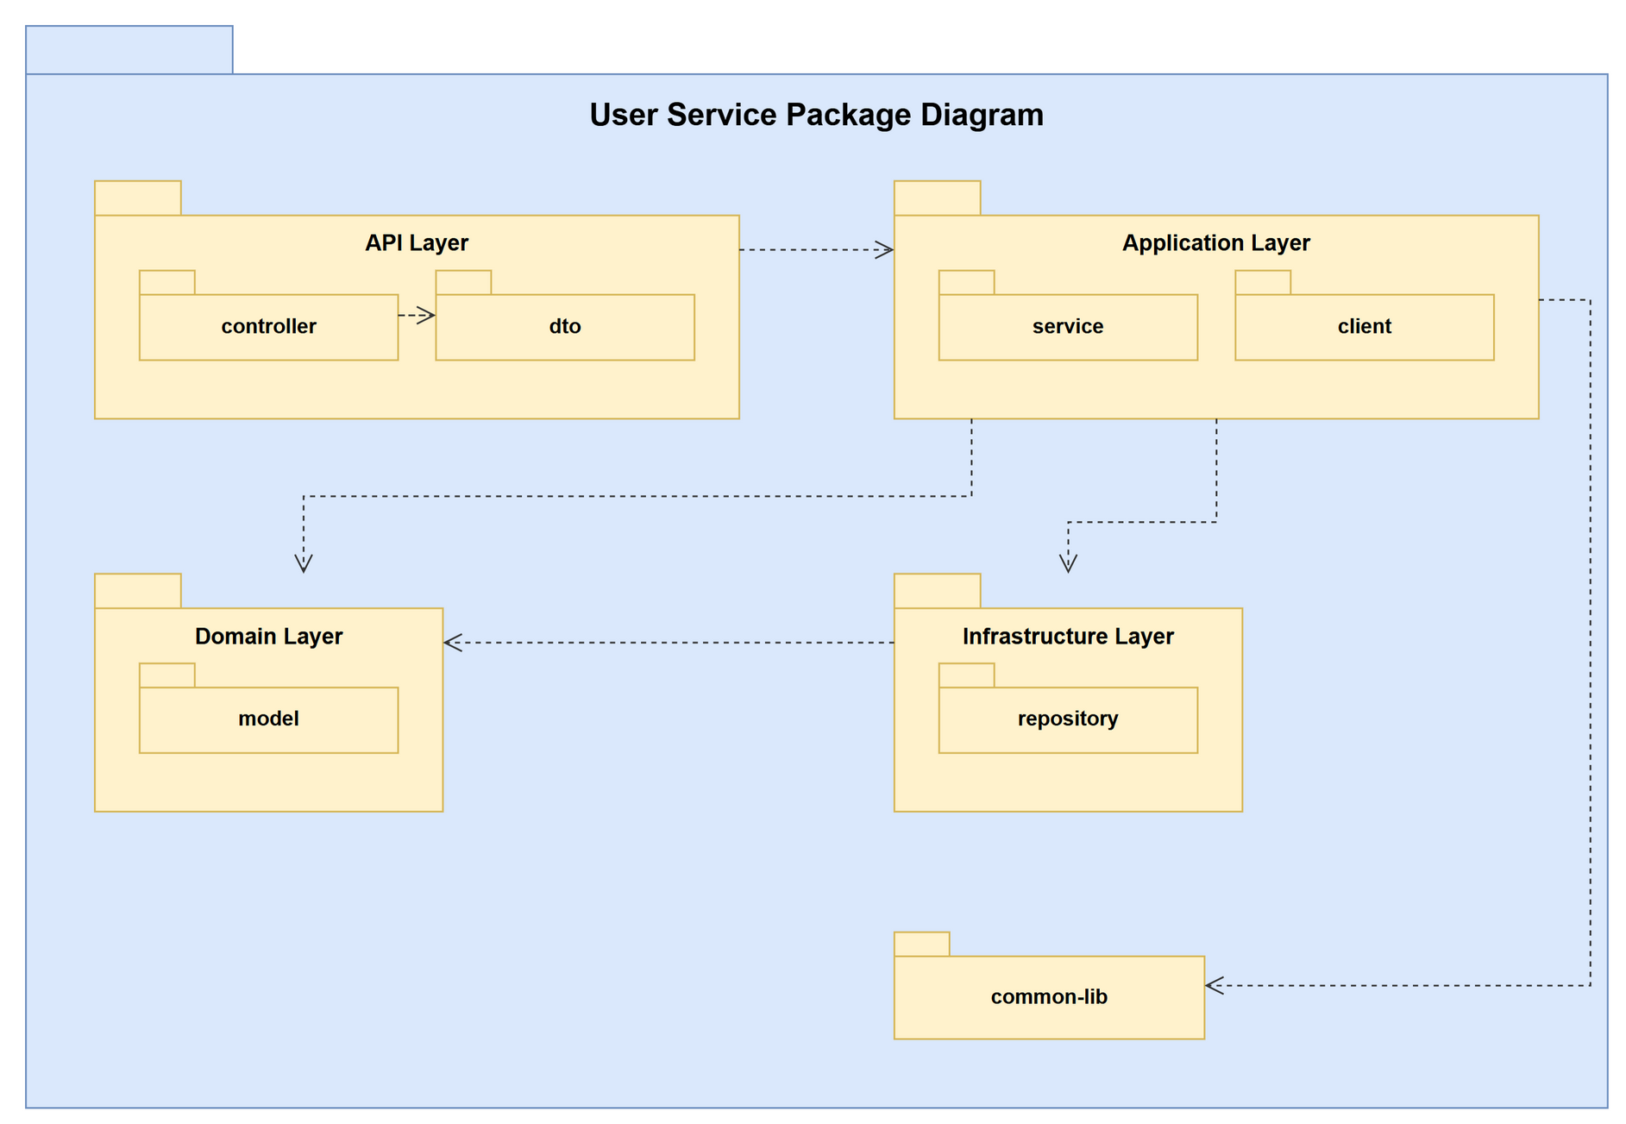
Figure 1.2.3: User Service package diagram
Table 1.2.3: Packages of user-service
No | Package | Description
01 | client | OpenFeign clients that call other services through Eureka on their /internal/** endpoints. Main classes: AuthClient, NotificationClient.
02 | controller | REST controllers (@RestController). Receive requests routed by the gateway, read the X-User-Id / X-User-Roles headers, validate the input and wrap results in ApiResponse. Main classes: InternalUserLookupController, MediaController, UserController.
03 | dto | Request and response records exchanged with clients and other services. Main classes: AdminCreateUserRequest, AdminUserView, UserGrowthPoint, UserProfileRequest, UserProfileView.
04 | model | JPA entities mapped to the tables of the service database, and entity listeners that publish change events. Main classes: AdminDataChangeListener, UserProfile.
05 | repository | Spring Data JPA repositories: derived queries, custom JPQL, pessimistic locks. Main classes: UserProfileRepository.
06 | service | Business logic (@Service / @Component): use cases, business-rule checks, transactions, scheduled jobs and publishing of domain events. Main classes: UserProfileService.

1.2.4 Order Service Package Diagram
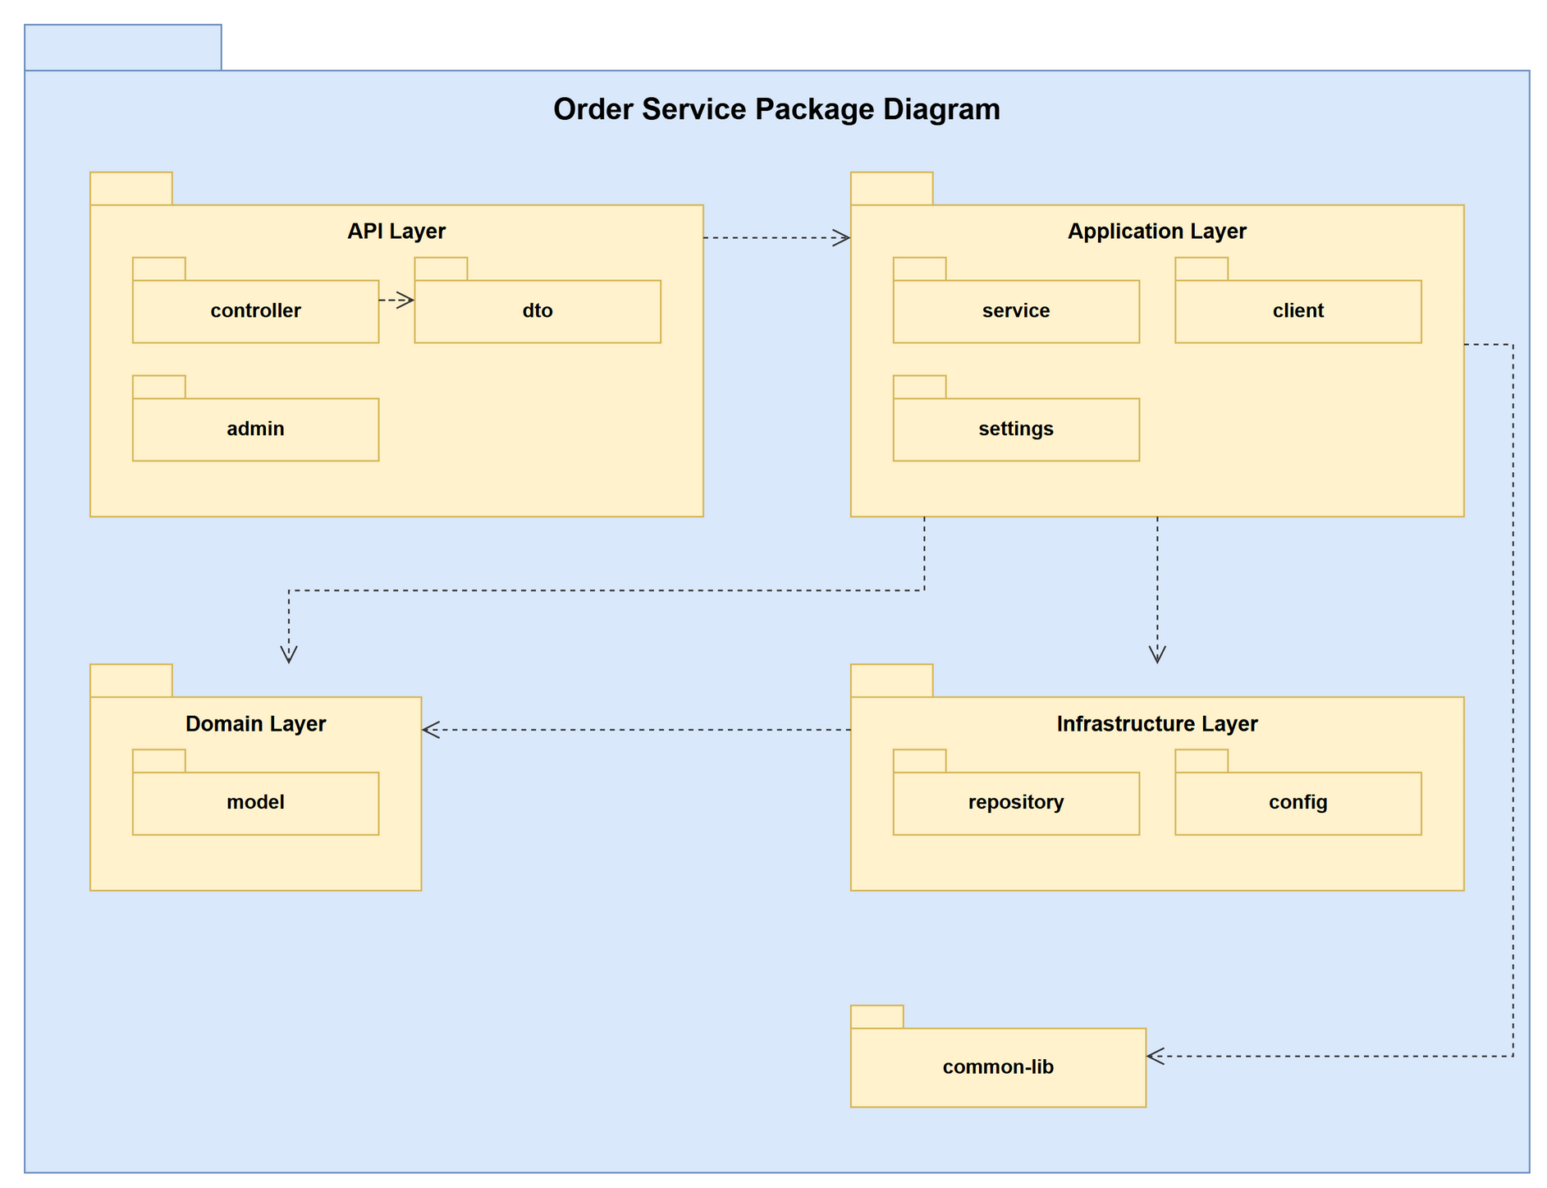
Figure 1.2.4: Order Service package diagram
Table 1.2.4: Packages of order-service
No | Package | Description
01 | admin | Response DTOs used by the admin web lists and reports. Main classes: AdminOrderResponse, BoxInfo, CollectedPayments, FeedbackDtos, LockerInfo, OrderBriefResponse, OrderPaymentSummary, RevenueDtos … (9 classes).
02 | client | OpenFeign clients that call other services through Eureka on their /internal/** endpoints. Main classes: DronePositionClient, LockerCellClient, LockerClient, LockerDroneClient, LockerLookupClient, LoyaltyClient, NotificationClient, PaymentRefundClient … (12 classes).
03 | config | Spring configuration: RabbitMQ exchange / queues / bindings, security, Firebase, WebSocket. Main classes: RabbitConfig.
04 | controller | REST controllers (@RestController). Receive requests routed by the gateway, read the X-User-Id / X-User-Roles headers, validate the input and wrap results in ApiResponse. Main classes: AdminFeedbackController, AdminOrderController, AdminRevenueController, DroneLockerCommLogController, DroneParcelIncidentController, OrderController.
05 | dto | Request and response records exchanged with clients and other services. Main classes: AcceptDroneOrderRequest, ActiveBoxOrderResponse, AdvanceDroneOrderRequest, AssignDronePickupRequest, AssignDroneRecoveryRequest, BoxCellDto, BoxIncidentNotice, CancelDroneOrderRequest … (81 classes).
06 | model | JPA entities mapped to the tables of the service database, and entity listeners that publish change events. Main classes: AdminDataChangeListener, DroneDeliverySession, DroneFailureReasons, DroneIncidentEvidence, DroneIncidentResolutionProposal, DroneIncidentStates, DroneIncidentTimeline, DroneLockerCommLog … (22 classes).
07 | repository | Spring Data JPA repositories: derived queries, custom JPQL, pessimistic locks. Main classes: DroneDeliverySessionRepository, DroneIncidentEvidenceRepository, DroneIncidentResolutionProposalRepository, DroneIncidentTimelineRepository, DroneLockerCommLogRepository, DroneMissionRepository, DroneParcelIncidentRepository, DronePickupOfferRepository … (19 classes).
08 | service | Business logic (@Service / @Component): use cases, business-rule checks, transactions, scheduled jobs and publishing of domain events. Main classes: AdminFeedbackService, AdminOrderQueryService, AdminReferenceResolver, DashboardInsightService, DroneDeliveryBlockService, DroneDeliveryFailureService, DroneDeliveryMailer, DroneDeliveryQueryService … (55 classes).
09 | settings | Rules and SettingsCatalog of the service: business settings editable on the admin web (common-lib BusinessSettings). Main classes: OrderRules, OrderSettingsCatalog.

1.2.5 Locker Service Package Diagram
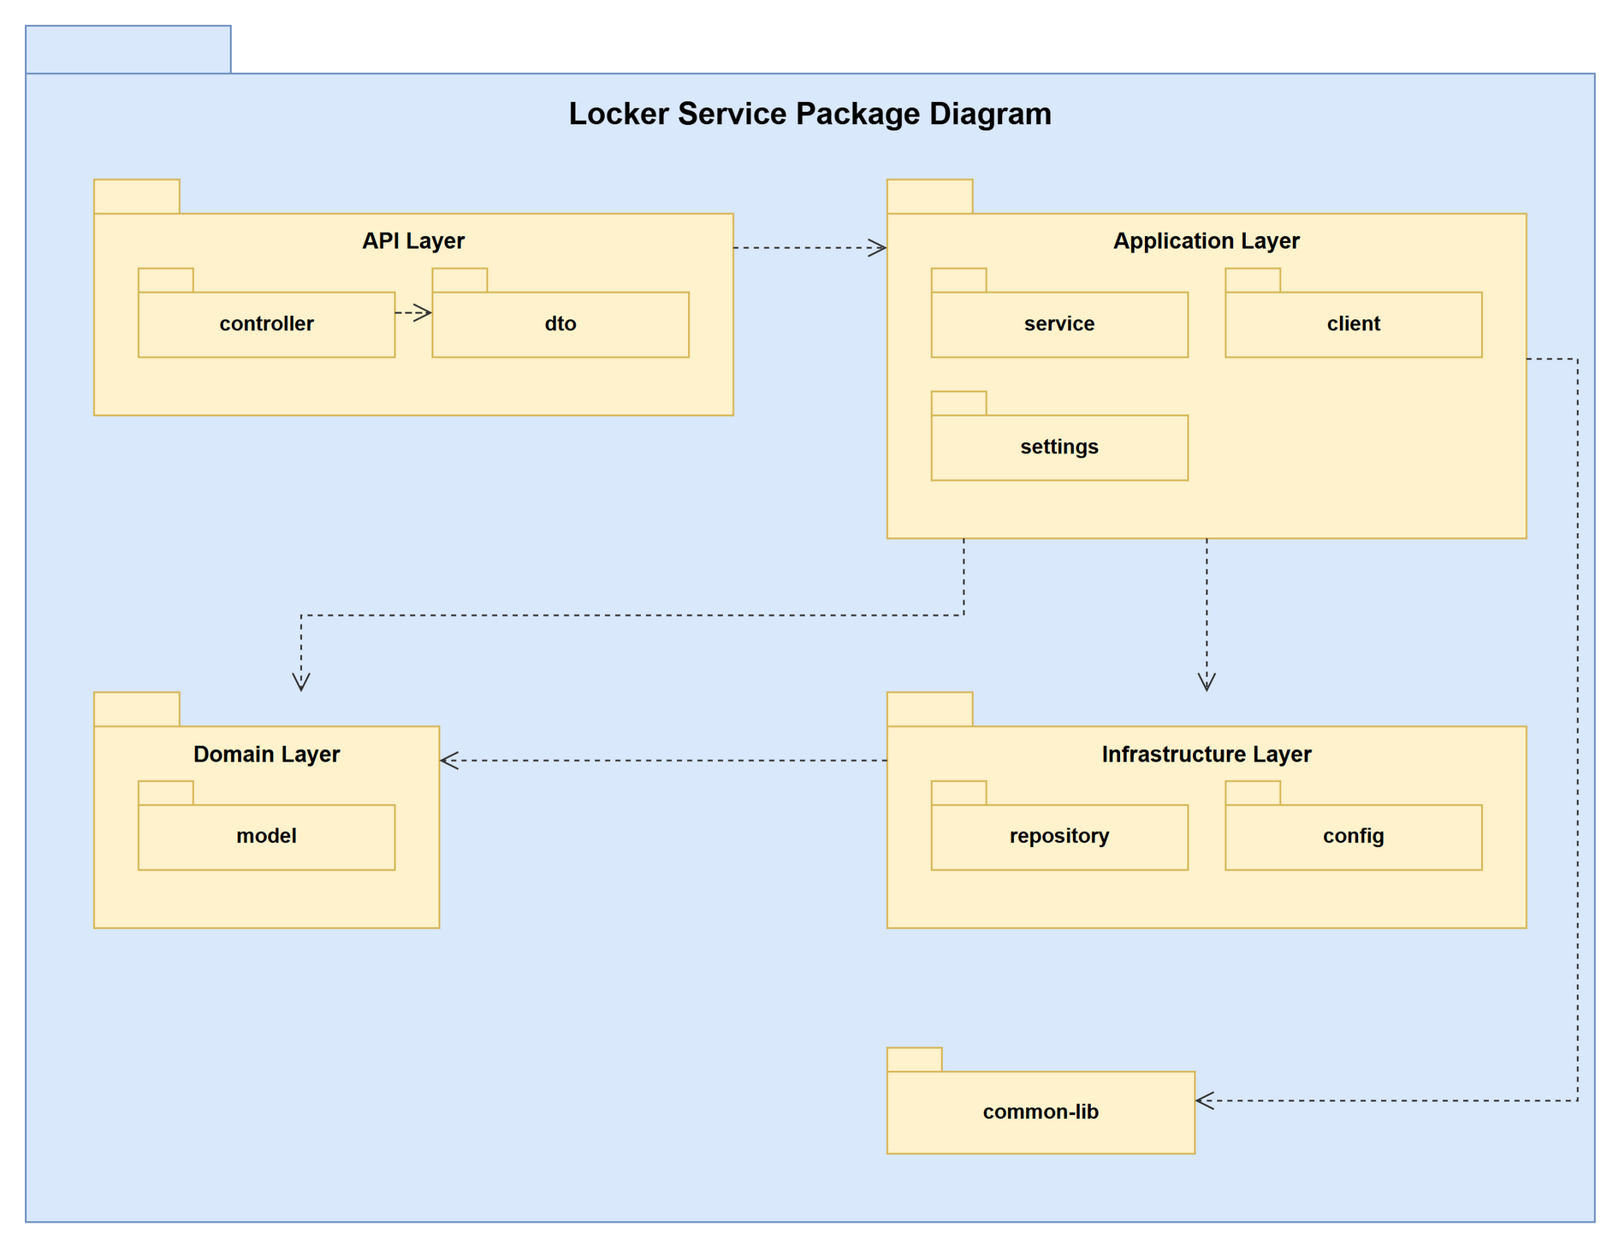
Figure 1.2.5: Locker Service package diagram
Table 1.2.5: Packages of locker-service
No | Package | Description
01 | client | OpenFeign clients that call other services through Eureka on their /internal/** endpoints. Main classes: IotClient, OrderClient, UserClient.
02 | config | Spring configuration: RabbitMQ exchange / queues / bindings, security, Firebase, WebSocket. Main classes: RabbitConfig.
03 | controller | REST controllers (@RestController). Receive requests routed by the gateway, read the X-User-Id / X-User-Roles headers, validate the input and wrap results in ApiResponse. Main classes: DroneDeliveryController, InternalLockerLookupController, LockerController.
04 | dto | Request and response records exchanged with clients and other services. Main classes: ActiveBoxOrderDto, AssignDroneDeviceRequest, AssignTechnicianScheduleRequest, BatchCreateBoxesRequest, BatchDeleteBoxesRequest, BatchDeleteLockersRequest, BatchDeleteReportsRequest, BoxAnomalyResponse … (61 classes).
05 | model | JPA entities mapped to the tables of the service database, and entity listeners that publish change events. Main classes: AttachmentStage, CellType, DroneDeliveryRequest, DroneDevice, DroneIotLog, DroneMaintenanceLog, DroneStatus, DroneUnit … (20 classes).
06 | repository | Spring Data JPA repositories: derived queries, custom JPQL, pessimistic locks. Main classes: DroneDeliveryRequestRepository, DroneDeviceRepository, DroneIotLogRepository, DroneMaintenanceLogRepository, DroneUnitRepository, LockerBoxRepository, LockerReportRatingRepository, LockerReportRepository … (14 classes).
07 | service | Business logic (@Service / @Component): use cases, business-rule checks, transactions, scheduled jobs and publishing of domain events. Main classes: DroneDeliveryService, LockerLookupService, LockerScheduler, LockerService, ReportAttachmentService, TechnicianPresenceService.
08 | settings | Rules and SettingsCatalog of the service: business settings editable on the admin web (common-lib BusinessSettings). Main classes: LockerRules, LockerSettingsCatalog.

1.2.6 Payment Service Package Diagram
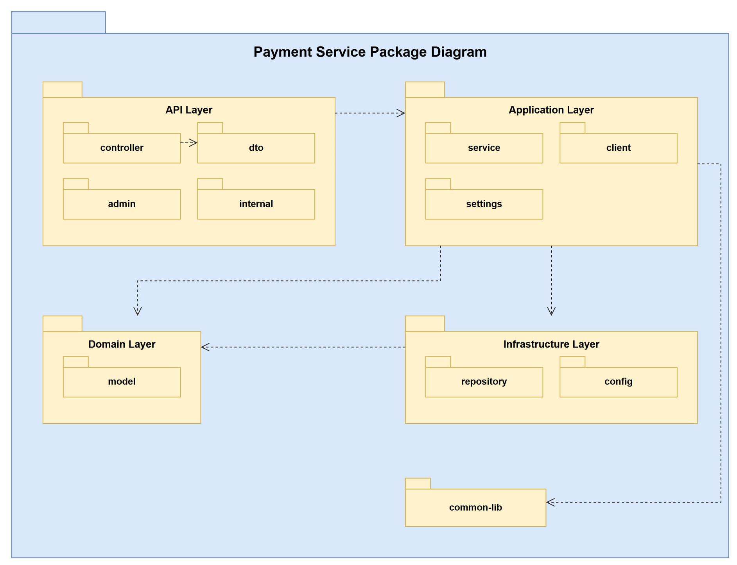
Figure 1.2.6: Payment Service package diagram
Table 1.2.6: Packages of payment-service
No | Package | Description
01 | admin | Response DTOs used by the admin web lists and reports. Main classes: AdminPaymentDetailResponse, AdminPaymentResponse, AdminRefundResponse, AdminWalletTransactionResponse, OrderBrief, OrderRef, PaymentStatsResponse, PersonRef.
02 | client | OpenFeign clients that call other services through Eureka on their /internal/** endpoints. Main classes: NotificationClient, OrderClient, OrderLookupClient, UserLookupClient.
03 | config | Spring configuration: RabbitMQ exchange / queues / bindings, security, Firebase, WebSocket. Main classes: RabbitConfig.
04 | controller | REST controllers (@RestController). Receive requests routed by the gateway, read the X-User-Id / X-User-Roles headers, validate the input and wrap results in ApiResponse. Main classes: AdminPaymentController, InternalPaymentReportController, PaymentController, WalletController.
05 | dto | Request and response records exchanged with clients and other services. Main classes: AdminWithdrawProcessRequest, CheckoutRequest, CreatePaymentRequest, CreateRefundRequest, CreateTopupRequest, PaymentResponse, ProcessRefundRequest, RefundRequest … (23 classes).
06 | internal | DTOs of the /internal/** API that only other services call. Main classes: CollectedPaymentsResponse, CompensationRefundResult, OrderPaymentSummary, OrderRefundResult.
07 | model | JPA entities mapped to the tables of the service database, and entity listeners that publish change events. Main classes: AdminDataChangeListener, PaymentRecord, RefundRecord, UserBankAccount, Wallet, WalletTransaction, WithdrawalRecord.
08 | repository | Spring Data JPA repositories: derived queries, custom JPQL, pessimistic locks. Main classes: PaymentRepository, PaymentSpecifications, RefundRepository, UserBankAccountRepository, WalletRepository, WalletTransactionRepository, WithdrawalRepository.
09 | service | Business logic (@Service / @Component): use cases, business-rule checks, transactions, scheduled jobs and publishing of domain events. Main classes: AdminPaymentQueryService, InternalPaymentReportService, PaymentReferenceResolver, PaymentReportRules, PaymentService, PaymentStatsService, SepayService, WalletEvents … (9 classes).
10 | settings | Rules and SettingsCatalog of the service: business settings editable on the admin web (common-lib BusinessSettings). Main classes: PaymentRules, PaymentSettingsCatalog.

1.2.7 Notification Service Package Diagram
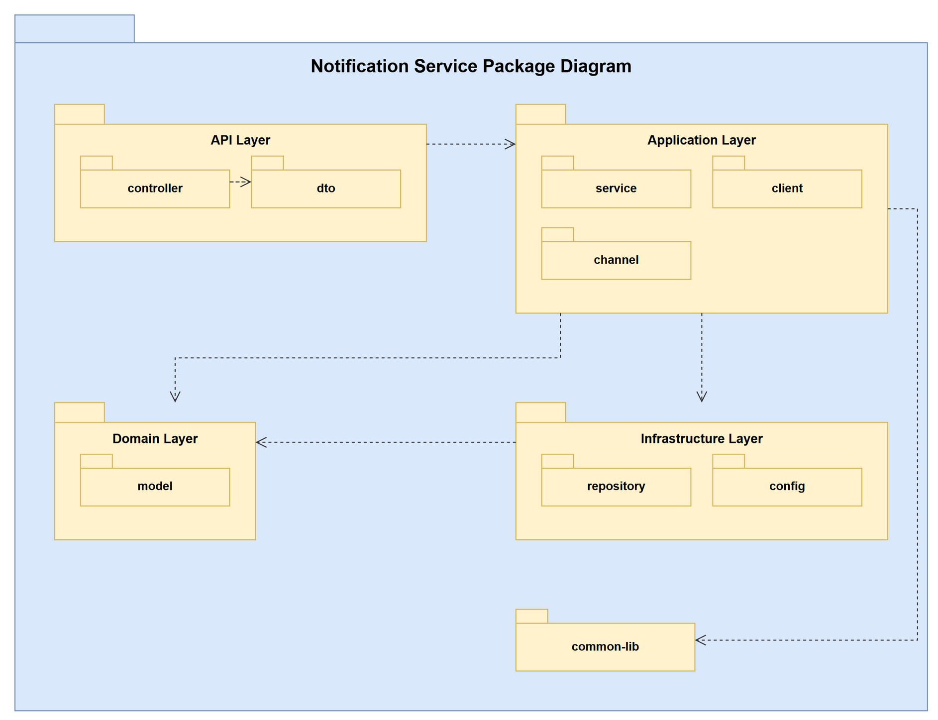
Figure 1.2.7: Notification Service package diagram
Table 1.2.7: Packages of notification-service
No | Package | Description
01 | channel | SMS and e-mail channels (Twilio, eSMS, logging fallback) used for pickup codes of guests. Main classes: EsmsSmsSender, GuestEmailSender, LoggingSmsSender, PhoneNumbers, SmsChannelConfig, SmsSender, TwilioSmsSender.
02 | client | OpenFeign clients that call other services through Eureka on their /internal/** endpoints. Main classes: OrderParticipantClient.
03 | config | Spring configuration: RabbitMQ exchange / queues / bindings, security, Firebase, WebSocket. Main classes: BrokerDestinationGuardInterceptor, DeliveryTopicSubscriptionInterceptor, FirebaseConfig, JwtHandshakePrincipalHandler, JwtStompPrincipalChannelInterceptor, RabbitConfig, StompPrincipal, WebSocketConfig.
04 | controller | REST controllers (@RestController). Receive requests routed by the gateway, read the X-User-Id / X-User-Roles headers, validate the input and wrap results in ApiResponse. Main classes: NotificationController.
05 | dto | Request and response records exchanged with clients and other services. Main classes: AdminBroadcastRequest, DeliveryStatusNotificationRequest, DeviceTokenRequest, DronePositionRequest, FcmTokenRequest, GuestNotificationRequest, GuestNotificationResponse, NotificationResponse … (9 classes).
06 | model | JPA entities mapped to the tables of the service database, and entity listeners that publish change events. Main classes: FcmToken, NotificationMessage.
07 | repository | Spring Data JPA repositories: derived queries, custom JPQL, pessimistic locks. Main classes: FcmTokenRepository, NotificationRepository.
08 | service | Business logic (@Service / @Component): use cases, business-rule checks, transactions, scheduled jobs and publishing of domain events. Main classes: DeliveryNotificationService, DronePositionService, FcmPushNotificationService, GuestNotificationService, NotificationEventListener, NotificationService, WebSocketNotificationService.

1.2.8 IoT Service Package Diagram
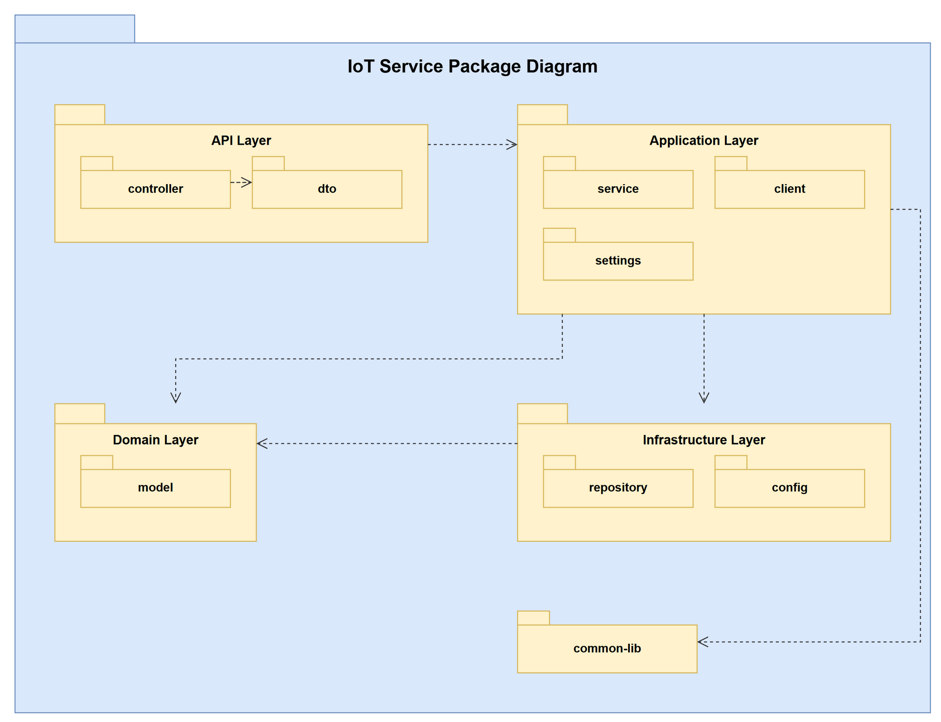
Figure 1.2.8: IoT Service package diagram
Table 1.2.8: Packages of iot-service
No | Package | Description
01 | client | OpenFeign clients that call other services through Eureka on their /internal/** endpoints. Main classes: LockerClient, OrderClient.
02 | config | Spring configuration: RabbitMQ exchange / queues / bindings, security, Firebase, WebSocket. Main classes: RabbitConfig.
03 | controller | REST controllers (@RestController). Receive requests routed by the gateway, read the X-User-Id / X-User-Roles headers, validate the input and wrap results in ApiResponse. Main classes: BleTestController, CabinetControlController, GatewayController, IotController, TechnicianController.
04 | dto | Request and response records exchanged with clients and other services. Main classes: AssignGatewayRequest, BleOpenTokenResponse, BleTestGrantRequest, BleTestGrantResponse, BleTestLockerResponse, BoxAccessLogResponse, BoxHardwareStatusResponse, BoxStateSyncRequest … (25 classes).
05 | model | JPA entities mapped to the tables of the service database, and entity listeners that publish change events. Main classes: AccessAttempt, BleSigningKey, BleTestGrant, BoxAccessLog, BoxHardwareStatus, CabinetControlLog, CabinetHardwareConfig, DeviceStatus … (9 classes).
06 | repository | Spring Data JPA repositories: derived queries, custom JPQL, pessimistic locks. Main classes: AccessAttemptRepository, BleSigningKeyRepository, BleTestGrantRepository, BoxAccessLogRepository, BoxHardwareStatusRepository, CabinetControlLogRepository, CabinetHardwareConfigRepository, DeviceStatusRepository … (9 classes).
07 | service | Business logic (@Service / @Component): use cases, business-rule checks, transactions, scheduled jobs and publishing of domain events. Main classes: BleTestService, BleTokenSigner, CabinetControlLogService, CabinetControlService, CabinetHardwareConfigService, CabinetLayoutLookup, DeviceManagementService, GatewayProvisioningService … (10 classes).
08 | settings | Rules and SettingsCatalog of the service: business settings editable on the admin web (common-lib BusinessSettings). Main classes: IotRules, IotSettingsCatalog.

1.2.9 Store Service Package Diagram
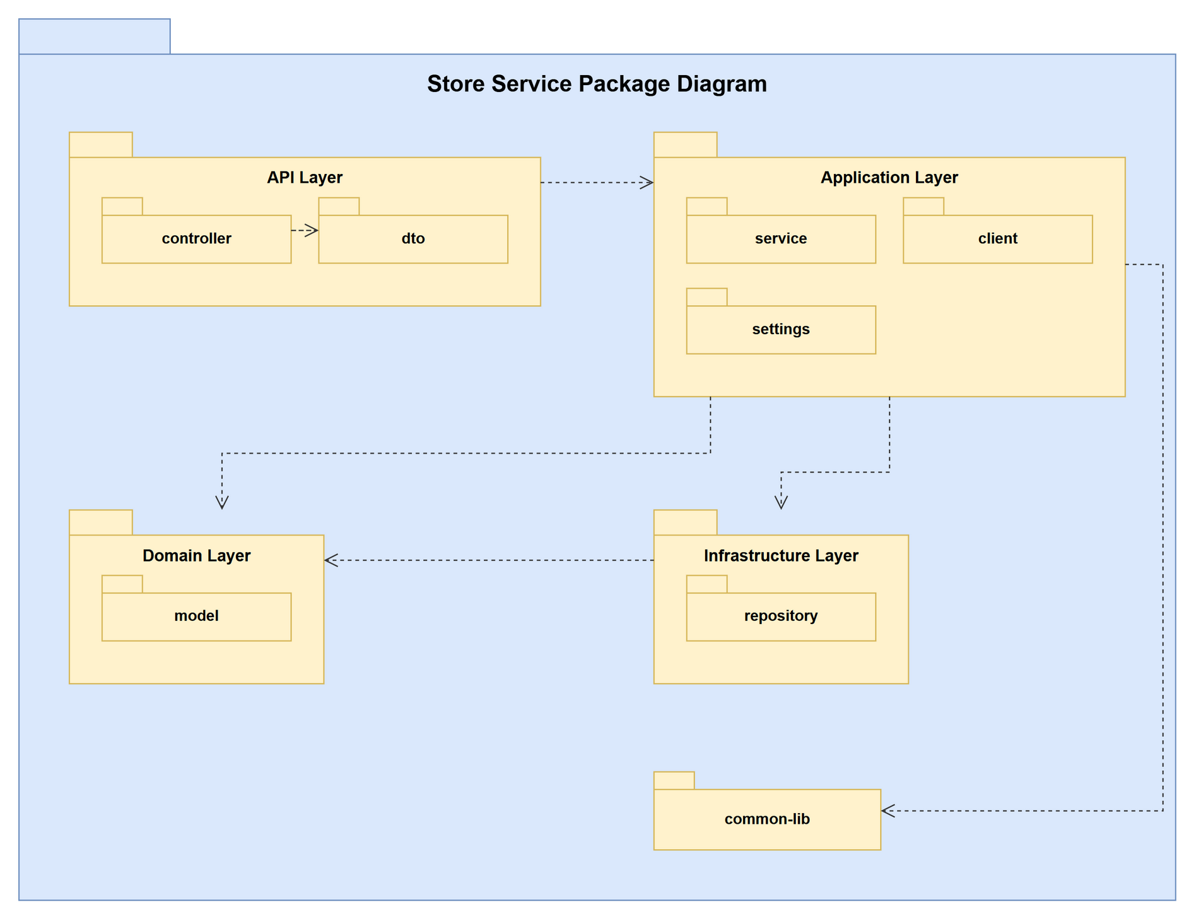
Figure 1.2.9: Store Service package diagram
Table 1.2.9: Packages of store-service
No | Package | Description
01 | client | OpenFeign clients that call other services through Eureka on their /internal/** endpoints. Main classes: LockerClient, OrderClient.
02 | controller | REST controllers (@RestController). Receive requests routed by the gateway, read the X-User-Id / X-User-Roles headers, validate the input and wrap results in ApiResponse. Main classes: InternalStoreLookupController, StoreController.
03 | dto | Request and response records exchanged with clients and other services. Main classes: StoreRequest, StoreResponse.
04 | model | JPA entities mapped to the tables of the service database, and entity listeners that publish change events. Main classes: StoreLocation.
05 | repository | Spring Data JPA repositories: derived queries, custom JPQL, pessimistic locks. Main classes: StoreRepository.
06 | service | Business logic (@Service / @Component): use cases, business-rule checks, transactions, scheduled jobs and publishing of domain events. Main classes: StoreService.
07 | settings | Rules and SettingsCatalog of the service: business settings editable on the admin web (common-lib BusinessSettings). Main classes: StoreRules, StoreSettingsCatalog.

1.2.10 Loyalty Service Package Diagram
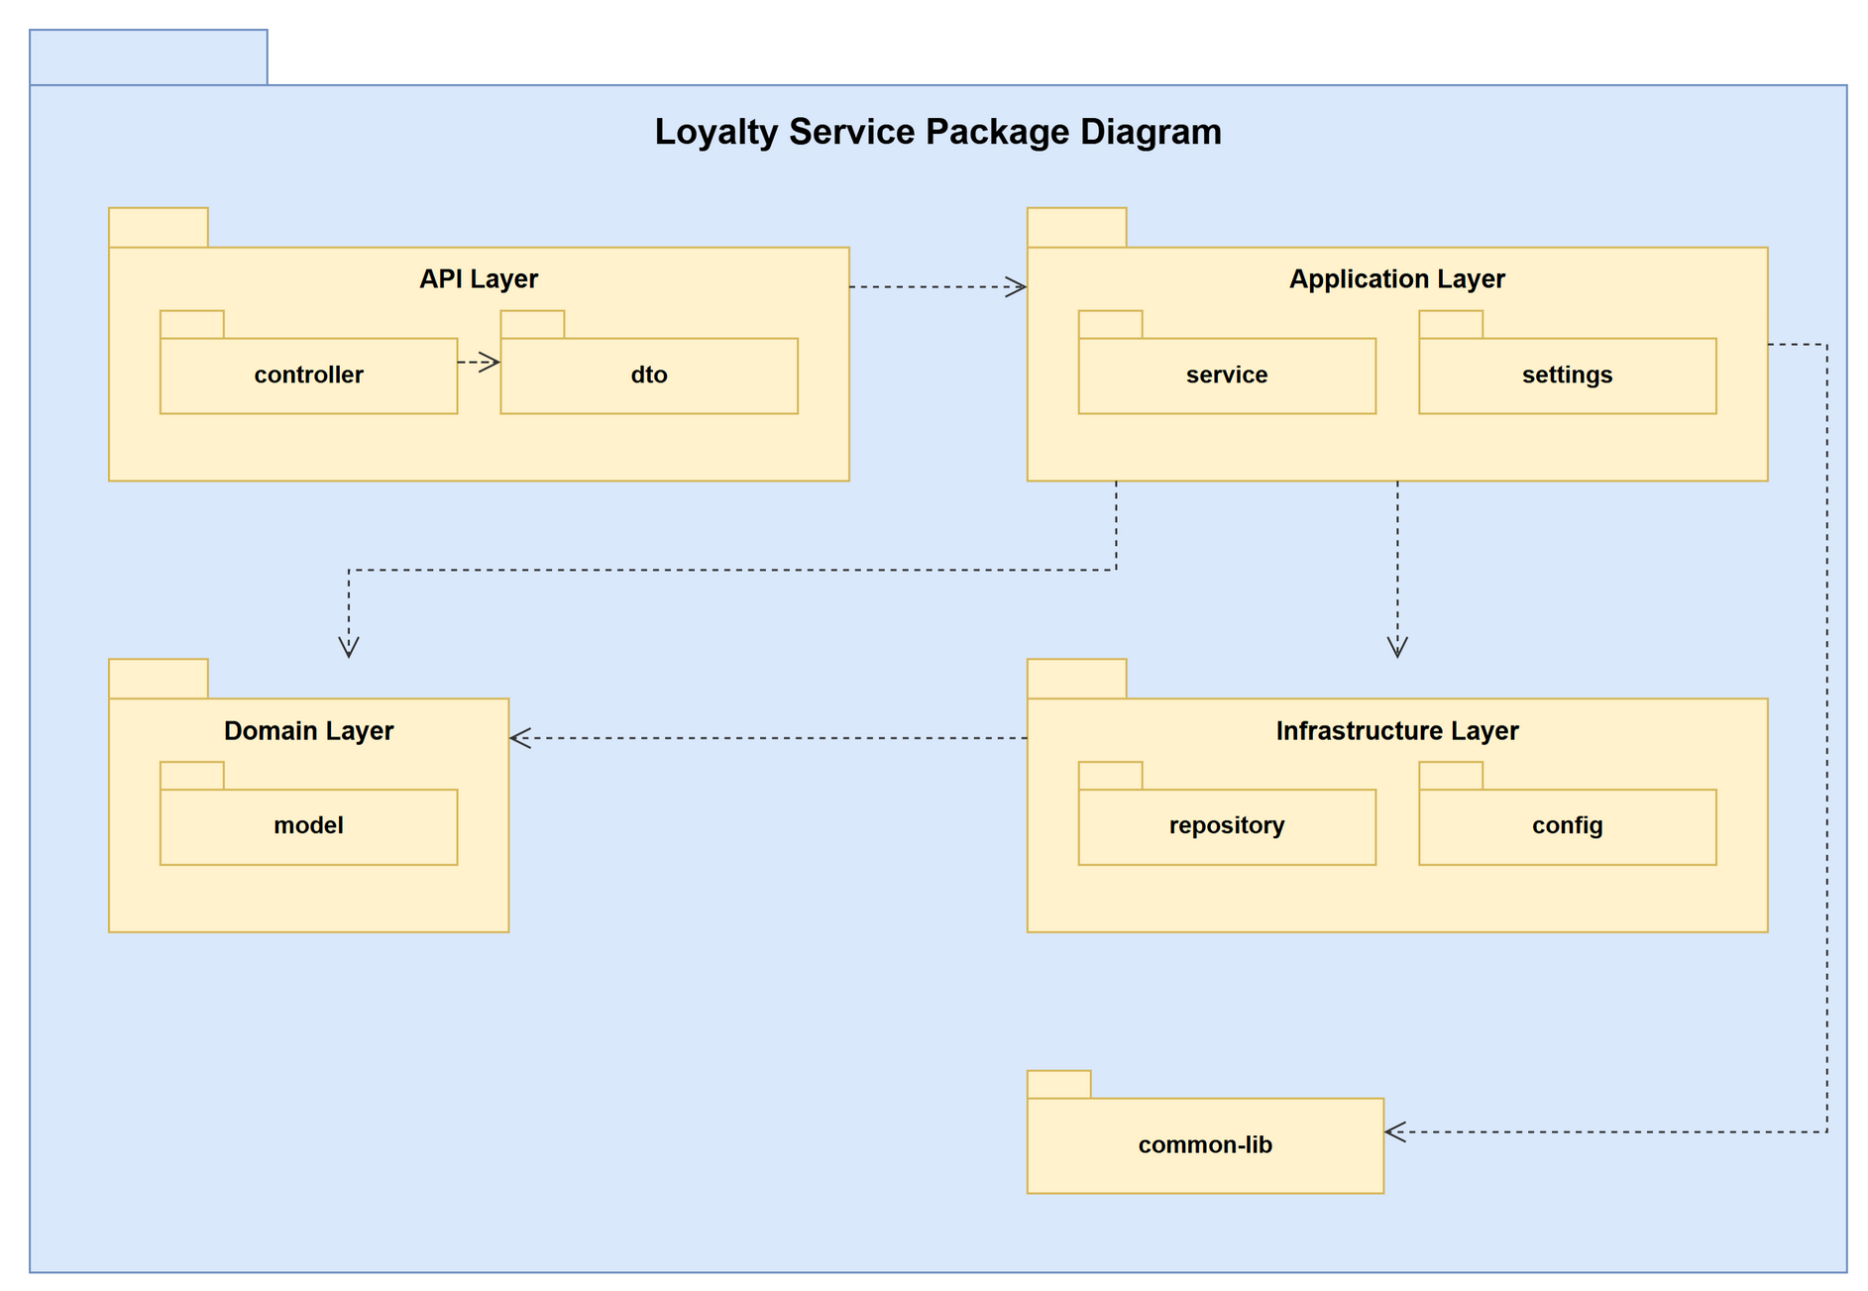
Figure 1.2.10: Loyalty Service package diagram
Table 1.2.10: Packages of loyalty-service
No | Package | Description
01 | config | Spring configuration: RabbitMQ exchange / queues / bindings, security, Firebase, WebSocket. Main classes: RabbitConfig.
02 | controller | REST controllers (@RestController). Receive requests routed by the gateway, read the X-User-Id / X-User-Roles headers, validate the input and wrap results in ApiResponse. Main classes: LoyaltyController.
03 | dto | Request and response records exchanged with clients and other services. Main classes: AdjustPointsRequest, LoyaltyAccountResponse, LoyaltyStatisticsResponse, OrderRedemptionRefundResponse, OrderRedemptionRequest, OrderRedemptionResponse, PointTransactionResponse, RedeemPointsRequest … (12 classes).
04 | model | JPA entities mapped to the tables of the service database, and entity listeners that publish change events. Main classes: LoyaltyAccount, PointTransaction.
05 | repository | Spring Data JPA repositories: derived queries, custom JPQL, pessimistic locks. Main classes: LoyaltyAccountRepository, PointTransactionRepository.
06 | service | Business logic (@Service / @Component): use cases, business-rule checks, transactions, scheduled jobs and publishing of domain events. Main classes: LoyaltyEvents, LoyaltyService, OrderCompletedPointsListener.
07 | settings | Rules and SettingsCatalog of the service: business settings editable on the admin web (common-lib BusinessSettings). Main classes: LoyaltyRules, LoyaltySettingsCatalog.

1.2.11 Assistant Service Package Diagram
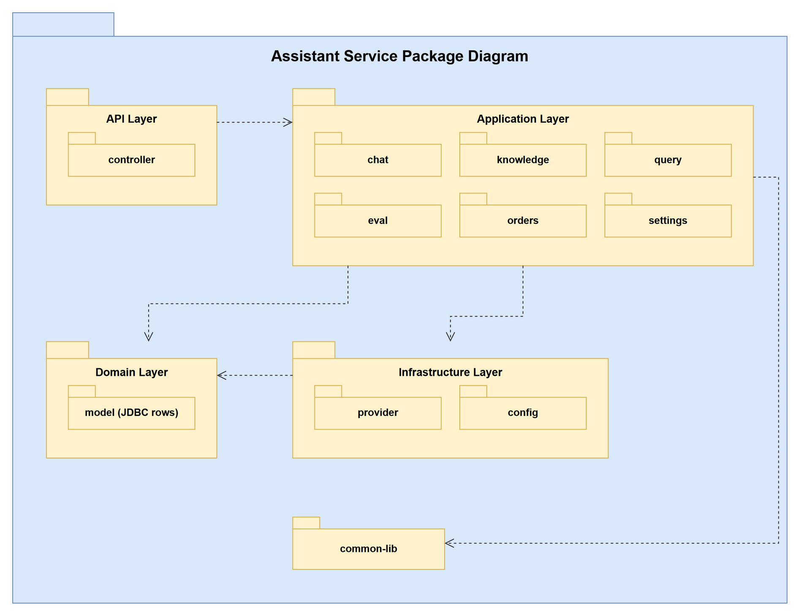
Figure 1.2.11: Assistant Service package diagram
Table 1.2.11: Packages of assistant-service
No | Package | Description
01 | chat | Question answering: AssistantService and the conversation repository (JDBC). Main classes: AssistantService, ChatDtos, ConversationRepository.
02 | config | Spring configuration: RabbitMQ exchange / queues / bindings, security, Firebase, WebSocket. Main classes: AssistantProperties.
03 | controller | REST controllers (@RestController). Receive requests routed by the gateway, read the X-User-Id / X-User-Roles headers, validate the input and wrap results in ApiResponse. Main classes: AssistantController, AssistantExceptionHandler, KnowledgeAdminController.
04 | eval | Evaluation cases used to measure retrieval quality. Main classes: EvalService.
05 | knowledge | Knowledge base: documents, chunks, document parser, text chunker and background indexer. Main classes: ChunkRepository, DocumentParser, DocumentRepository, KnowledgeChunk, KnowledgeDocument, KnowledgeIndexer, KnowledgeService, RetrievedChunk … (10 classes).
06 | orders | Feign clients and formatter that load the asker's own orders as answer context. Main classes: LockerLookupClient, OrderContextService, OrderDocumentFormatter, OrderDtos, OrderServiceClient.
07 | provider | Adapters for external AI providers: Claude answer generator, Voyage embeddings, diacritics restorer. Main classes: AnswerGenerator, ClaudeAnswerGenerator, ClaudeClientProvider, ClaudeDiacriticsRestorer, DiacriticsRestorer, EmbeddingProvider, ProviderException, VoyageEmbeddingProvider.
08 | query | Question preparation: Vietnamese normalisation and order intent detection. Main classes: OrderIntent, QuestionPreparer, VietnameseText.
09 | settings | Rules and SettingsCatalog of the service: business settings editable on the admin web (common-lib BusinessSettings). Main classes: AssistantRules, AssistantSettingsCatalog.

1.2.12 Admin Web Application Package Diagram
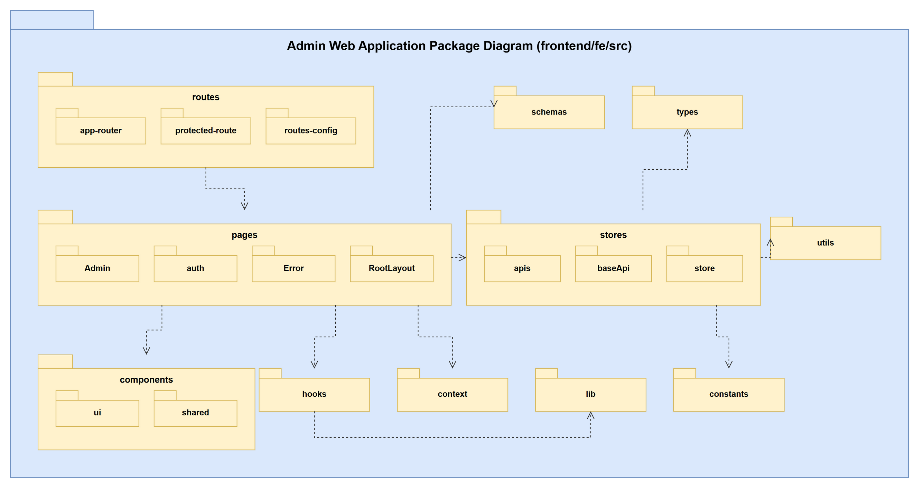
Figure 1.2.12: Admin web application package diagram
Table 1.2.12: Packages of the admin web application
No | Package | Description
01 | routes | app-router, protected-route (role check) and routes-config of every admin page (lazy loaded).
02 | pages | Screens: auth (2FA login) and Admin/* feature folders - dashboard, revenue, users, technicians, stores, lockers, cabinet-control, maintenance, drones, drone-orders, drone-incidents, drone-logs, orders, payments, refunds, promotions, loyalty, feedback, notifications, scheduler, services, settings, knowledge.
03 | components | ui (shadcn-style primitives: button, dialog, table, form...) and shared (data-table, layout, page-header, media, status tabs, charts).
04 | stores | Redux store and RTK Query: baseApi (auth header, refresh, error handling) and apis (adminApi, authApi, loyaltyApi, notificationApi, media).
05 | hooks | useAdminRealtimeSync (STOMP -> cache invalidation), useWebSocket, useImageUpload, use-toast.
06 | context | AuthContext (session and role), sidebar and theme contexts.
07 | lib | Helpers: admin realtime tag map, Cloudinary upload, date/time, locker layout helper, report formatting, validation.
08 | schemas | Zod schemas for admin forms.
09 | types | TypeScript types of API resources.
10 | constants | API paths, roles, sidebar menu, order setting keys.
11 | utils | API helpers, auth session storage, i18n.

1.2.13 Mobile Application Package Diagram
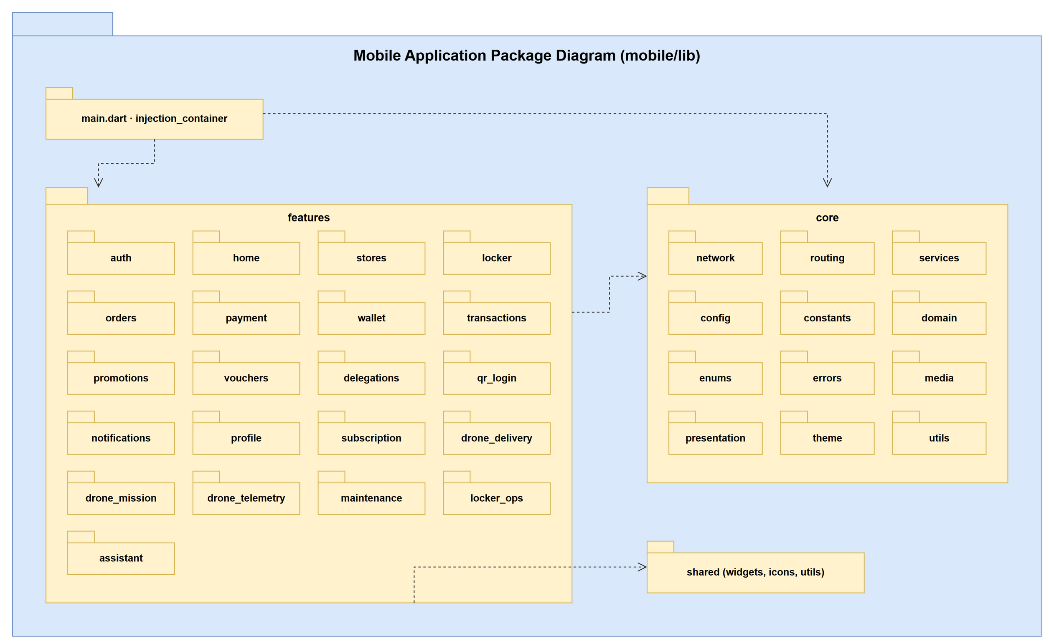
Figure 1.2.13: Mobile application package diagram
Table 1.2.13: Packages of the mobile application
No | Package | Description
01 | main.dart / injection_container | Application entry, Firebase initialisation and provider factories that wire data sources, repositories and use cases (per-feature *_injection providers).
02 | features | One folder per business feature: auth, home, stores, locker, orders, payment, wallet, transactions, promotions, vouchers, delegations, qr_login, notifications, profile, subscription, drone_delivery, drone_mission, drone_telemetry, maintenance (locker technician), locker_ops, assistant.
03 | core/network | dio ApiClient, AuthInterceptor (token refresh), gateway client.
04 | core/routing | go_router configuration, role-based routes, main navigation wrapper, notification deep links.
05 | core/services | Session and token storage, Firebase auth / messaging, BLE open service, biometric, app event bus.
06 | core/config, constants, theme | Environment config, business config loaded from /api/settings/*/public, colours, strings, themes.
07 | core/domain, enums, errors, utils, media, presentation | Shared entities, enums, failures, formatters, media upload and common pages.
08 | shared | Reusable widgets, icons and utilities.

1.2.14 Mobile Feature Module Package Diagram
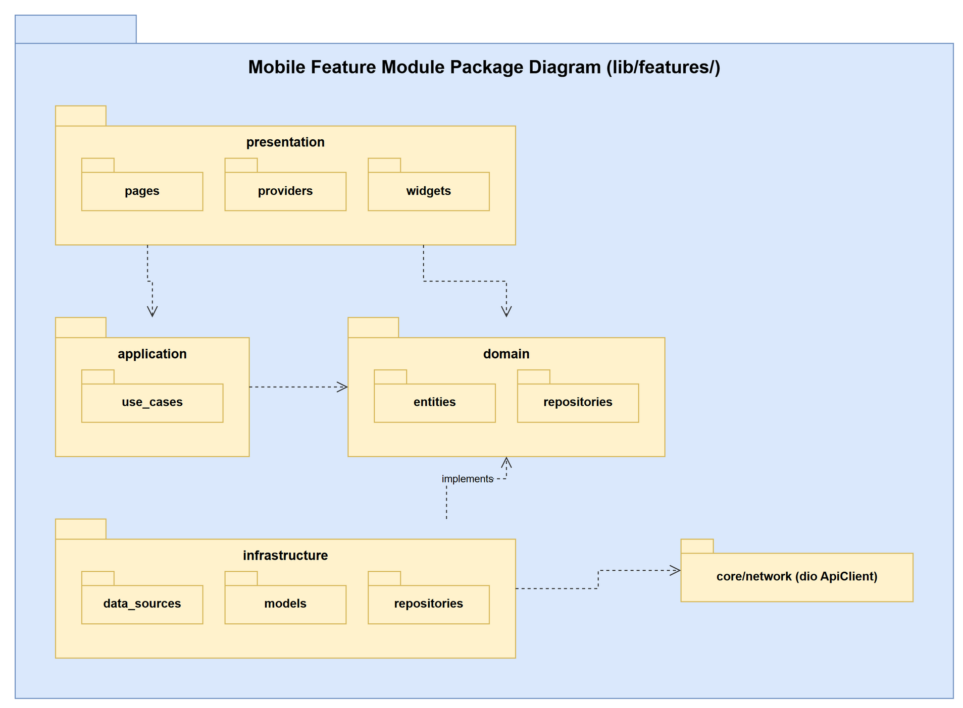
Figure 1.2.14: Package structure inside one mobile feature module
Table 1.2.14: Layers of a mobile feature module
No | Package | Description
01 | presentation | pages (screens), widgets and providers (Riverpod / provider / bloc state).
02 | application | use_cases: one class per user action (e.g. LoginUseCase, GetMyOrdersUseCase).
03 | domain | entities and repository interfaces of the feature, independent of the API.
04 | infrastructure | data_sources (remote calls through ApiClient), models (JSON serializable, *.g.dart) and repository implementations.

1.2.15 IoT Locker Controller Package Diagram
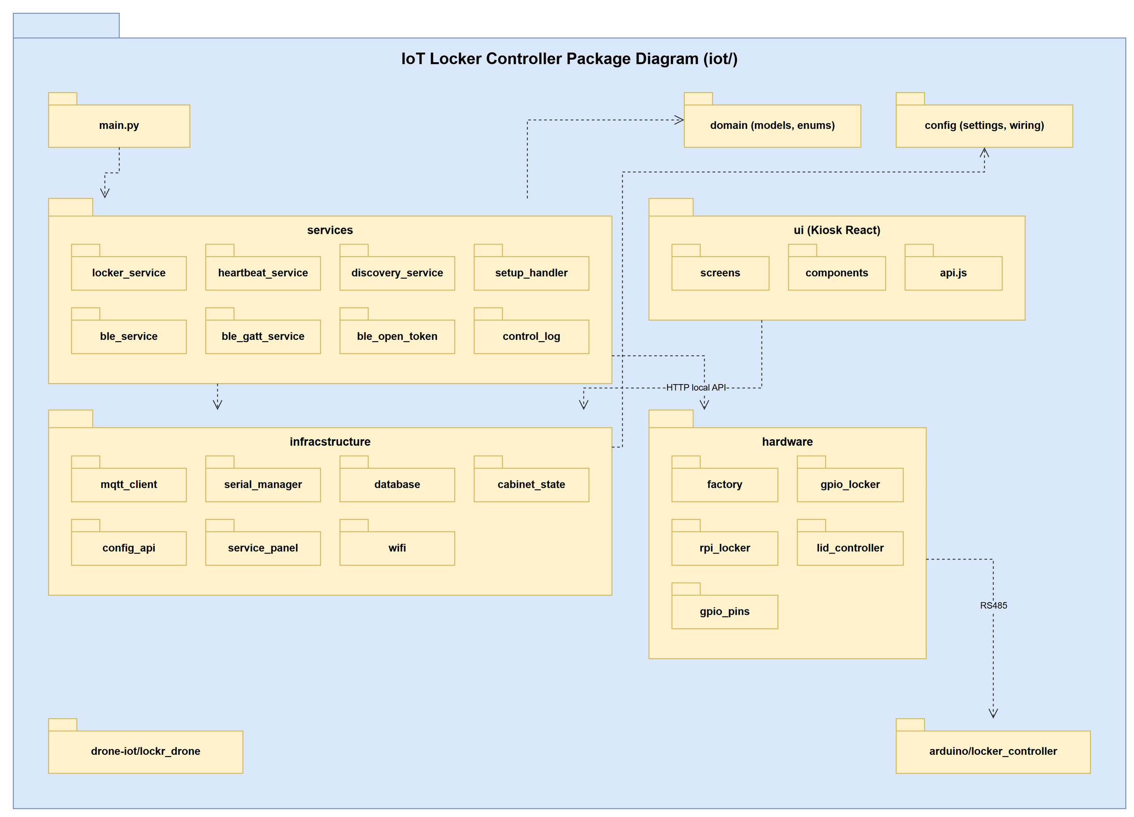
Figure 1.2.15: IoT locker controller package diagram
Table 1.2.15: Packages of the IoT locker controller
No | Package | Description
01 | main.py | Starts the controller: loads config, connects MQTT, starts heartbeat, discovery / setup handlers, BLE service and local API.
02 | services | locker_service (open / lid / sync commands), heartbeat_service, discovery_service and setup_handler (provisioning), ble_service / ble_gatt_service / ble_open_token (offline open), control_log.
03 | infracstructure | mqtt_client (paho-mqtt, topics cabinet/* and iot/*), serial_manager (RS485 to Arduino), database (local PostgreSQL log store, psycopg2), cabinet_state, config_api and service_panel (local FastAPI HTTP API), wifi.
04 | hardware | factory selecting the driver, gpio_locker / rpi_locker (relays and reed sensors through gpiod), lid_controller (sliding lid), gpio_pins.
05 | domain | Models and enums of boxes, commands and results.
06 | config | settings (environment), wiring_default.json and hardware_config.
07 | ui (Kiosk React) | KioskScreen and AdminScreen, components (virtual keyboard, animations) and api.js calling the backend and the Pi.
08 | arduino/locker_controller | Arduino sketch driving relays and reading sensors over RS485.
09 | drone-iot/lockr_drone | Companion computer on the drone: reads MAVLink and publishes signed telemetry to MQTT.

2. Database Design
Lock.R follows the database-per-service pattern: each microservice owns one PostgreSQL 16 database whose schema is created by Flyway migrations and validated by Hibernate at start-up; the assistant uses a separate pgvector database. Foreign keys exist only between tables of the same database. A column that refers to a row of another service (for example orders.user_id -> user_profiles) is a logical reference: it is checked by the owning service through Feign calls and is shown as (FK) in the diagrams. The figures list the primary key, the foreign keys and the first columns of each table; very wide tables (orders, drone_parcel_incidents, drone_missions) show the number of remaining columns. Crow's-foot notation: | exactly one, o| zero or one, o< zero or many.

2.1 auth_db (auth-service)
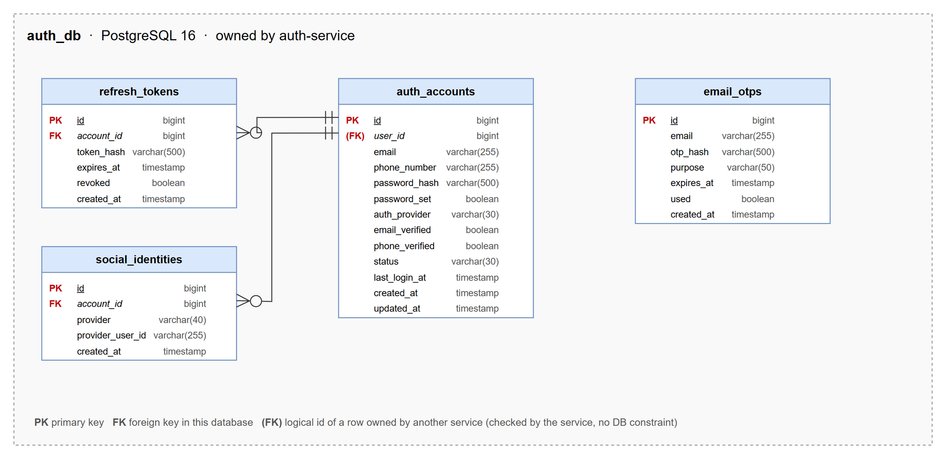
Figure 2.1: Database diagram of auth_db
Table 2.1: Table descriptions of auth_db
No | Table | Description
01 | auth_accounts | Login credentials of a user: email, phone, password hash, provider (LOCAL / GOOGLE / PHONE), status and 2FA flag.  - Primary keys: id  - Foreign keys: user_id -> user_profiles (logical, user-service)
02 | email_otps | One-time passwords for login, password reset and admin 2FA, stored hashed with expiry and attempts.  - Primary keys: id  - Foreign keys: none
03 | refresh_tokens | Refresh tokens issued at login, stored hashed and revoked on logout or when the account is locked.  - Primary keys: id  - Foreign keys: account_id -> auth_accounts
04 | social_identities | Google / Firebase identities linked to an account.  - Primary keys: id  - Foreign keys: account_id -> auth_accounts

2.2 user_db (user-service)
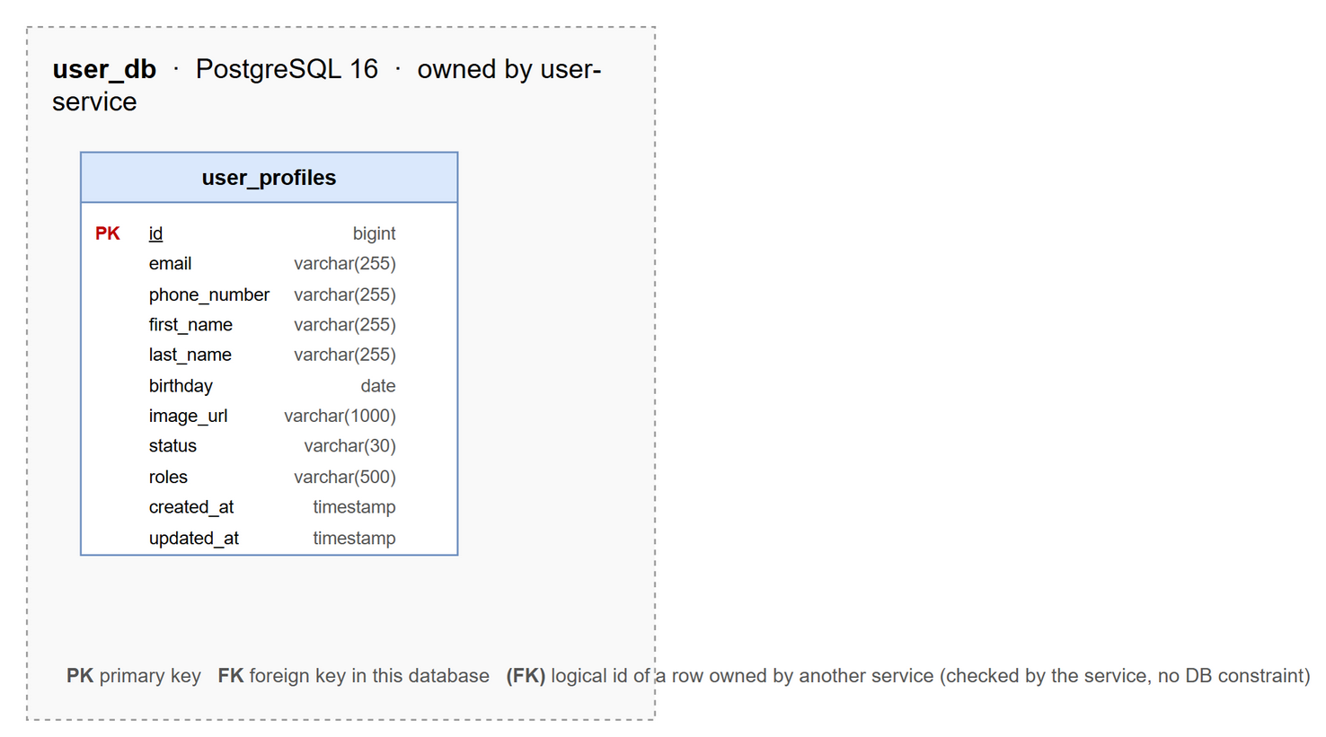
Figure 2.2: Database diagram of user_db
Table 2.2: Table descriptions of user_db
No | Table | Description
01 | user_profiles | Profile of a user: name, email, phone, avatar, roles (CUSTOMER, LOCKER_TECHNICIAN, DRONE_TECHNICIAN, ADMIN) and status.  - Primary keys: id  - Foreign keys: none

2.3 store_db (store-service)
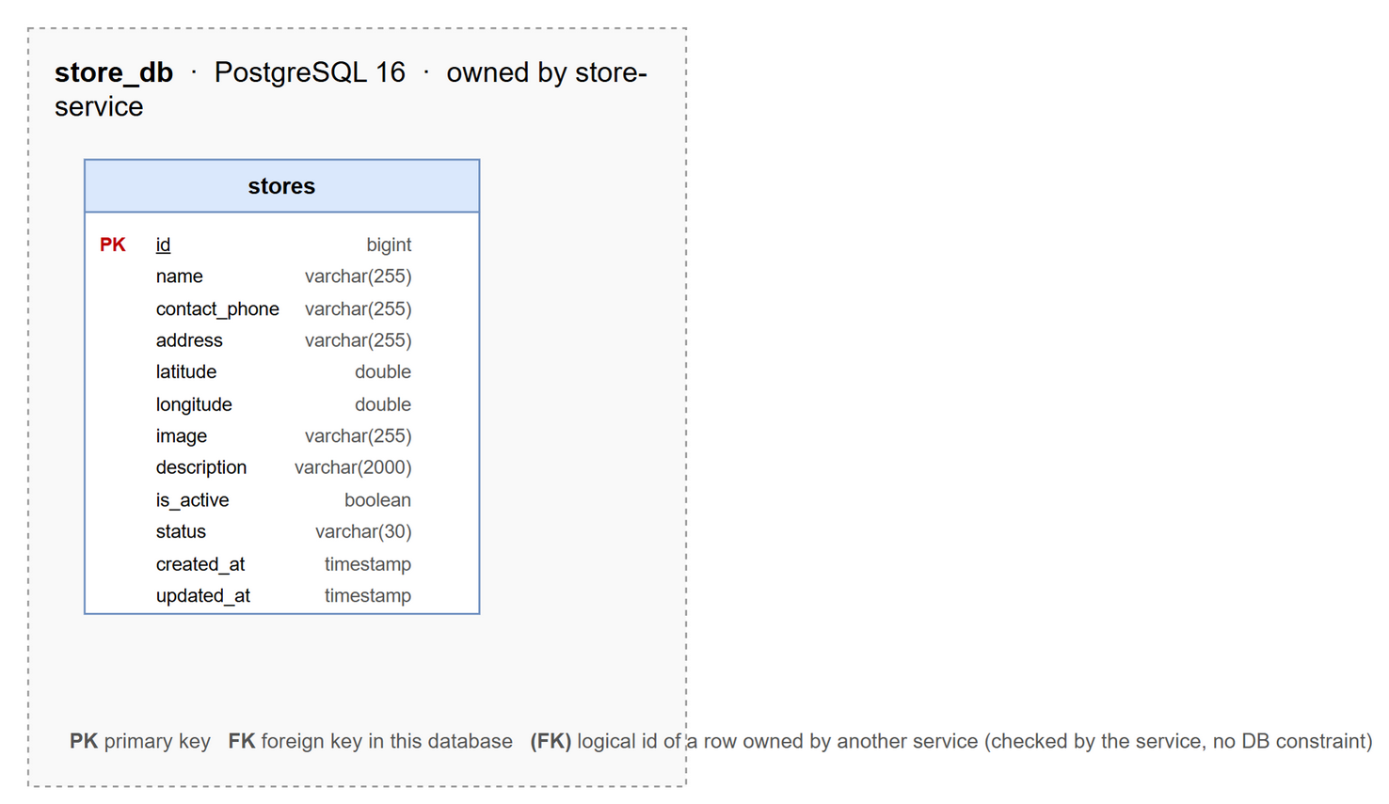
Figure 2.3: Database diagram of store_db
Table 2.3: Table descriptions of store_db
No | Table | Description
01 | stores | Store (location) that hosts lockers: name, address, coordinates, status.  - Primary keys: id  - Foreign keys: none

2.4 locker_db (locker-service)
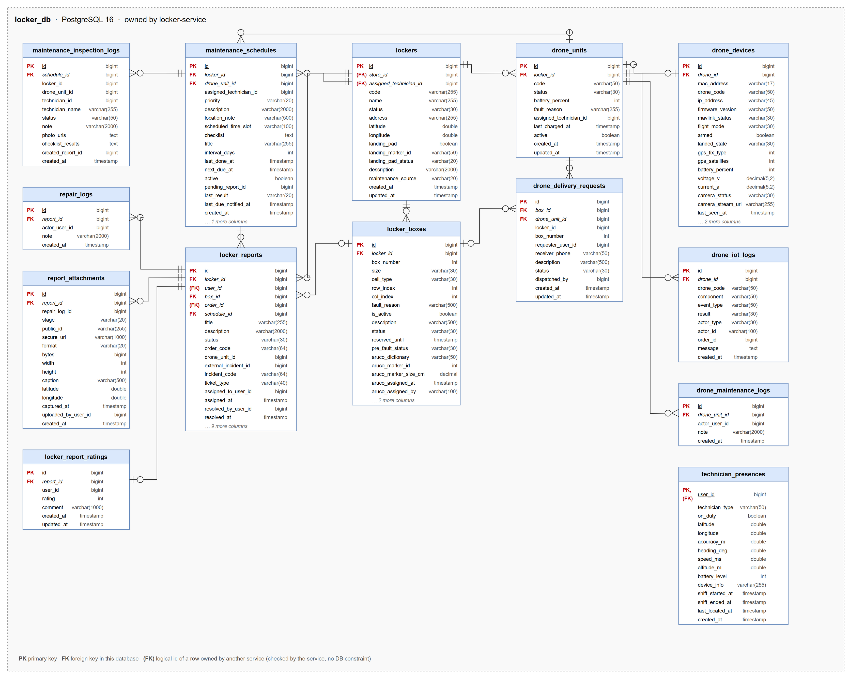
Figure 2.4: Database diagram of locker_db
Table 2.4: Table descriptions of locker_db
No | Table | Description
01 | drone_delivery_requests | Request to deliver to a drone box of a locker.  - Primary keys: id  - Foreign keys: box_id -> locker_boxes, drone_unit_id -> drone_units
02 | drone_devices | Hardware device (Pi + flight controller) installed on a drone.  - Primary keys: id  - Foreign keys: drone_id -> drone_units
03 | drone_iot_logs | IoT events reported by a drone device.  - Primary keys: id  - Foreign keys: drone_id -> drone_units
04 | drone_maintenance_logs | Maintenance note of a drone.  - Primary keys: id  - Foreign keys: drone_unit_id -> drone_units
05 | drone_units | Drone of the fleet: code, station locker, status, battery and responsible technician.  - Primary keys: id  - Foreign keys: locker_id -> lockers
06 | locker_boxes | Box of a locker: number, size, cell type (STANDARD / XL / DRONE), grid position and status.  - Primary keys: id  - Foreign keys: locker_id -> lockers
07 | locker_report_ratings | Reporter's rating of the technician after a ticket is resolved.  - Primary keys: id  - Foreign keys: report_id -> locker_reports
08 | locker_reports | Ticket for a box, locker or drone: category, status (OPEN / IN_PROGRESS / RESOLVED / REJECTED), assignee, SLA and resolution.  - Primary keys: id  - Foreign keys: locker_id -> lockers, box_id -> locker_boxes, user_id -> user_profiles (logical, user-service), order_id -> orders (logical, order-service), schedule_id -> maintenance_schedules
09 | lockers | Locker cabinet: code, store, address, GPS, status (ACTIVE / MAINTENANCE / OFFLINE), landing pad and responsible technician.  - Primary keys: id  - Foreign keys: store_id -> stores (logical, store-service), assigned_technician_id -> user_profiles (logical, user-service)
10 | maintenance_inspection_logs | Result of one inspection with Pass / Fail per checklist item and photos.  - Primary keys: id  - Foreign keys: schedule_id -> maintenance_schedules
11 | maintenance_schedules | Periodic inspection plan of a locker or a drone with checklist, interval and assigned technician.  - Primary keys: id  - Foreign keys: locker_id -> lockers, drone_unit_id -> drone_units
12 | repair_logs | Progress note of a ticket written by the technician.  - Primary keys: id  - Foreign keys: report_id -> locker_reports
13 | report_attachments | Photo of a ticket (before / during / after repair) with GPS and capture time.  - Primary keys: id  - Foreign keys: report_id -> locker_reports
14 | technician_presences | Shift state, last GPS location and penalty level of a locker technician.  - Primary keys: user_id  - Foreign keys: user_id -> user_profiles (logical, user-service)

2.5 order_db (order-service)
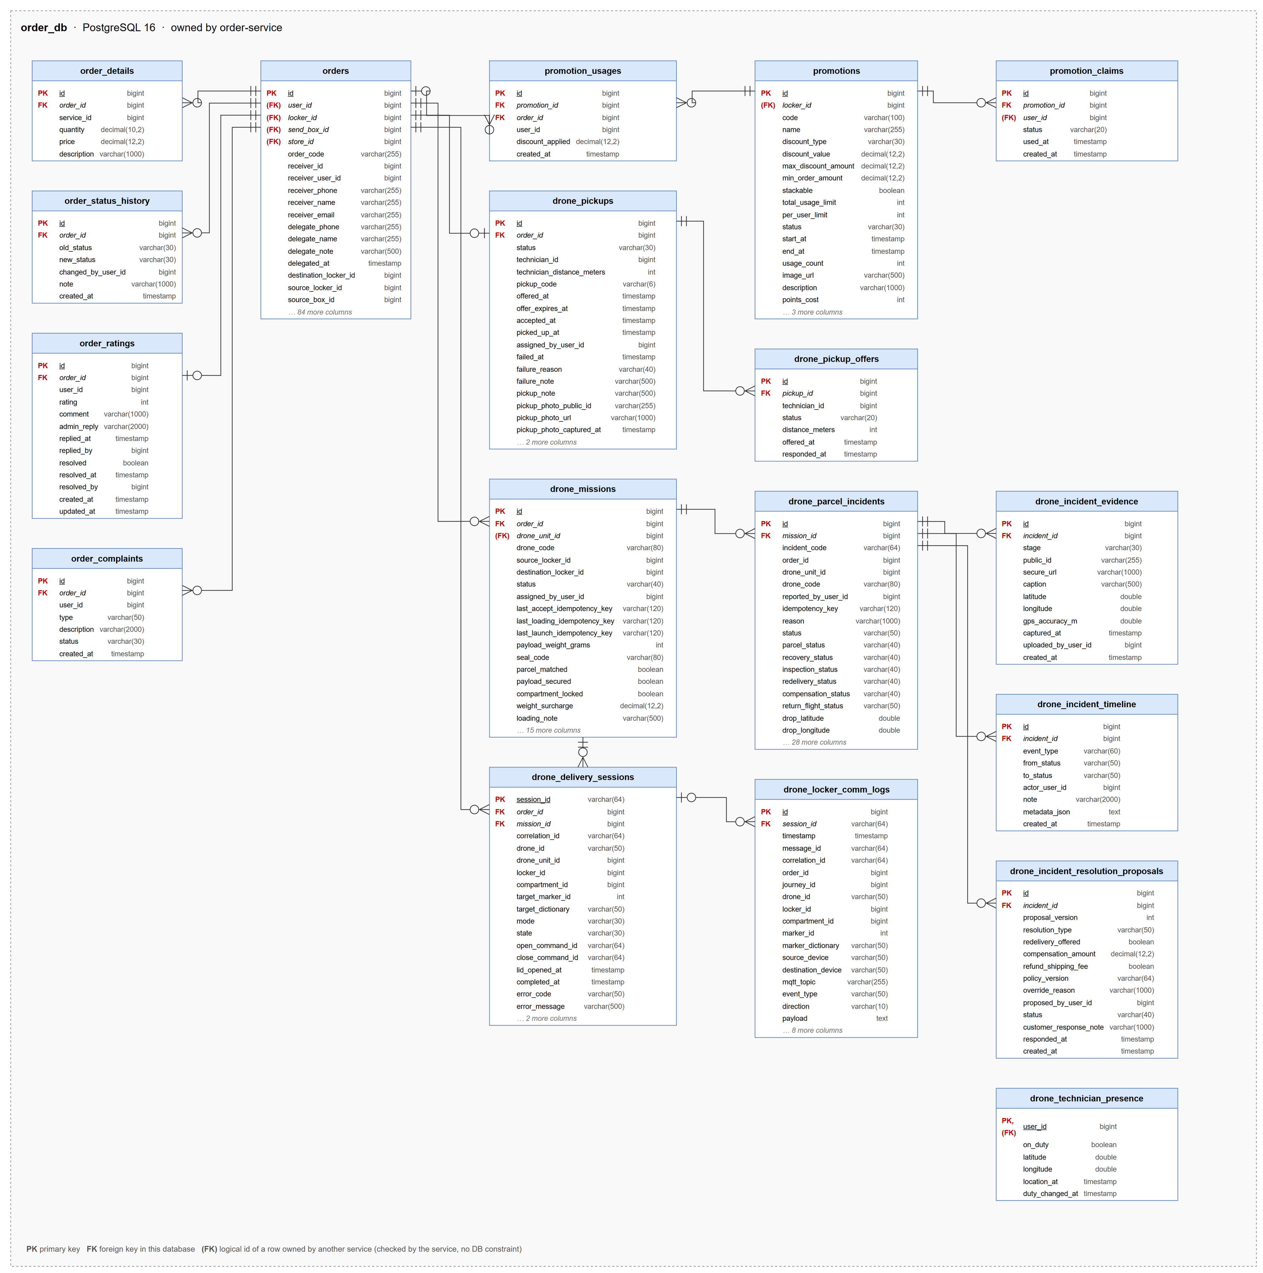
Figure 2.5: Database diagram of order_db
Table 2.5: Table descriptions of order_db
No | Table | Description
01 | drone_delivery_sessions | Delivery session between a drone and the receiver locker (landing, compartment, lid).  - Primary keys: session_id  - Foreign keys: order_id -> orders, mission_id -> drone_missions
02 | drone_incident_evidence | Photo or telemetry evidence of a parcel drop incident.  - Primary keys: id  - Foreign keys: incident_id -> drone_parcel_incidents
03 | drone_incident_resolution_proposals | Redelivery or compensation proposal of an incident and its approval.  - Primary keys: id  - Foreign keys: incident_id -> drone_parcel_incidents
04 | drone_incident_timeline | Event timeline of a parcel drop incident.  - Primary keys: id  - Foreign keys: incident_id -> drone_parcel_incidents
05 | drone_locker_comm_logs | MQTT messages exchanged between a drone and a locker during a delivery.  - Primary keys: id  - Foreign keys: session_id -> drone_delivery_sessions
06 | drone_missions | One flight of a drone order: drone, route, loading data (weight, seal code, checklist), launch time, stages and end reason.  - Primary keys: id  - Foreign keys: order_id -> orders, drone_unit_id -> drone_units (logical, locker-service)
07 | drone_parcel_incidents | Parcel drop incident: location, evidence, recovery assignment, resolution and compensation.  - Primary keys: id  - Foreign keys: mission_id -> drone_missions
08 | drone_pickup_offers | Pickup offer sent to a drone technician and its answer.  - Primary keys: id  - Foreign keys: pickup_id -> drone_pickups
09 | drone_pickups | Home pickup of a drone order: location, technician, photo and deadlines.  - Primary keys: id  - Foreign keys: order_id -> orders
10 | drone_technician_presence | Shift state and last GPS location of a drone technician.  - Primary keys: user_id  - Foreign keys: user_id -> user_profiles (logical, user-service)
11 | order_complaints | Complaint about an order with type, content and handling status.  - Primary keys: id  - Foreign keys: order_id -> orders
12 | order_details | Item line of an order (parcel description, size, weight).  - Primary keys: id  - Foreign keys: order_id -> orders
13 | order_ratings | Customer rating of a completed order with the admin reply.  - Primary keys: id  - Foreign keys: order_id -> orders
14 | order_status_history | Every status change of an order with actor and note.  - Primary keys: id  - Foreign keys: order_id -> orders
15 | orders | Order of type SEND, RENTAL, STORAGE or DRONE_DELIVERY: code, customer, receiver, lockers and boxes, prices, PIN, deadlines, payment and status.  - Primary keys: id  - Foreign keys: user_id -> user_profiles (logical, user-service), locker_id -> lockers (logical, locker-service), send_box_id -> locker_boxes (logical, locker-service), store_id -> stores (logical, store-service)
16 | promotion_claims | Voucher saved or exchanged by a user.  - Primary keys: id  - Foreign keys: promotion_id -> promotions, user_id -> user_profiles (logical, user-service)
17 | promotion_usages | Use of a promotion in an order.  - Primary keys: id  - Foreign keys: promotion_id -> promotions, order_id -> orders
18 | promotions | Promotion definition: code, discount, period, limits, locker scope and point price.  - Primary keys: id  - Foreign keys: locker_id -> lockers (logical, locker-service)

2.6 payment_db (payment-service)
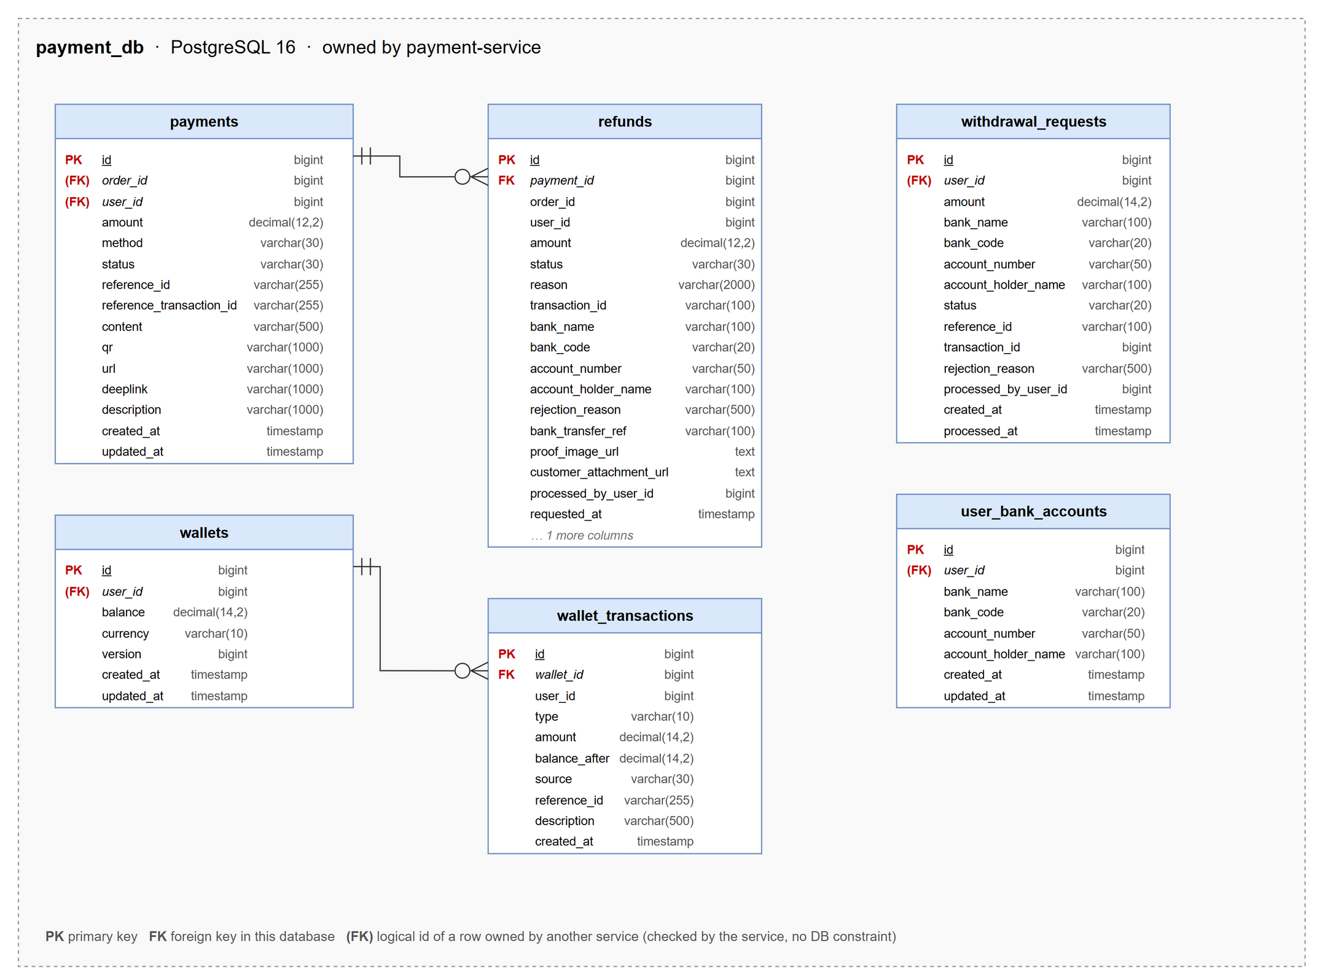
Figure 2.6: Database diagram of payment_db
Table 2.6: Table descriptions of payment_db
No | Table | Description
01 | payments | Payment attempt of an order: method, amount, status, VietQR content and transaction id.  - Primary keys: id  - Foreign keys: order_id -> orders (logical, order-service), user_id -> user_profiles (logical, user-service)
02 | refunds | Refund request of a payment with bank account, evidence, transfer receipt and status.  - Primary keys: id  - Foreign keys: payment_id -> payments
03 | user_bank_accounts | Bank account saved by a user for refunds and withdrawals.  - Primary keys: id  - Foreign keys: user_id -> user_profiles (logical, user-service)
04 | wallet_transactions | Ledger entry of a wallet with type, amount and balance after.  - Primary keys: id  - Foreign keys: wallet_id -> wallets
05 | wallets | Lock.R wallet balance of a user.  - Primary keys: id  - Foreign keys: user_id -> user_profiles (logical, user-service)
06 | withdrawal_requests | Withdrawal request from the wallet to a bank account and its approval status.  - Primary keys: id  - Foreign keys: user_id -> user_profiles (logical, user-service)

2.7 notification_db (notification-service)
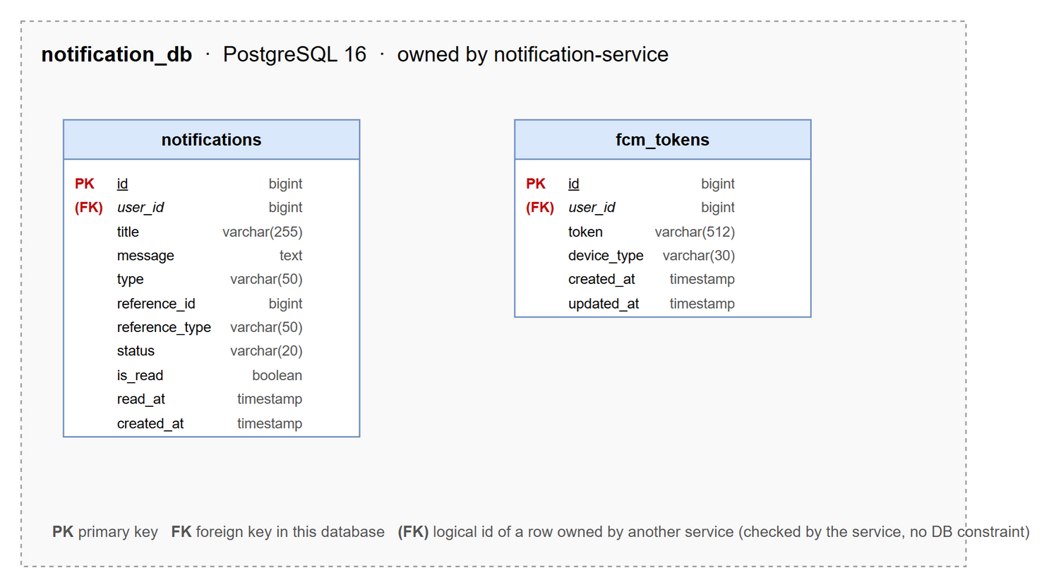
Figure 2.7: Database diagram of notification_db
Table 2.7: Table descriptions of notification_db
No | Table | Description
01 | fcm_tokens | Firebase push token of a user's device.  - Primary keys: id  - Foreign keys: user_id -> user_profiles (logical, user-service)
02 | notifications | In-app notification of a user with type, content, related object and read flag.  - Primary keys: id  - Foreign keys: user_id -> user_profiles (logical, user-service)

2.8 iot_db (iot-service)
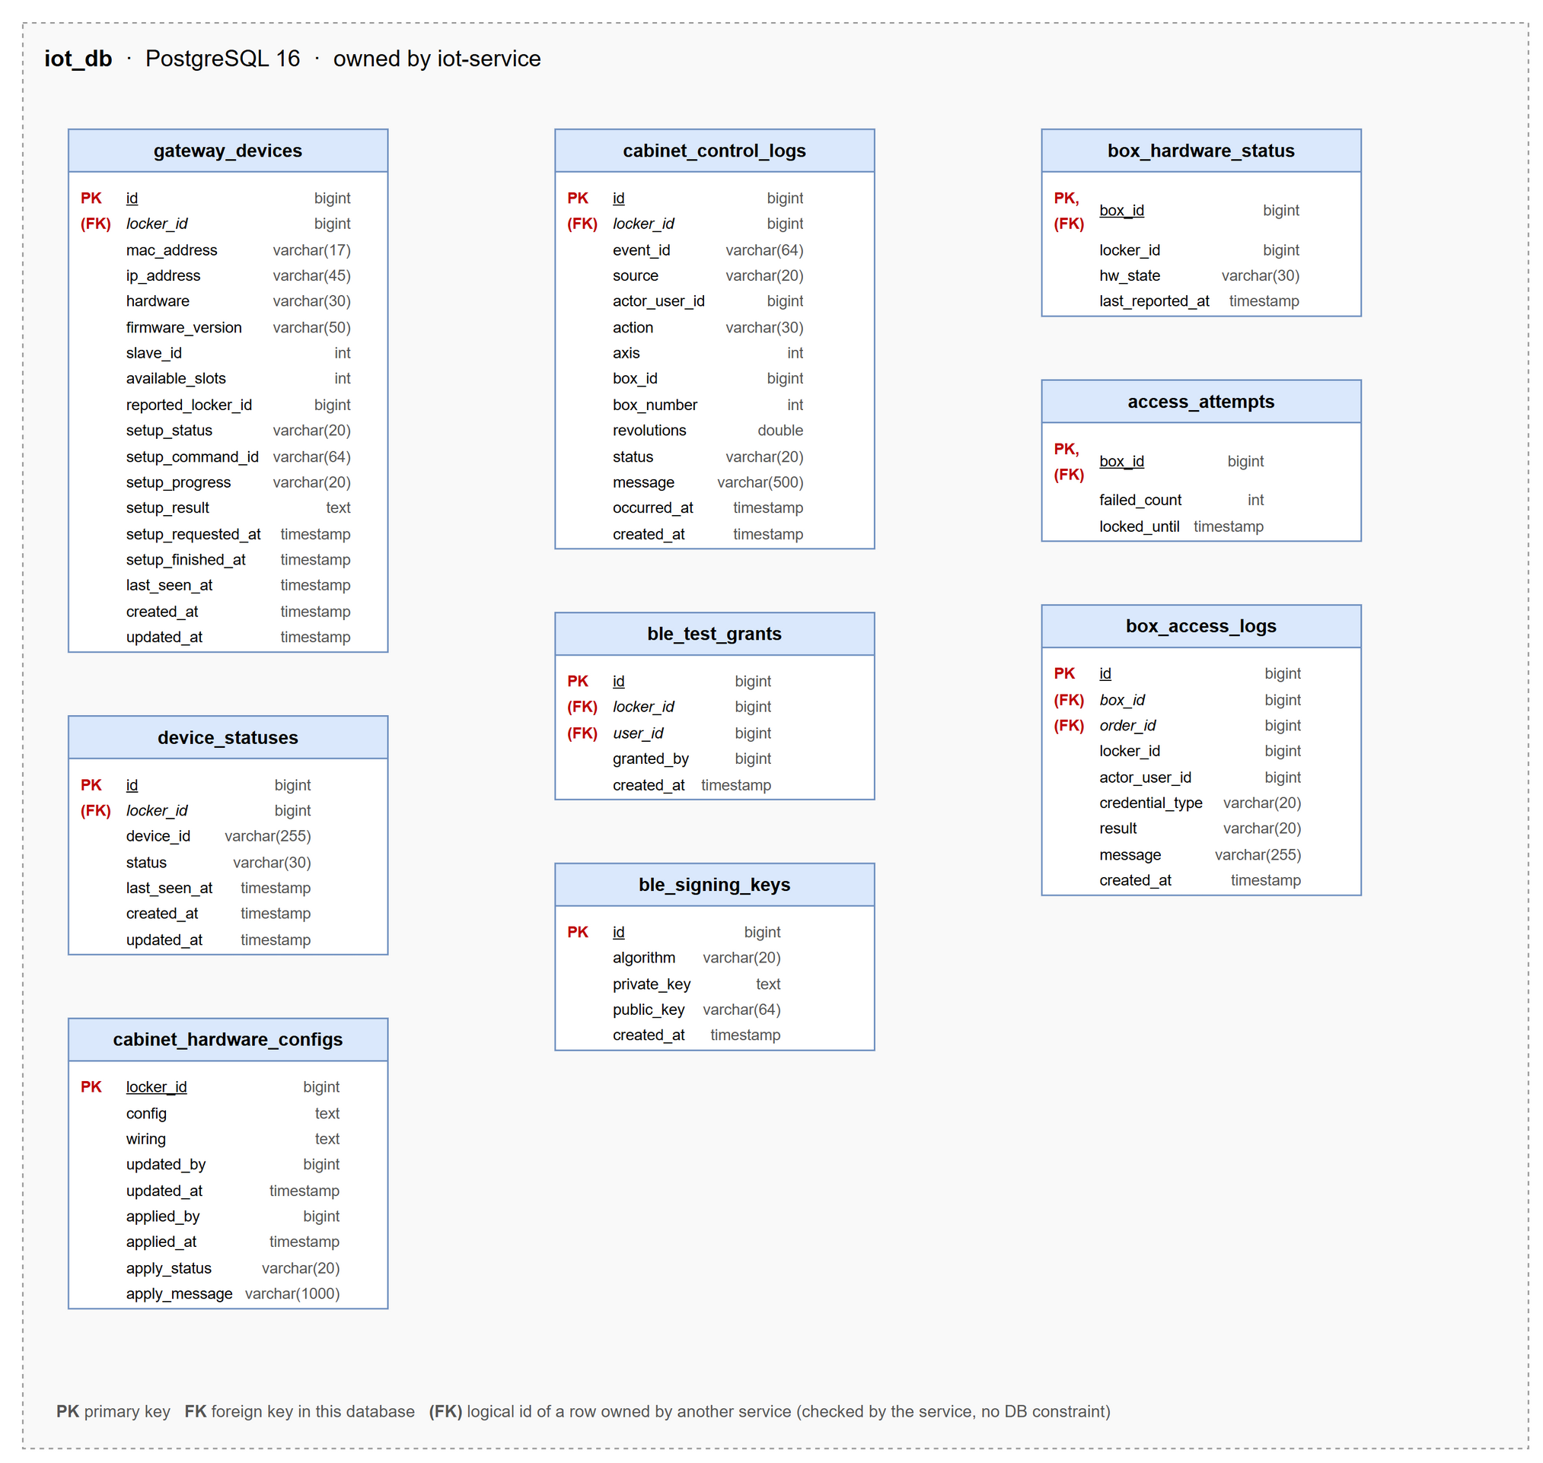
Figure 2.8: Database diagram of iot_db
Table 2.8: Table descriptions of iot_db
No | Table | Description
01 | access_attempts | Wrong-PIN counter and lock-out time of a box.  - Primary keys: box_id  - Foreign keys: box_id -> locker_boxes (logical, locker-service)
02 | ble_signing_keys | Ed25519 key pair used to sign Bluetooth open tokens.  - Primary keys: id  - Foreign keys: none
03 | ble_test_grants | Permission of a customer account to test opening boxes of a locker by Bluetooth.  - Primary keys: id  - Foreign keys: locker_id -> lockers (logical, locker-service), user_id -> user_profiles (logical, user-service)
04 | box_access_logs | Every open attempt of a box with credential type, order and result.  - Primary keys: id  - Foreign keys: box_id -> locker_boxes (logical, locker-service), order_id -> orders (logical, order-service)
05 | box_hardware_status | Current door state (open / closed) of each box reported by the controller.  - Primary keys: box_id  - Foreign keys: box_id -> locker_boxes (logical, locker-service)
06 | cabinet_control_logs | Control actions of a cabinet (box open, lid move, Bluetooth open) from the web or done by the Pi, with result.  - Primary keys: id  - Foreign keys: locker_id -> lockers (logical, locker-service)
07 | cabinet_hardware_configs | Hardware configuration of a cabinet (GPIO / RS485 wiring, lid tuning) edited by technicians and applied to the Pi, with apply status.  - Primary keys: locker_id  - Foreign keys: none
08 | device_statuses | Online / offline events of a locker controller.  - Primary keys: id  - Foreign keys: locker_id -> lockers (logical, locker-service)
09 | gateway_devices | Raspberry Pi controller of a locker: MAC, firmware, assigned locker and last seen time.  - Primary keys: id  - Foreign keys: locker_id -> lockers (logical, locker-service)

2.9 loyalty_db (loyalty-service)
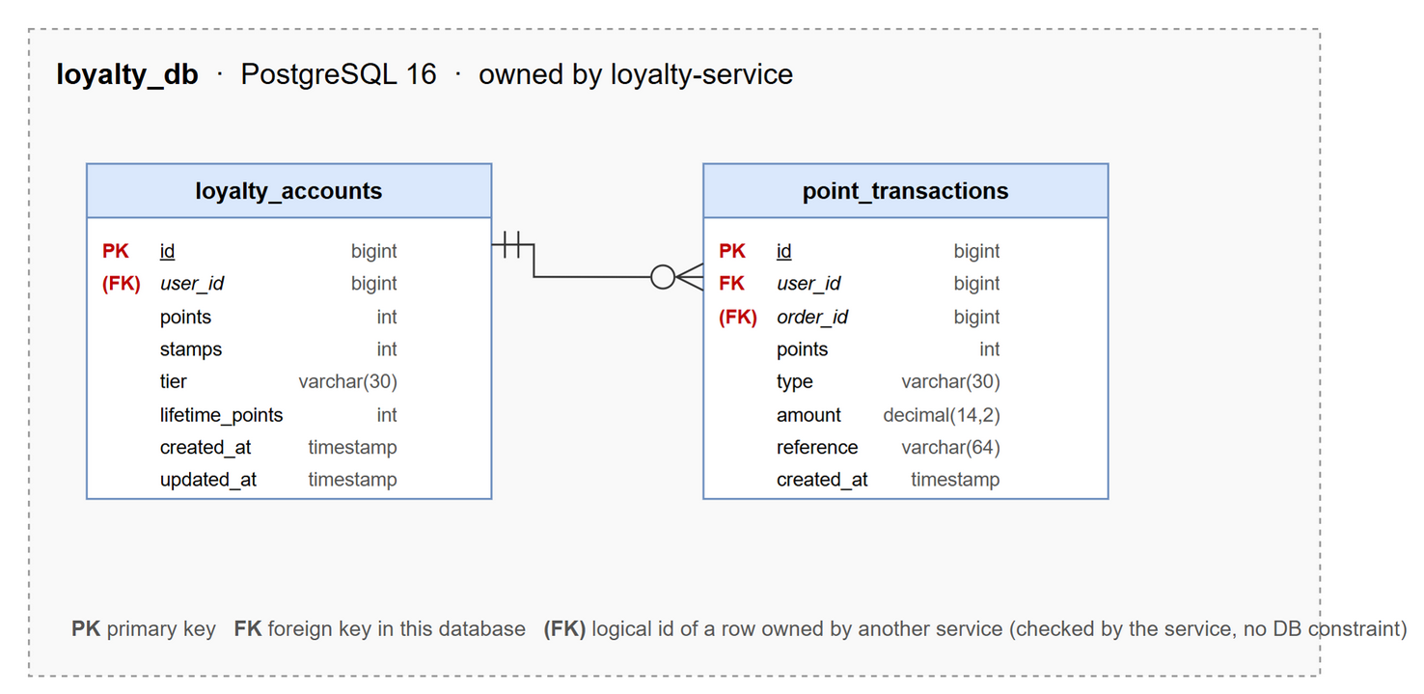
Figure 2.9: Database diagram of loyalty_db
Table 2.9: Table descriptions of loyalty_db
No | Table | Description
01 | loyalty_accounts | Points, lifetime points and tier of a user.  - Primary keys: id  - Foreign keys: user_id -> user_profiles (logical, user-service)
02 | point_transactions | Every earn / redeem / reversal of loyalty points.  - Primary keys: id  - Foreign keys: user_id -> loyalty_accounts, order_id -> orders (logical, order-service)

2.10 assistant_db (assistant-service)
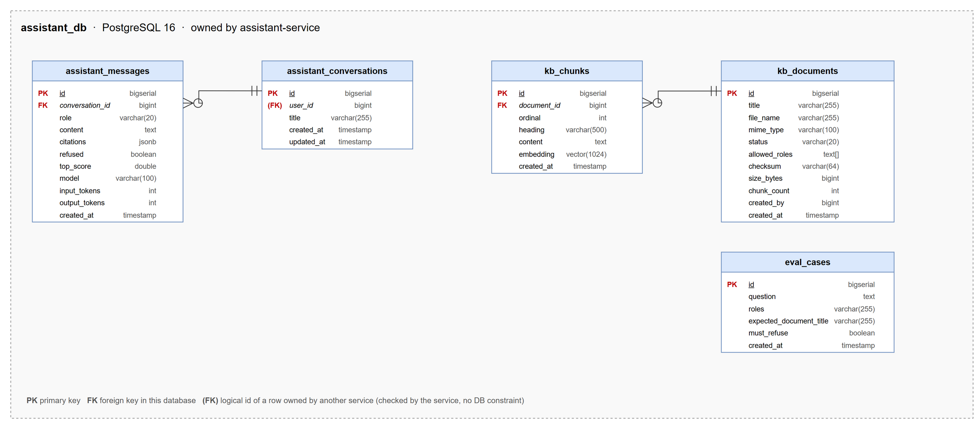
Figure 2.10: Database diagram of assistant_db
Table 2.10: Table descriptions of assistant_db
No | Table | Description
01 | assistant_conversations | A conversation of a user with the AI assistant.  - Primary keys: id  - Foreign keys: user_id -> user_profiles (logical, user-service)
02 | assistant_messages | Question or answer in a conversation, with cited sources and rating.  - Primary keys: id  - Foreign keys: conversation_id -> assistant_conversations
03 | eval_cases | Evaluation question used to measure retrieval quality of the AI assistant.  - Primary keys: id  - Foreign keys: none
04 | kb_chunks | Embedded chunk of a knowledge base document used for retrieval.  - Primary keys: id  - Foreign keys: document_id -> kb_documents
05 | kb_documents | Knowledge base document of the AI assistant with file, allowed roles and indexing status.  - Primary keys: id  - Foreign keys: none

3. Detailed Design
This section gives, for every feature, the class diagram of the classes that take part, the sequence diagram(s) of its main flows and the specification of the controller and service classes. Controllers receive requests already authenticated by the API gateway (X-User-Id, X-User-Roles), services hold the business logic, Feign clients call other services and repositories access the database of the service. Names are the real class and method names in the source code.

3.1 Authentication
Customers and technicians sign in with email or phone and password, with a Firebase ID token (phone OTP / Google) or with an email OTP; administrators sign in with a password followed by an email OTP (2FA). auth-service owns the credentials and issues a JWT access token (24 h) and a hashed, revocable refresh token (30 days); roles are read from user-service.

3.1.1 Class Diagram
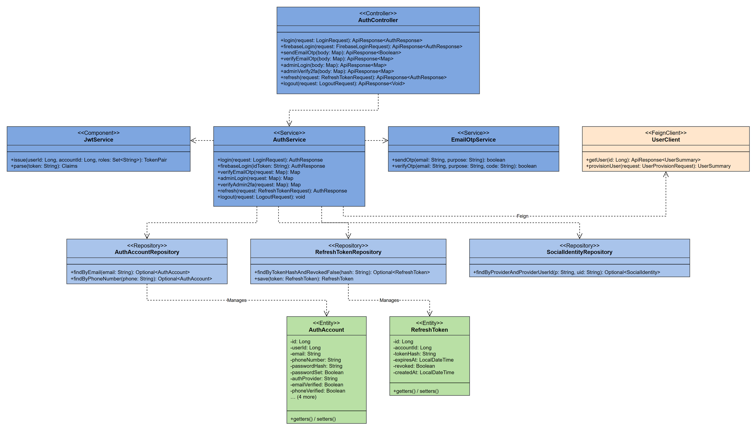
Figure 3.1.1: Class diagram - Authentication

3.1.2 Sign in with Password
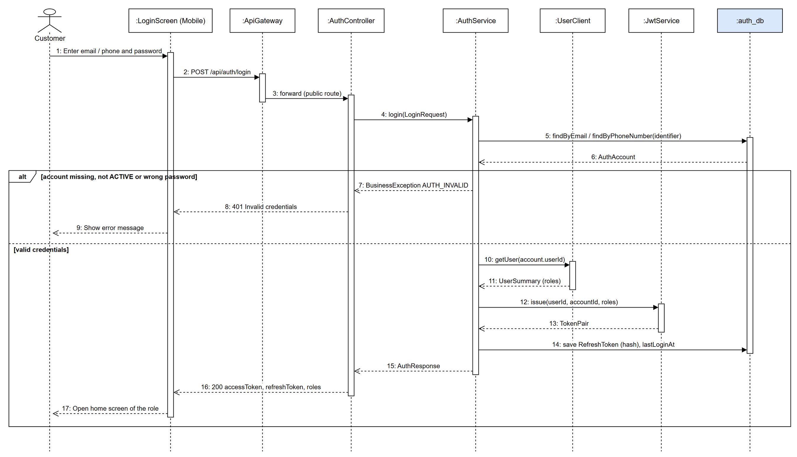
Figure 3.1.2: Sequence diagram - Sign in with Password

3.1.3 Sign in with Phone Number (Firebase OTP)
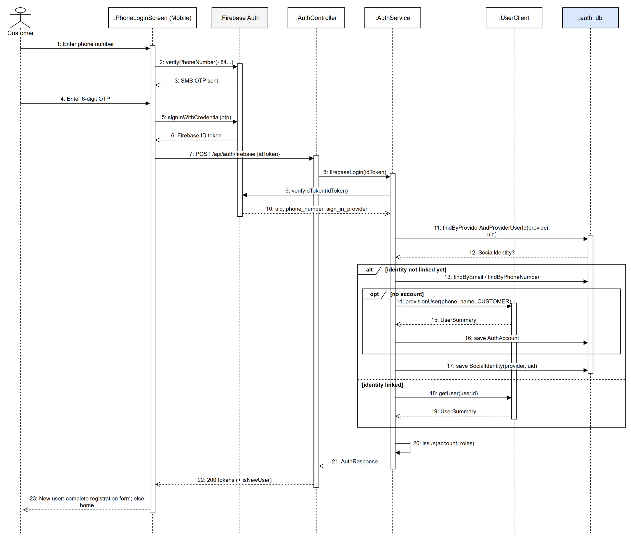
Figure 3.1.3: Sequence diagram - Sign in with Phone Number (Firebase OTP)

3.1.4 Administrator Sign in with 2FA
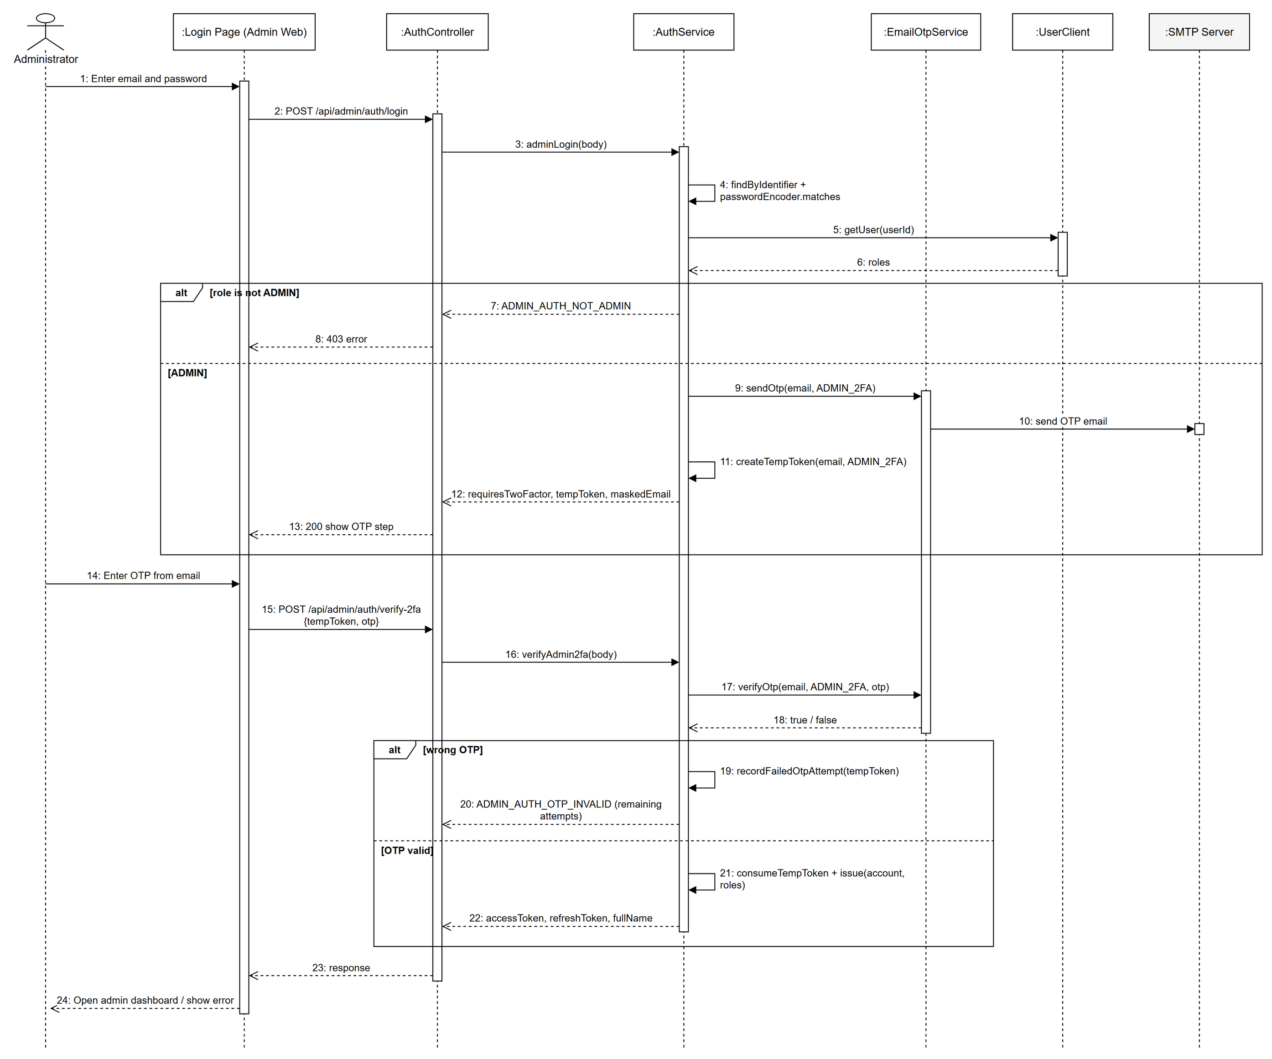
Figure 3.1.4: Sequence diagram - Administrator Sign in with 2FA

3.1.5 Refresh Token and Sign out
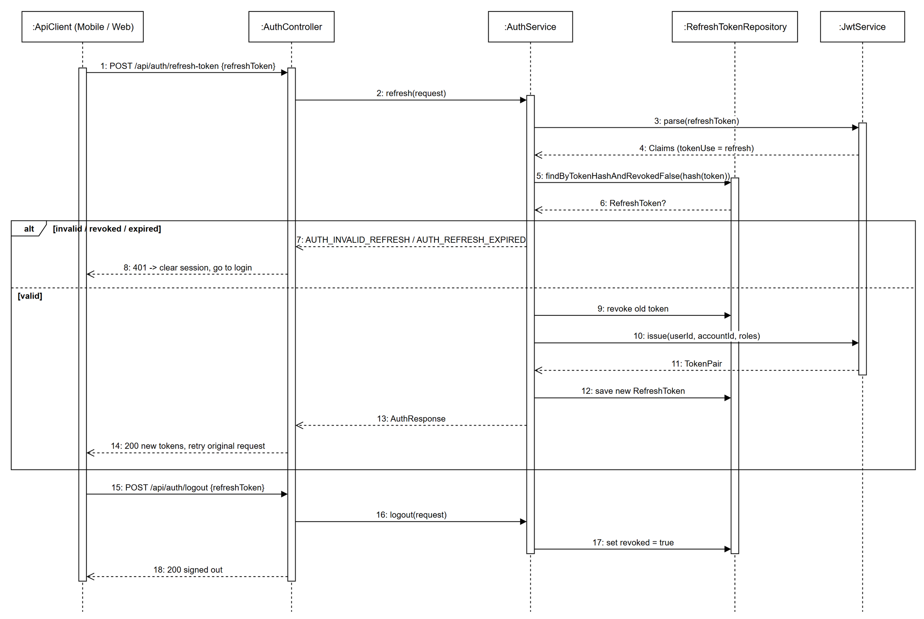
Figure 3.1.5: Sequence diagram - Refresh Token and Sign out

3.1.6 Class Specification
3.1.6.a AuthController
Table 3.1.6.a: AuthController description
No | Method | Description
01 | login(request: LoginRequest): ApiResponse<AuthResponse> | Signs in a customer or technician by email / phone and password.
02 | firebaseLogin(request: FirebaseLoginRequest): ApiResponse<AuthResponse> | Exchanges a verified Firebase ID token (phone OTP, Google) for Lock.R tokens.
03 | sendEmailOtp(body: Map): ApiResponse<Boolean> | Sends a 6-digit login / registration OTP to an email address.
04 | verifyEmailOtp(body: Map): ApiResponse<Map> | Verifies the email OTP; returns tokens, or a temp token when the account still has to be registered.
05 | adminLogin(body: Map): ApiResponse<Map> | Admin step 1: checks password and ADMIN role, sends the 2FA OTP and returns a temp token.
06 | adminVerify2fa(body: Map): ApiResponse<Map> | Admin step 2: verifies the OTP bound to the temp token and issues tokens.
07 | refresh(request: RefreshTokenRequest): ApiResponse<AuthResponse> | Rotates the refresh token and issues a new access token.
08 | logout(request: LogoutRequest): ApiResponse<Void> | Revokes the refresh token of the device.

3.1.6.b AuthService
Table 3.1.6.b: AuthService description
No | Method | Description
01 | login(request: LoginRequest): AuthResponse | Finds the account by identifier, checks ACTIVE status and the BCrypt hash, loads roles and issues tokens.
02 | firebaseLogin(idToken: String): AuthResponse | Verifies the ID token with Firebase Admin, links or provisions the account through SocialIdentity and issues tokens.
03 | verifyEmailOtp(request: Map): Map | Checks the OTP with EmailOtpService; known email -> tokens, new email -> temp token.
04 | adminLogin(request: Map): Map | Validates admin credentials, sends the ADMIN_2FA OTP and creates a short-lived temp token.
05 | verifyAdmin2fa(request: Map): Map | Verifies the OTP (limited attempts), consumes the temp token and issues tokens.
06 | refresh(request: RefreshTokenRequest): AuthResponse | Validates the stored refresh-token hash, revokes it and issues a new pair.
07 | logout(request: LogoutRequest): void | Marks the refresh token as revoked.

3.1.6.c JwtService
Table 3.1.6.c: JwtService description
No | Method | Description
01 | issue(userId: Long, accountId: Long, roles: Set<String>): TokenPair | Signs the access token (sub, accountId, roles, tokenUse) and creates a random refresh token.
02 | parse(token: String): Claims | Verifies the HS signature and returns the claims.

3.1.6.d EmailOtpService
Table 3.1.6.d: EmailOtpService description
No | Method | Description
01 | sendOtp(email: String, purpose: String): boolean | Generates an OTP, stores its hash with expiry and sends it by SMTP.
02 | verifyOtp(email: String, purpose: String, code: String): boolean | Matches the latest unused OTP of the purpose and marks it used.

3.2 Kiosk Login by QR
A customer signs in at the locker kiosk by scanning a QR code with the mobile app. The kiosk creates a short-lived session, the logged-in app confirms it with the short code, and the kiosk polls until it receives a kiosk-scoped login grant.

3.2.1 Class Diagram
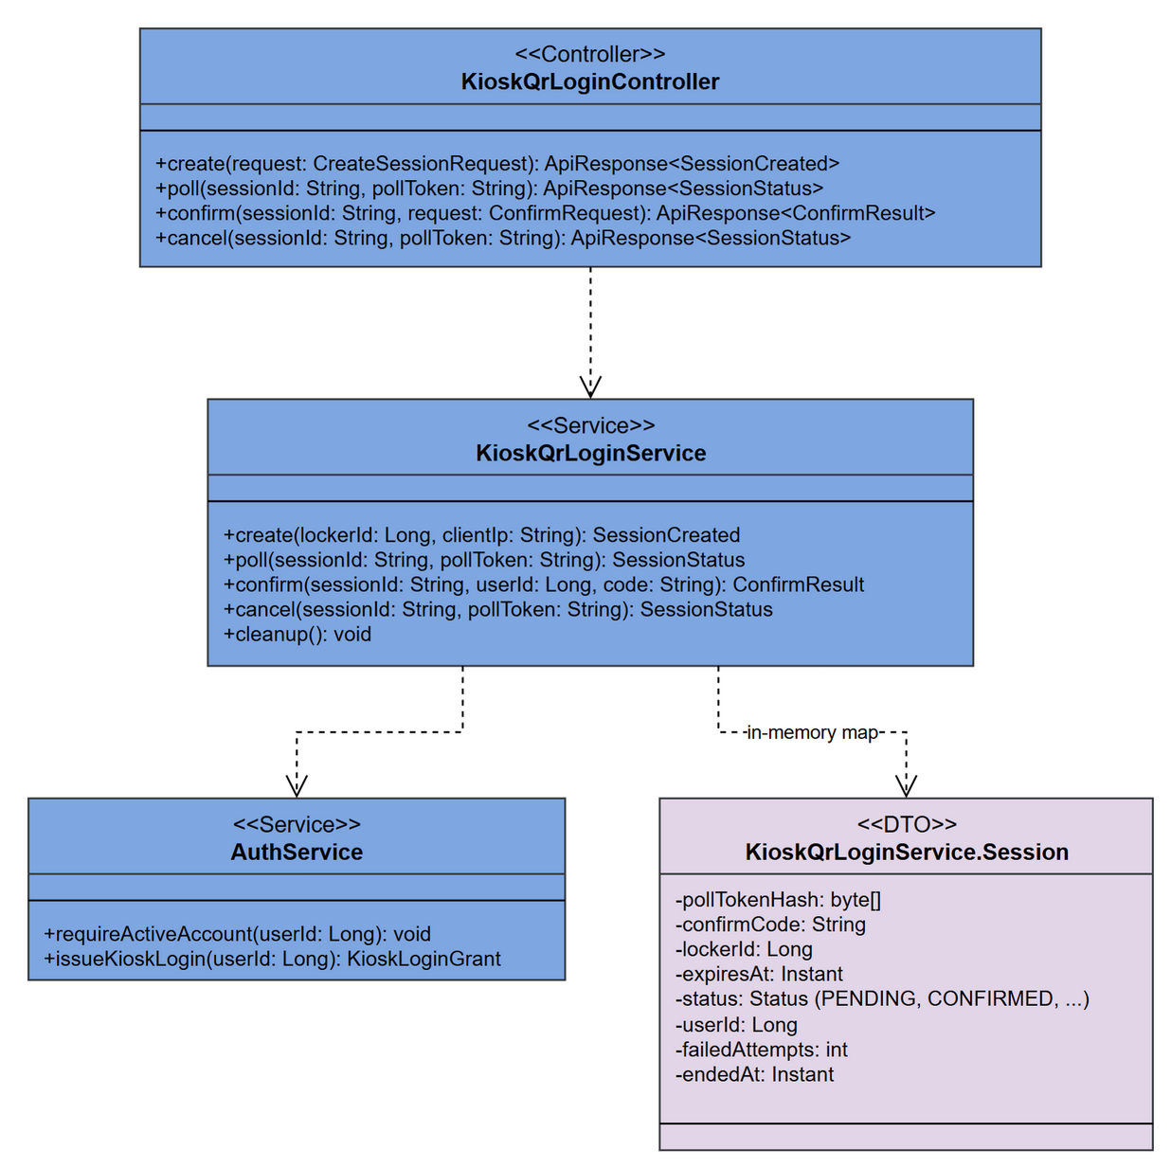
Figure 3.2.1: Class diagram - Kiosk Login by QR

3.2.2 Kiosk Login by QR
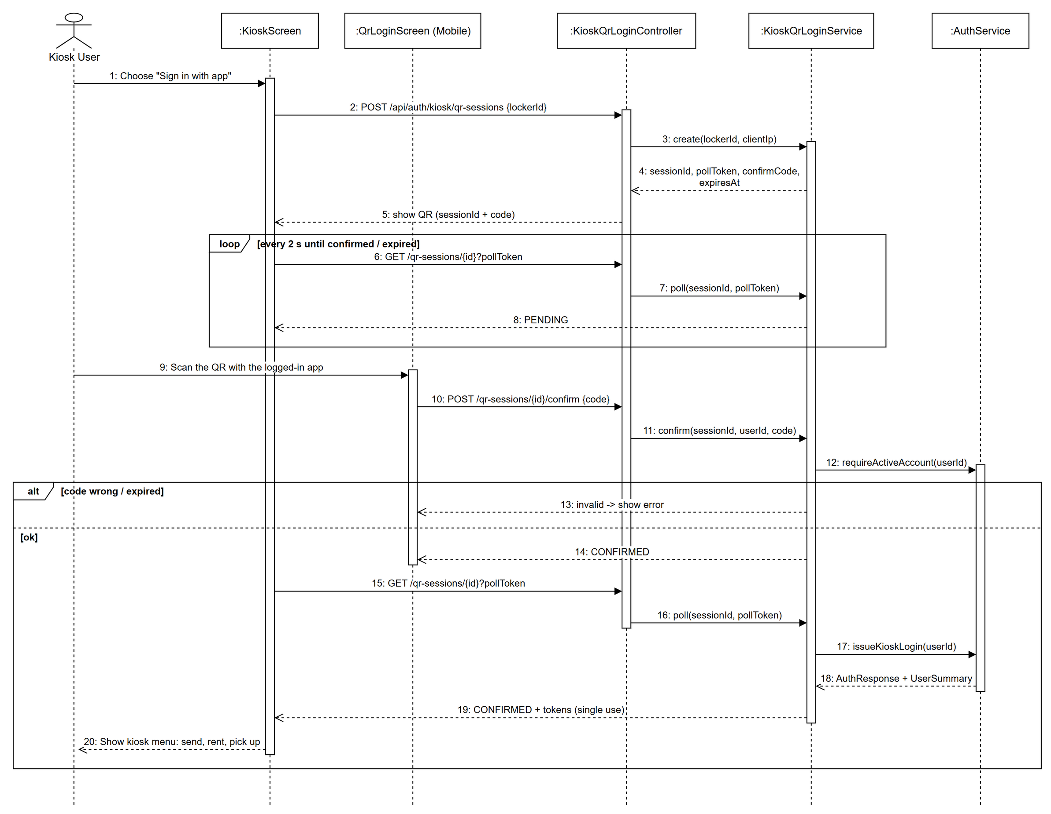
Figure 3.2.2: Sequence diagram - Kiosk Login by QR

3.2.3 Class Specification
3.2.3.a KioskQrLoginController
Table 3.2.3.a: KioskQrLoginController description
No | Method | Description
01 | create(request: CreateSessionRequest): ApiResponse<SessionCreated> | Kiosk opens a QR login session for its locker.
02 | poll(sessionId: String, pollToken: String): ApiResponse<SessionStatus> | Kiosk polls the session; returns tokens once confirmed.
03 | confirm(sessionId: String, request: ConfirmRequest): ApiResponse<ConfirmResult> | Logged-in app confirms the session with the confirm code.
04 | cancel(sessionId: String, pollToken: String): ApiResponse<SessionStatus> | Kiosk cancels the session.

3.2.3.b KioskQrLoginService
Table 3.2.3.b: KioskQrLoginService description
No | Method | Description
01 | create(lockerId: Long, clientIp: String): SessionCreated | Rate-limits per locker and creates an in-memory session with a random poll token (stored hashed) and a confirm code.
02 | poll(sessionId: String, pollToken: String): SessionStatus | Checks the poll token, expires old sessions and, when CONFIRMED, issues the kiosk login once.
03 | confirm(sessionId: String, userId: Long, code: String): ConfirmResult | Matches the confirm code, requires an active account and binds the user to the session.
04 | cancel(sessionId: String, pollToken: String): SessionStatus | Ends the session as CANCELLED.
05 | cleanup(): void | Scheduled removal of expired sessions.

3.3 Profile and User Management
Every user keeps a profile (name, email, phone, avatar) in user-service. Images are uploaded straight to Cloudinary with a signature issued by the backend and verified before the URL is stored. Administrators create users and technicians, lock accounts and change roles; credential changes are pushed to auth-service through Feign.

3.3.1 Class Diagram
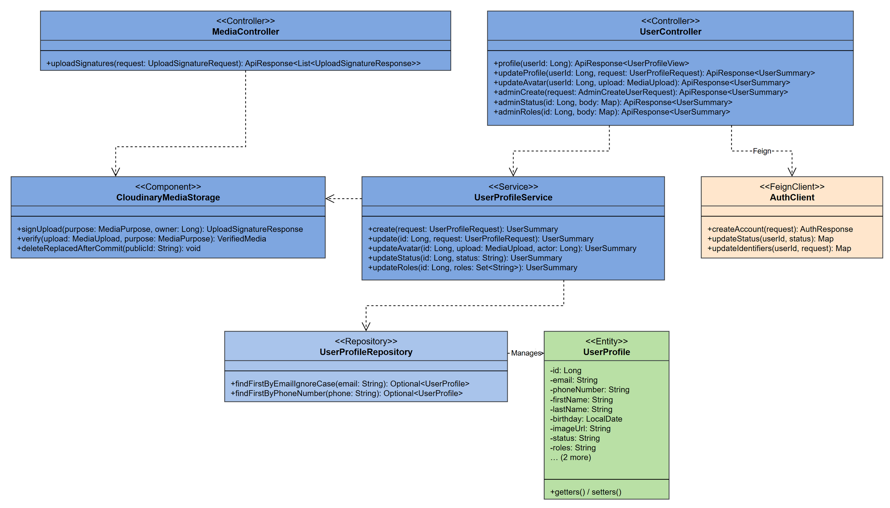
Figure 3.3.1: Class diagram - Profile and User Management

3.3.2 Update Profile Avatar
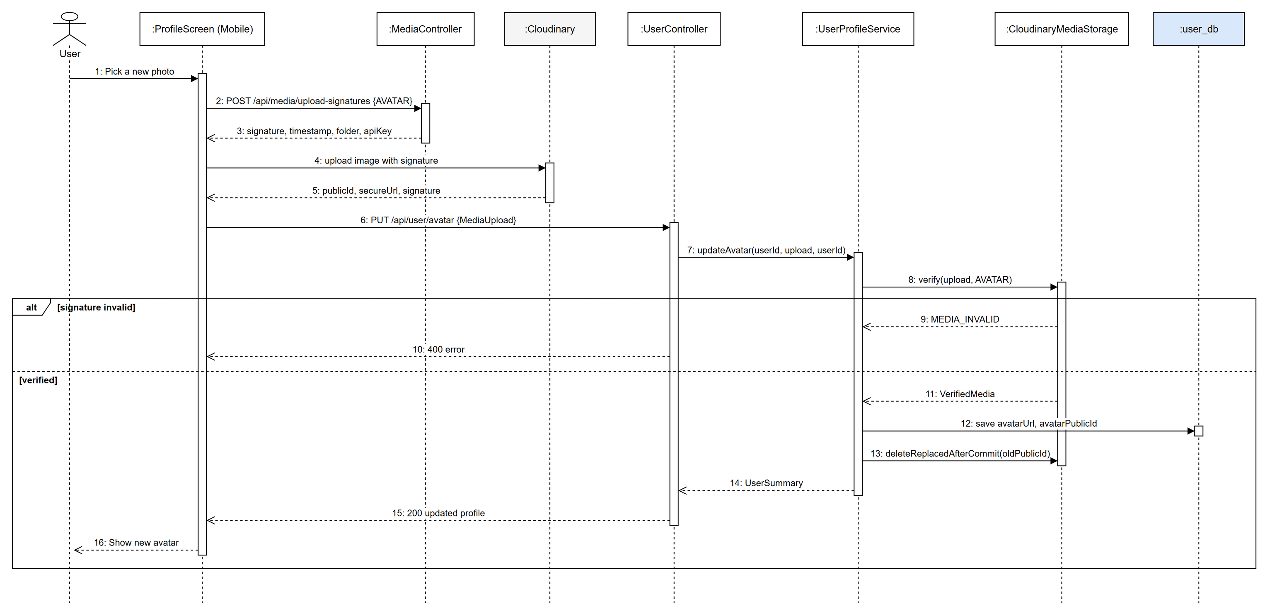
Figure 3.3.2: Sequence diagram - Update Profile Avatar

3.3.3 Administrator Creates and Deactivates a User
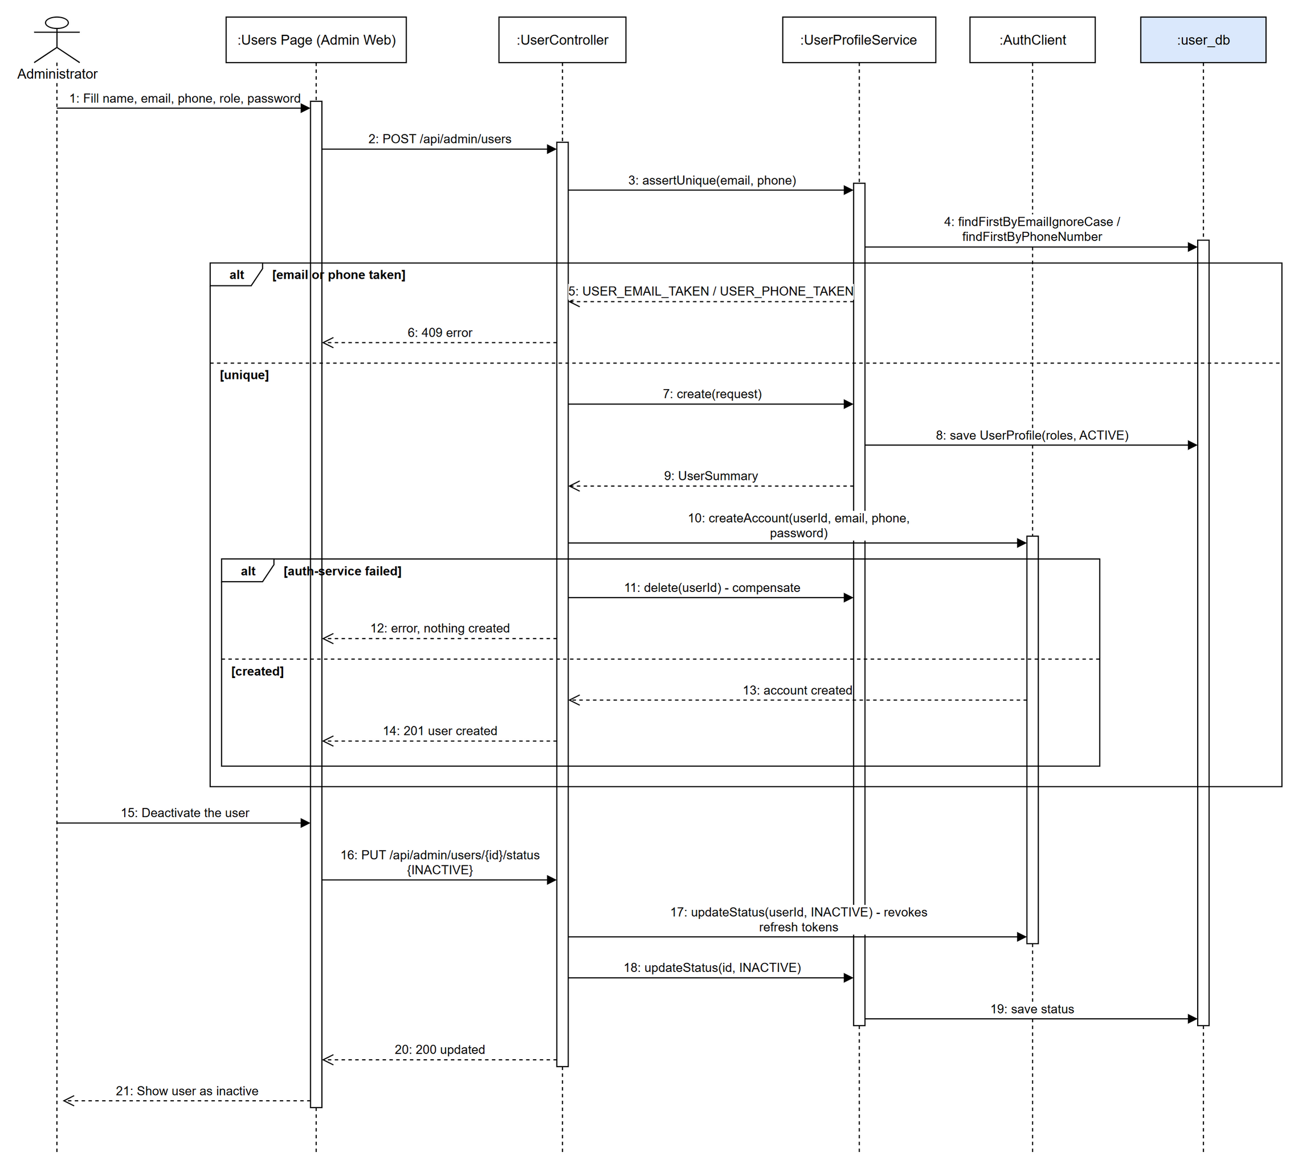
Figure 3.3.3: Sequence diagram - Administrator Creates and Deactivates a User

3.3.4 Class Specification
3.3.4.a UserController
Table 3.3.4.a: UserController description
No | Method | Description
01 | profile(userId: Long): ApiResponse<UserProfileView> | Returns the profile of the signed-in user.
02 | updateProfile(userId: Long, request: UserProfileRequest): ApiResponse<UserSummary> | Updates name, email, phone (checked for uniqueness).
03 | updateAvatar(userId: Long, upload: MediaUpload): ApiResponse<UserSummary> | Stores a verified Cloudinary avatar.
04 | adminCreate(request: AdminCreateUserRequest): ApiResponse<UserSummary> | Admin creates a customer or technician account.
05 | adminStatus(id: Long, body: Map): ApiResponse<UserSummary> | Admin deactivates / reactivates a user.
06 | adminRoles(id: Long, body: Map): ApiResponse<UserSummary> | Admin changes the roles of a user.

3.3.4.b MediaController
Table 3.3.4.b: MediaController description
No | Method | Description
01 | uploadSignatures(request: UploadSignatureRequest): ApiResponse<List<UploadSignatureResponse>> | Issues signed Cloudinary upload parameters for a media purpose.

3.3.4.c UserProfileService
Table 3.3.4.c: UserProfileService description
No | Method | Description
01 | create(request: UserProfileRequest): UserSummary | Validates unique email / phone and saves the profile.
02 | update(id: Long, request: UserProfileRequest): UserSummary | Updates profile fields after uniqueness checks.
03 | updateAvatar(id: Long, upload: MediaUpload, actor: Long): UserSummary | Verifies the Cloudinary upload and replaces the old image after commit.
04 | updateStatus(id: Long, status: String): UserSummary | Changes ACTIVE / INACTIVE status.
05 | updateRoles(id: Long, roles: Set<String>): UserSummary | Replaces the role set.

3.4 Store Management and Nearby Stores
Stores are the places that host lockers. Customers and guests list stores, find the nearest ones by GPS and see their lockers and ratings; administrators create, edit, deactivate stores and set their image.

3.4.1 Class Diagram
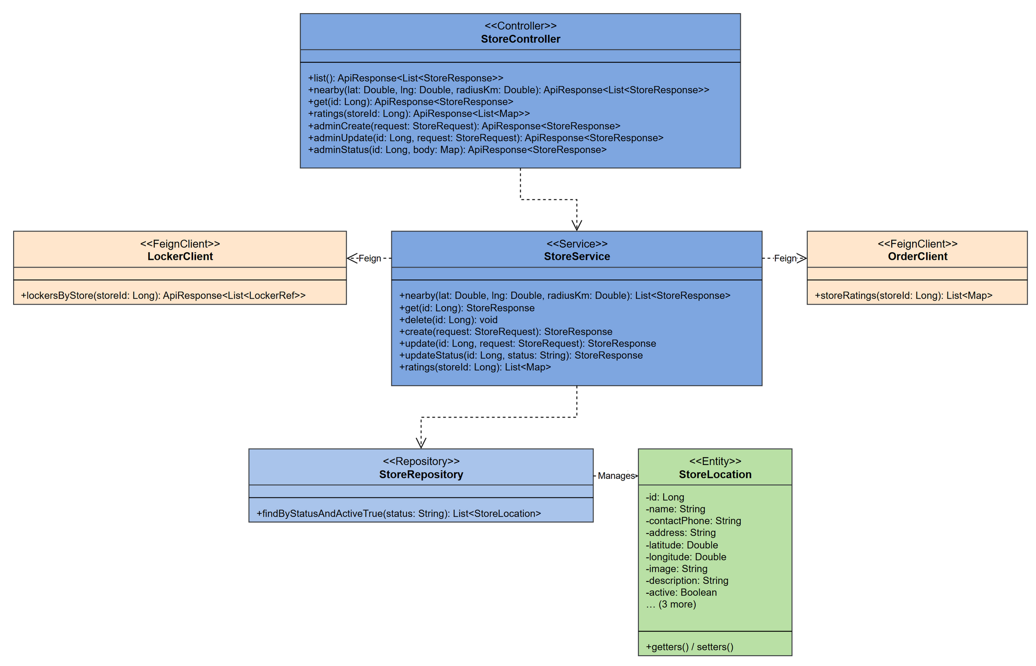
Figure 3.4.1: Class diagram - Store Management and Nearby Stores

3.4.2 Find Nearby Stores
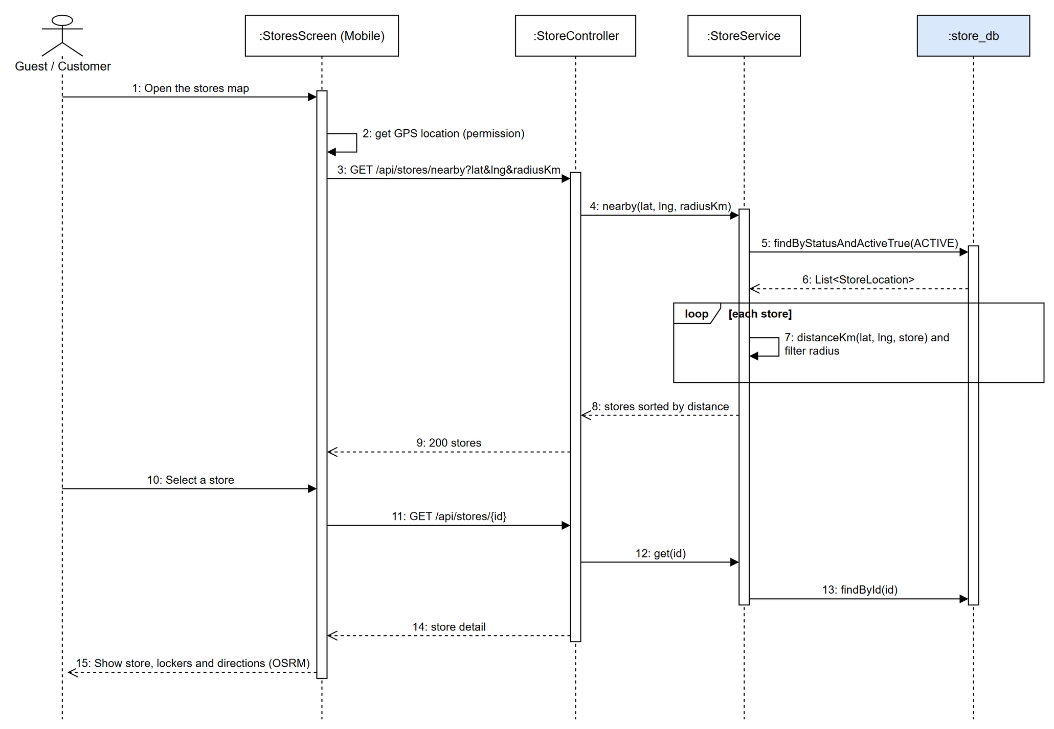
Figure 3.4.2: Sequence diagram - Find Nearby Stores

3.4.3 Class Specification
3.4.3.a StoreController
Table 3.4.3.a: StoreController description
No | Method | Description
01 | list(): ApiResponse<List<StoreResponse>> | Lists active stores.
02 | nearby(lat: Double, lng: Double, radiusKm: Double): ApiResponse<List<StoreResponse>> | Lists active stores within a radius ordered by distance.
03 | get(id: Long): ApiResponse<StoreResponse> | Store detail with its lockers.
04 | ratings(storeId: Long): ApiResponse<List<Map>> | Ratings of orders made at the store.
05 | adminCreate(request: StoreRequest): ApiResponse<StoreResponse> | Admin creates a store.
06 | adminUpdate(id: Long, request: StoreRequest): ApiResponse<StoreResponse> | Admin edits a store.
07 | adminStatus(id: Long, body: Map): ApiResponse<StoreResponse> | Admin activates / deactivates a store.

3.4.3.b StoreService
Table 3.4.3.b: StoreService description
No | Method | Description
01 | nearby(lat: Double, lng: Double, radiusKm: Double): List<StoreResponse> | Filters active stores by haversine distance and sorts them.
02 | get(id: Long): StoreResponse | Loads one store.
03 | delete(id: Long): void | Deletes a store after checking with locker-service that no locker still belongs to it.
04 | create(request: StoreRequest): StoreResponse | Validates and saves a store, publishes catalog.changed.
05 | update(id: Long, request: StoreRequest): StoreResponse | Updates fields and publishes catalog.changed.
06 | updateStatus(id: Long, status: String): StoreResponse | Changes the store status.
07 | ratings(storeId: Long): List<Map> | Reads store ratings from order-service.

3.5 Locker and Box Management
Administrators register locker cabinets for a store and define the box grid (number, size, cell type STANDARD / XL / DRONE, row / column). The locker layout combines the box states kept by locker-service with the door states and controller reported by iot-service, and is shown on the app, the kiosk and the admin web.

3.5.1 Class Diagram
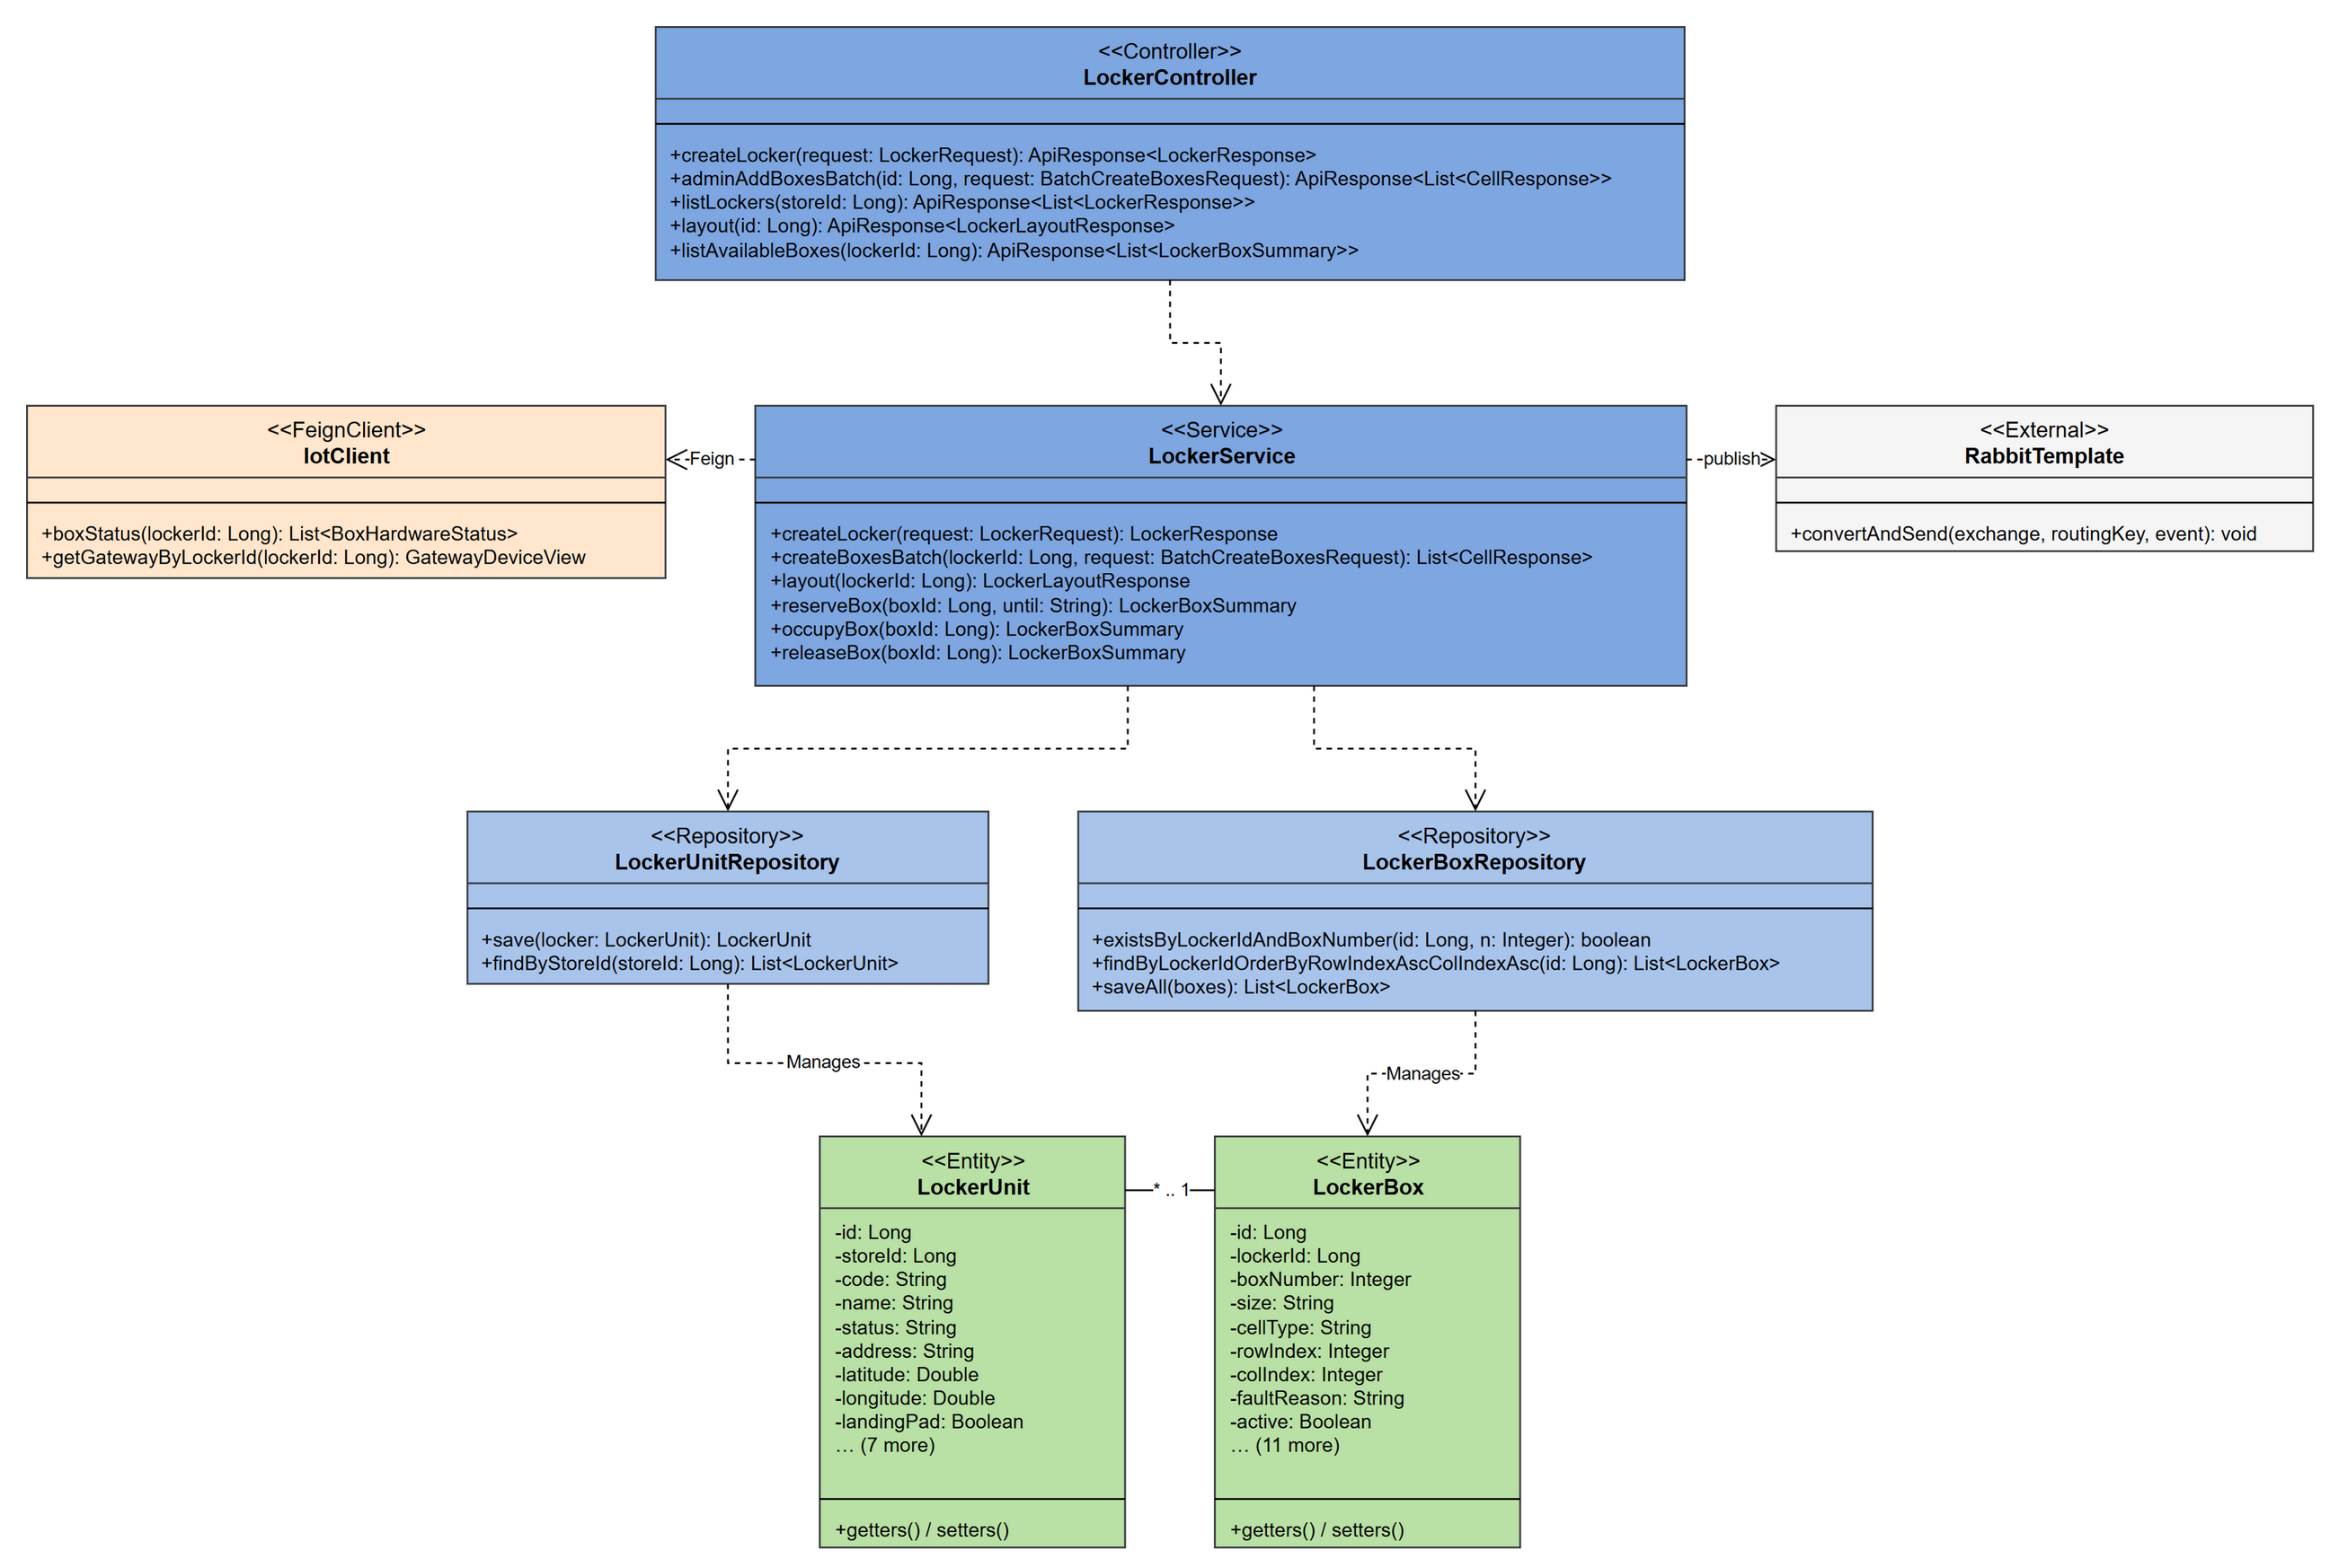
Figure 3.5.1: Class diagram - Locker and Box Management

3.5.2 Create Locker and Box Grid
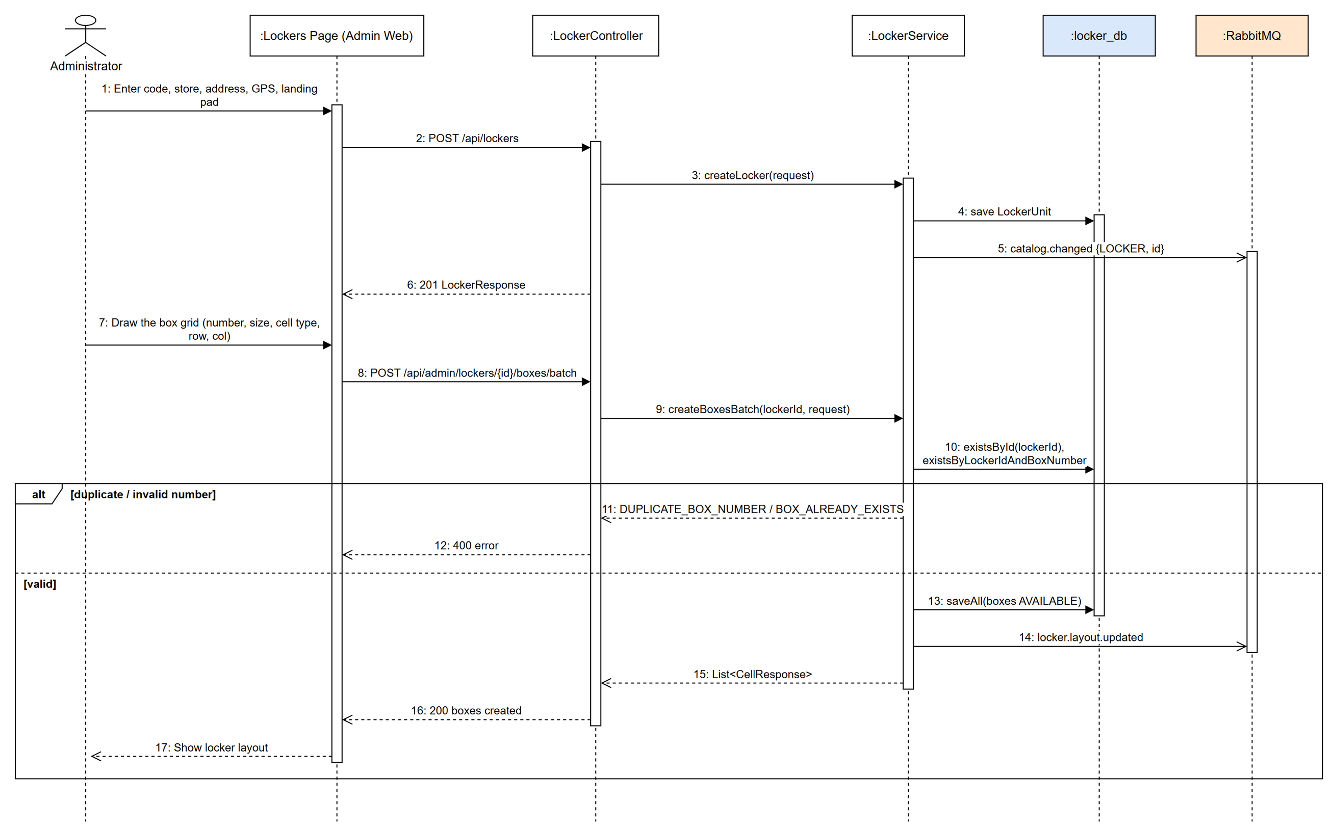
Figure 3.5.2: Sequence diagram - Create Locker and Box Grid

3.5.3 View Locker Layout
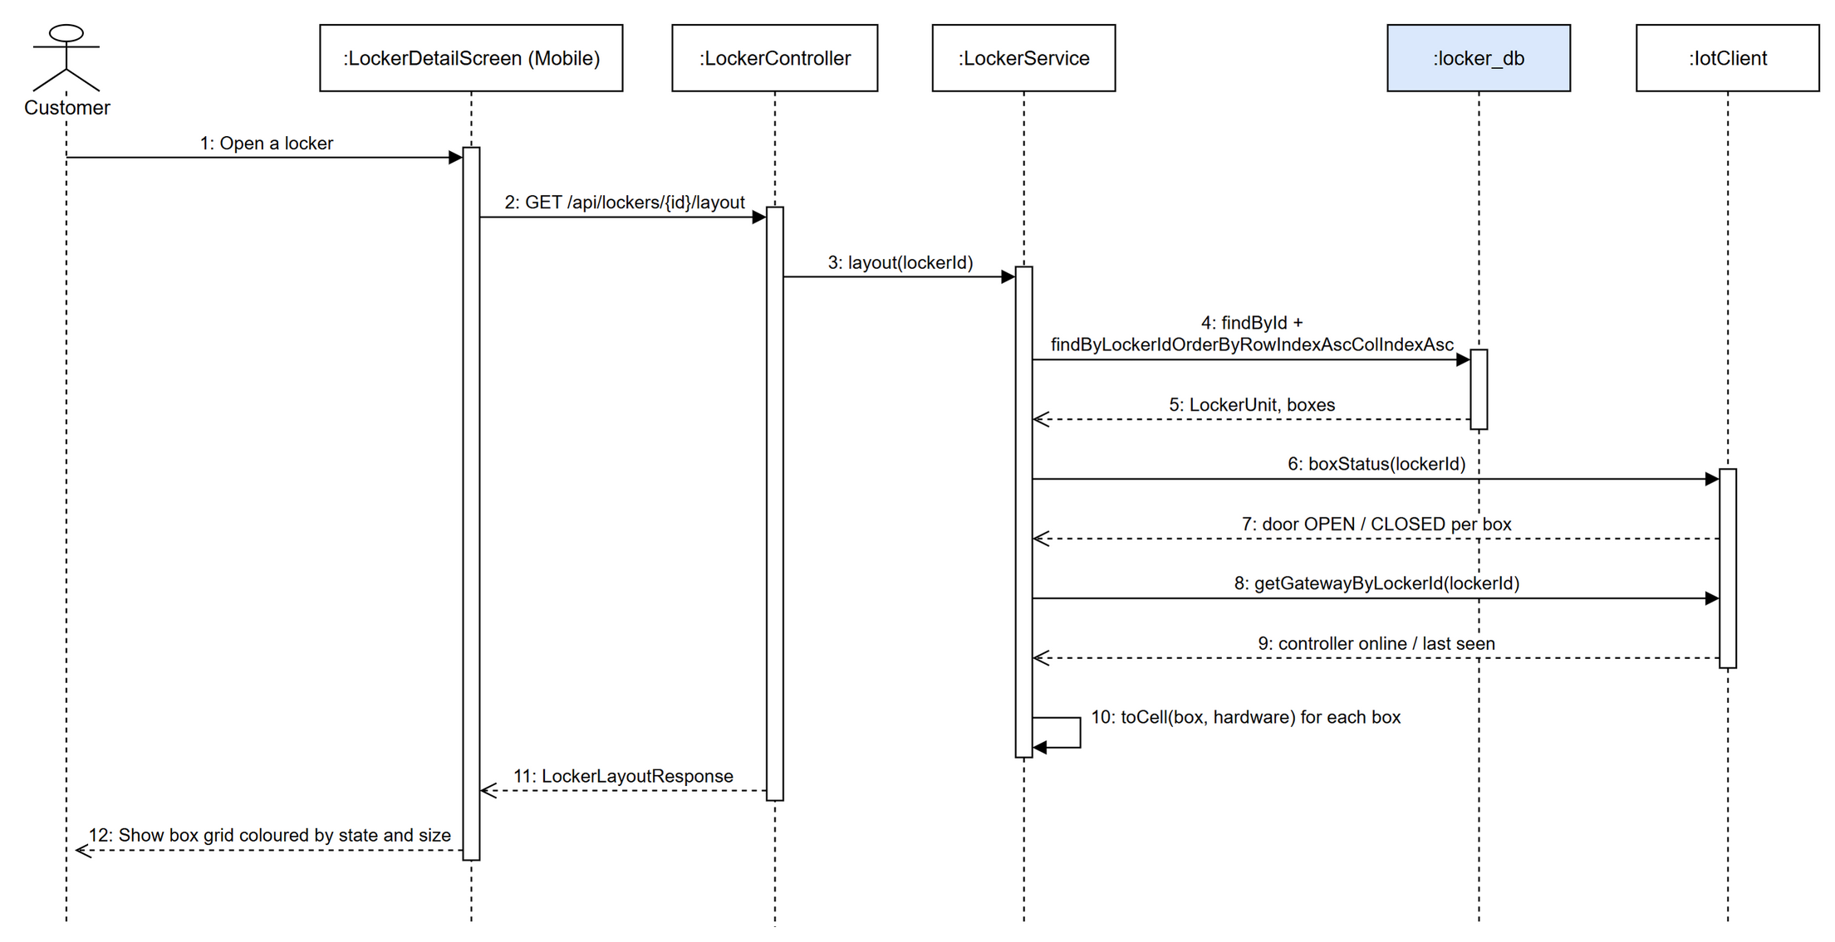
Figure 3.5.3: Sequence diagram - View Locker Layout

3.5.4 Class Specification
3.5.4.a LockerController
Table 3.5.4.a: LockerController description
No | Method | Description
01 | createLocker(request: LockerRequest): ApiResponse<LockerResponse> | Admin creates a locker cabinet.
02 | adminAddBoxesBatch(id: Long, request: BatchCreateBoxesRequest): ApiResponse<List<CellResponse>> | Admin adds several boxes to a locker grid.
03 | listLockers(storeId: Long): ApiResponse<List<LockerResponse>> | Lists lockers (optionally of a store) with free-box counts.
04 | layout(id: Long): ApiResponse<LockerLayoutResponse> | Returns the box grid with state, size and door state.
05 | listAvailableBoxes(lockerId: Long): ApiResponse<List<LockerBoxSummary>> | Lists AVAILABLE boxes of a locker.

3.5.4.b LockerService
Table 3.5.4.b: LockerService description
No | Method | Description
01 | createLocker(request: LockerRequest): LockerResponse | Saves the locker, applies the admin status and publishes catalog.changed.
02 | createBoxesBatch(lockerId: Long, request: BatchCreateBoxesRequest): List<CellResponse> | Validates numbers (no duplicates), saves all boxes and publishes locker.layout.updated.
03 | layout(lockerId: Long): LockerLayoutResponse | Builds the grid from boxes + hardware statuses + gateway of the locker.
04 | reserveBox(boxId: Long, until: String): LockerBoxSummary | Marks a box RESERVED for a new order.
05 | occupyBox(boxId: Long): LockerBoxSummary | Marks a box OCCUPIED after the parcel is dropped.
06 | releaseBox(boxId: Long): LockerBoxSummary | Returns a box to AVAILABLE.

3.6 Send Parcel
A customer chooses a locker and a box size, enters the receiver (phone, name, optional email), applies vouchers or loyalty points and creates a SEND order. order-service reserves a box in locker-service, generates the order code and the 6-digit PIN, records the status history and notifies the sender and, when the receiver has an account, the receiver.

3.6.1 Class Diagram
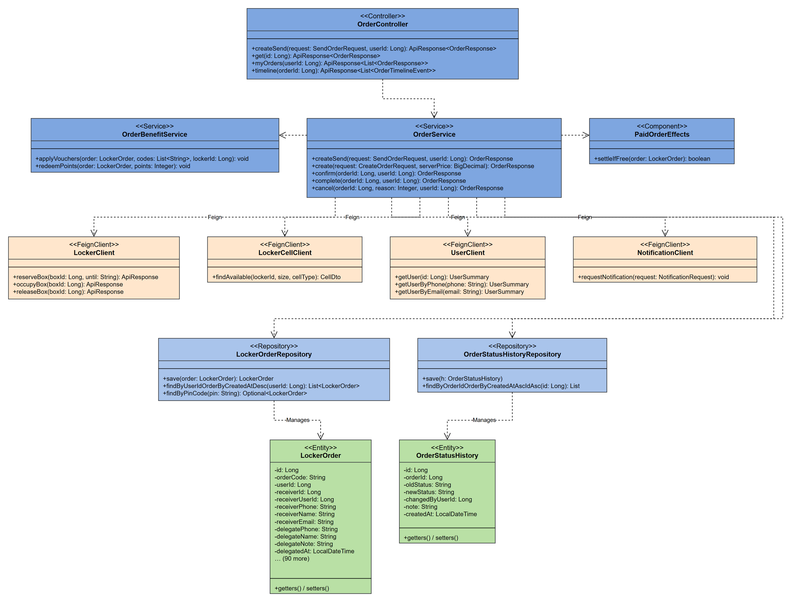
Figure 3.6.1: Class diagram - Send Parcel

3.6.2 Create Send Order
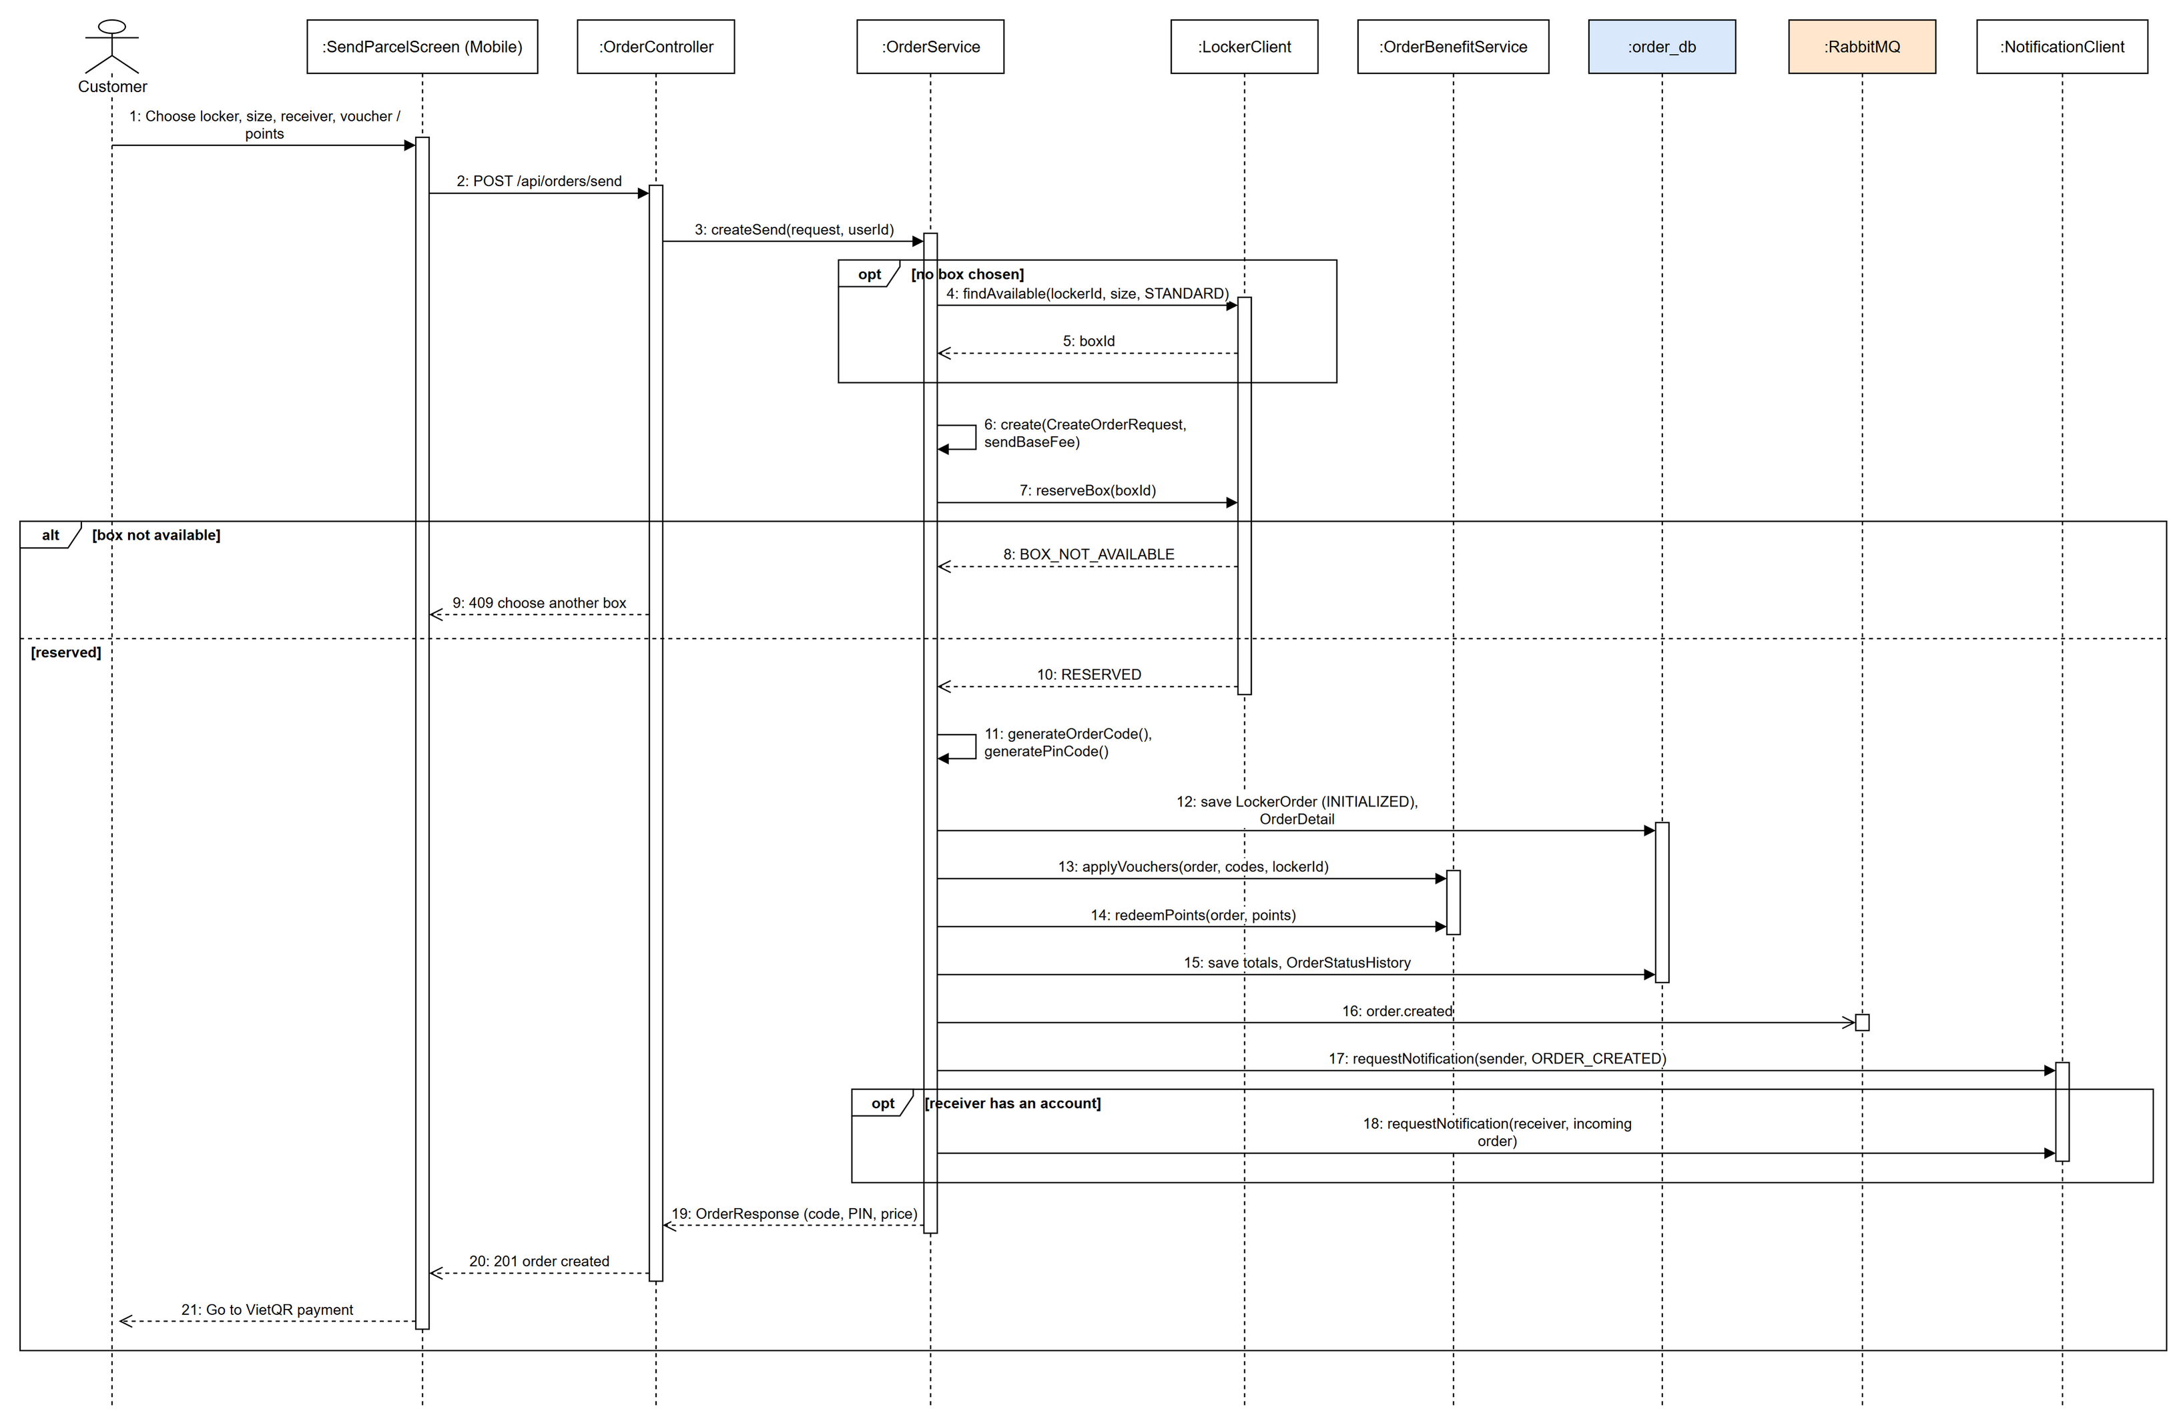
Figure 3.6.2: Sequence diagram - Create Send Order

3.6.3 Class Specification
3.6.3.a OrderController
Table 3.6.3.a: OrderController description
No | Method | Description
01 | createSend(request: SendOrderRequest, userId: Long): ApiResponse<OrderResponse> | Creates a SEND order for the signed-in customer.
02 | get(id: Long): ApiResponse<OrderResponse> | Order detail with PIN / QR for the owner.
03 | myOrders(userId: Long): ApiResponse<List<OrderResponse>> | Orders of the customer.
04 | timeline(orderId: Long): ApiResponse<List<OrderTimelineEvent>> | Status history of an order.

3.6.3.b OrderService
Table 3.6.3.b: OrderService description
No | Method | Description
01 | createSend(request: SendOrderRequest, userId: Long): OrderResponse | Finds a free cell when no box is given, creates the order with the SEND base fee and links the receiver account.
02 | create(request: CreateOrderRequest, serverPrice: BigDecimal): OrderResponse | Generates code and PIN, reserves the box, saves details, applies vouchers / points, writes history, publishes order.created and notifies.
03 | confirm(orderId: Long, userId: Long): OrderResponse | Sender confirms the drop: occupies the box, issues a new PIN and notifies the receiver.
04 | complete(orderId: Long, userId: Long): OrderResponse | Completes the order after pickup and releases the box.
05 | cancel(orderId: Long, reason: Integer, userId: Long): OrderResponse | Cancels an unpaid / undropped order and releases the box and benefits.

3.6.3.c OrderBenefitService
Table 3.6.3.c: OrderBenefitService description
No | Method | Description
01 | applyVouchers(order: LockerOrder, codes: List<String>, lockerId: Long): void | Validates vouchers for the locker and writes promotion usages.
02 | redeemPoints(order: LockerOrder, points: Integer): void | Redeems loyalty points as a discount through loyalty-service.

3.6.3.d PaidOrderEffects
Table 3.6.3.d: PaidOrderEffects description
No | Method | Description
01 | settleIfFree(order: LockerOrder): boolean | Marks a zero-price order as paid immediately.

3.7 VietQR Payment (SePay)
Orders and wallet top-ups are paid by bank transfer through SePay. payment-service creates a PENDING payment with a unique reference and returns a VietQR image and transfer details. When the bank transfer arrives, SePay calls the webhook; the payment becomes COMPLETED only from that verified webhook, then payment.completed is published and order-service marks the order PAID.

3.7.1 Class Diagram
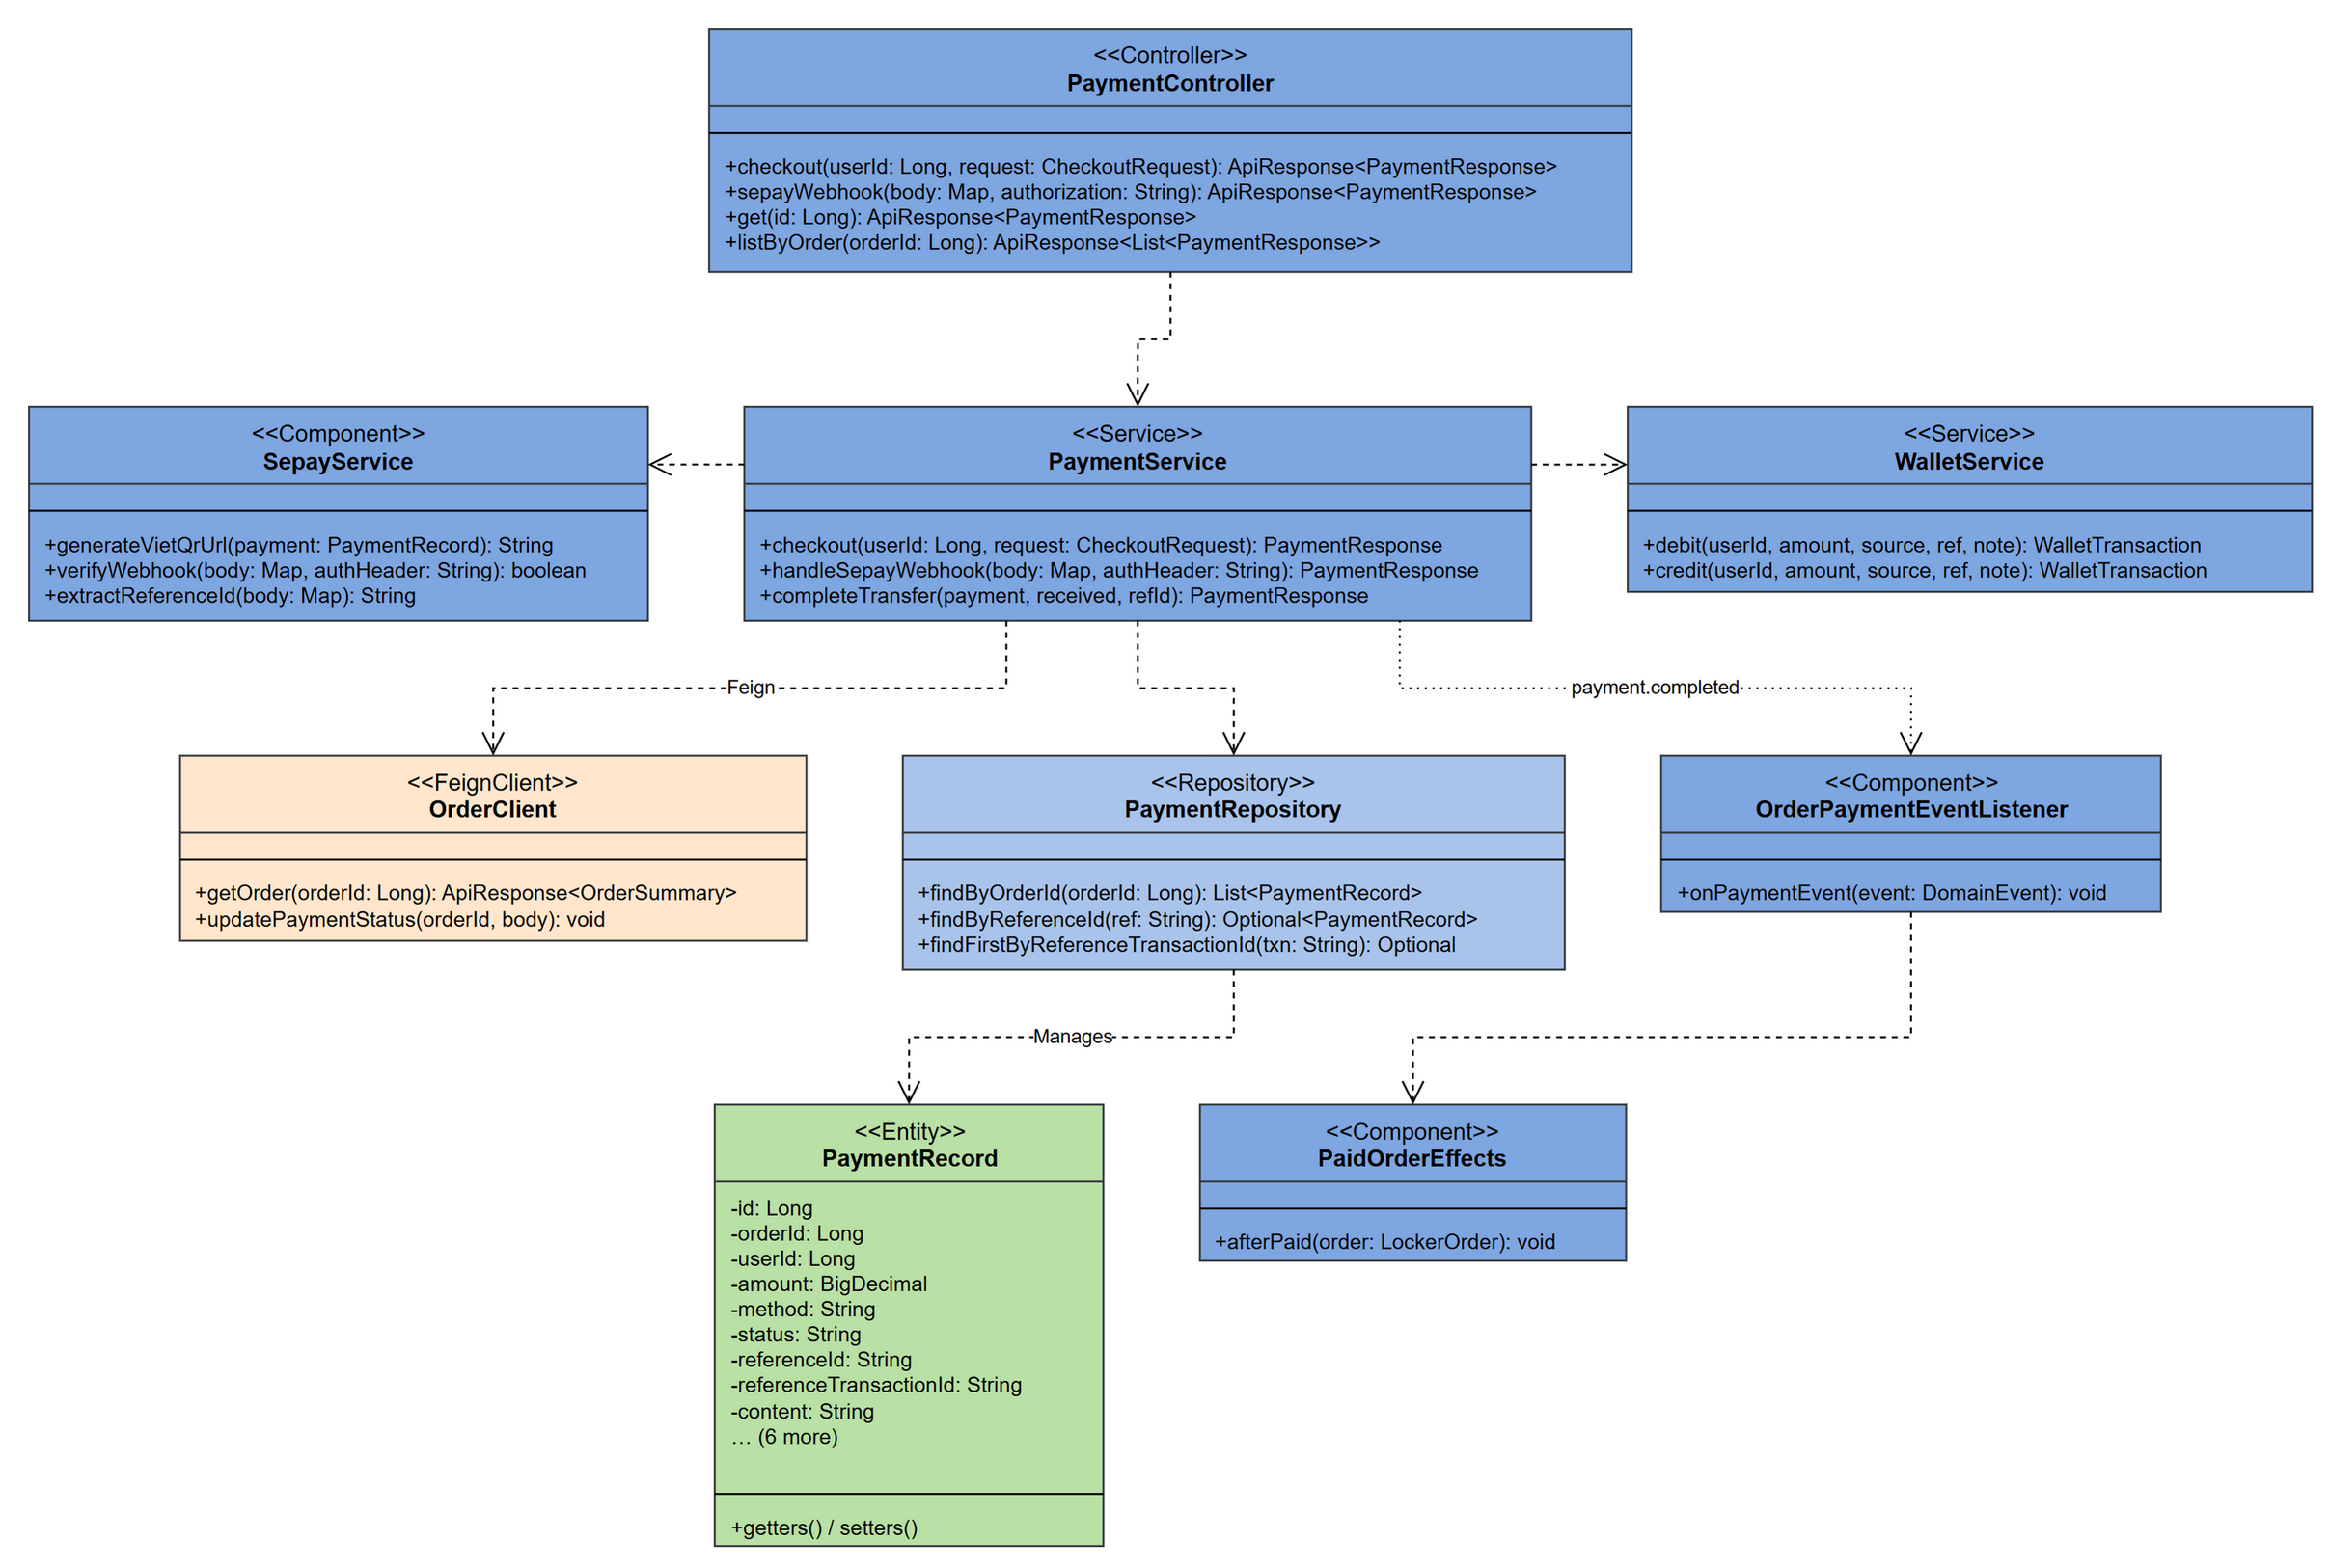
Figure 3.7.1: Class diagram - VietQR Payment (SePay)

3.7.2 Checkout with VietQR
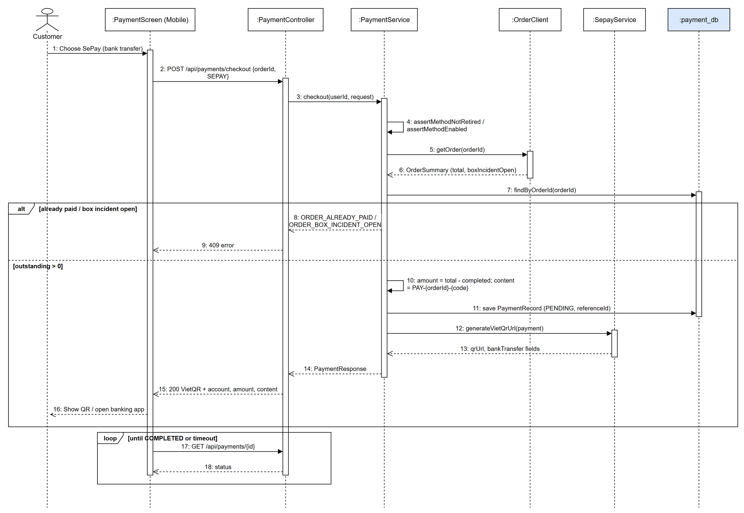
Figure 3.7.2: Sequence diagram - Checkout with VietQR

3.7.3 SePay Webhook Completes the Payment
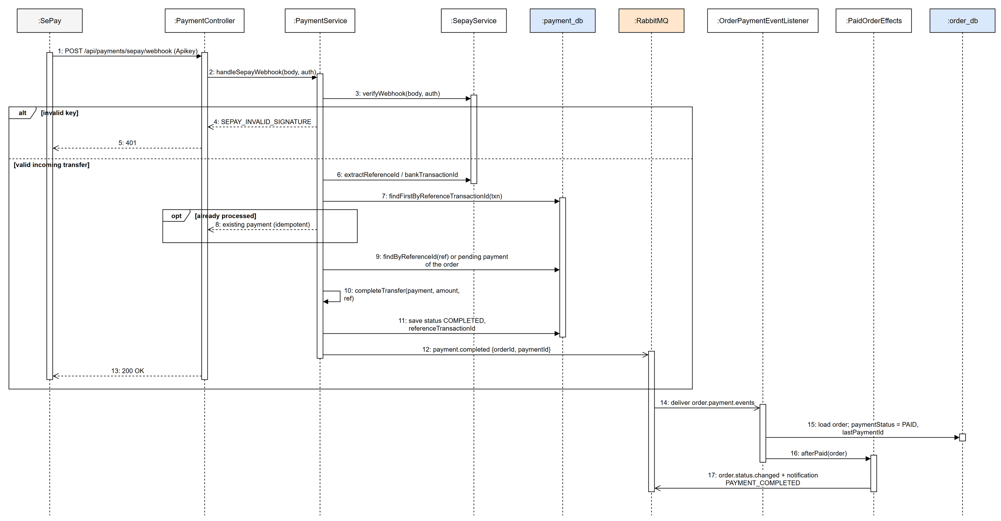
Figure 3.7.3: Sequence diagram - SePay Webhook Completes the Payment

3.7.4 Class Specification
3.7.4.a PaymentController
Table 3.7.4.a: PaymentController description
No | Method | Description
01 | checkout(userId: Long, request: CheckoutRequest): ApiResponse<PaymentResponse> | Creates / reuses the pending payment of an order (SEPAY or WALLET).
02 | sepayWebhook(body: Map, authorization: String): ApiResponse<PaymentResponse> | Receives the SePay bank-transfer webhook.
03 | get(id: Long): ApiResponse<PaymentResponse> | Payment status polled by the app.
04 | listByOrder(orderId: Long): ApiResponse<List<PaymentResponse>> | Payments of an order.

3.7.4.b PaymentService
Table 3.7.4.b: PaymentService description
No | Method | Description
01 | checkout(userId: Long, request: CheckoutRequest): PaymentResponse | Checks method and order, computes the outstanding amount, builds the transfer content and creates a PENDING payment; WALLET is debited at once.
02 | handleSepayWebhook(body: Map, authHeader: String): PaymentResponse | Verifies API key, ignores outgoing transfers and duplicates, finds the payment by reference and completes it.
03 | completeTransfer(payment, received, refId): PaymentResponse | Marks COMPLETED, credits any surplus to the wallet and publishes payment.completed.

3.7.4.c SepayService
Table 3.7.4.c: SepayService description
No | Method | Description
01 | generateVietQrUrl(payment: PaymentRecord): String | Builds the VietQR image URL (bank BIN, account, amount, content).
02 | verifyWebhook(body: Map, authHeader: String): boolean | Checks the SePay API key.
03 | extractReferenceId(body: Map): String | Reads the payment reference from the transfer content.

3.7.4.d OrderPaymentEventListener
Table 3.7.4.d: OrderPaymentEventListener description
No | Method | Description
01 | onPaymentEvent(event: DomainEvent): void | Consumes payment.completed in order-service and marks the order PAID.

3.7.4.e PaidOrderEffects
Table 3.7.4.e: PaidOrderEffects description
No | Method | Description
01 | afterPaid(order: LockerOrder): void | Publishes order.status.changed, notifies the customer and starts drone pickup for paid drone orders.

3.8 Drop and Pick Up Parcel at the Kiosk
At the locker the sender enters the order PIN / scans the QR to open the reserved box and drop the parcel; the receiver uses the PIN sent by SMS / email to open the box and take it. iot-service validates the code against order-service, enforces the wrong-PIN lockout, sends the open command over MQTT to the Raspberry Pi and waits for the result before updating the order and the box.

3.8.1 Class Diagram
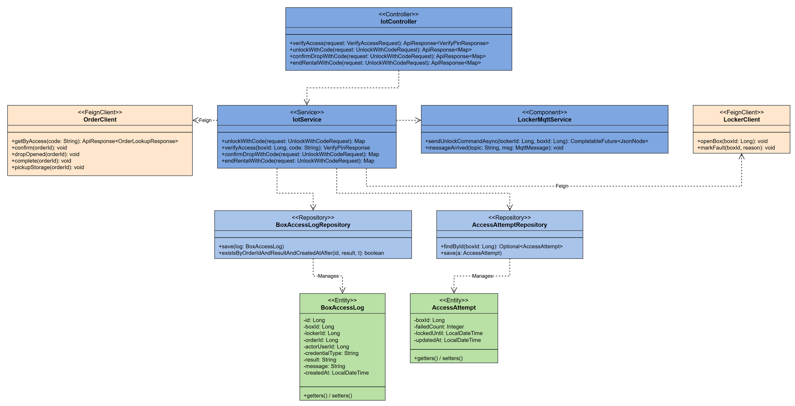
Figure 3.8.1: Class diagram - Drop and Pick Up Parcel at the Kiosk

3.8.2 Open Box with PIN at the Kiosk
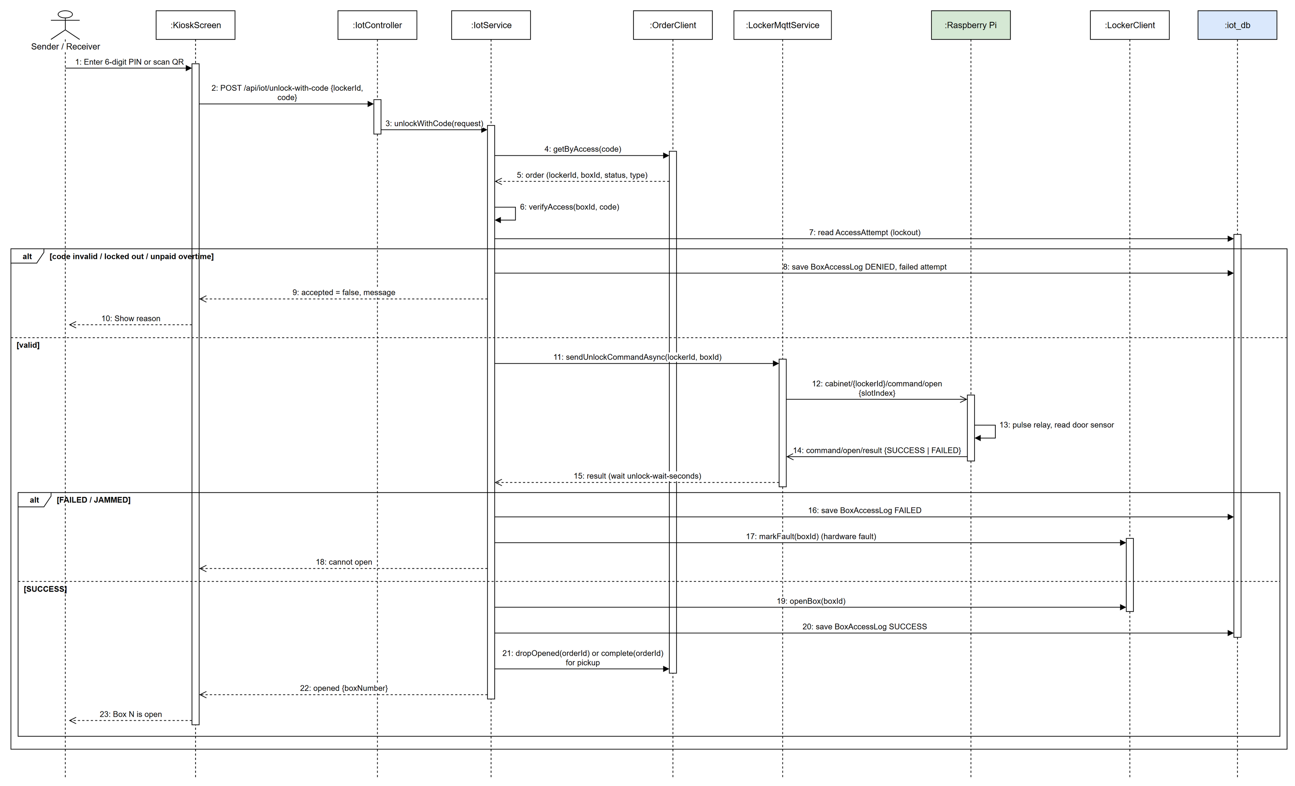
Figure 3.8.2: Sequence diagram - Open Box with PIN at the Kiosk

3.8.3 Confirm Parcel Drop
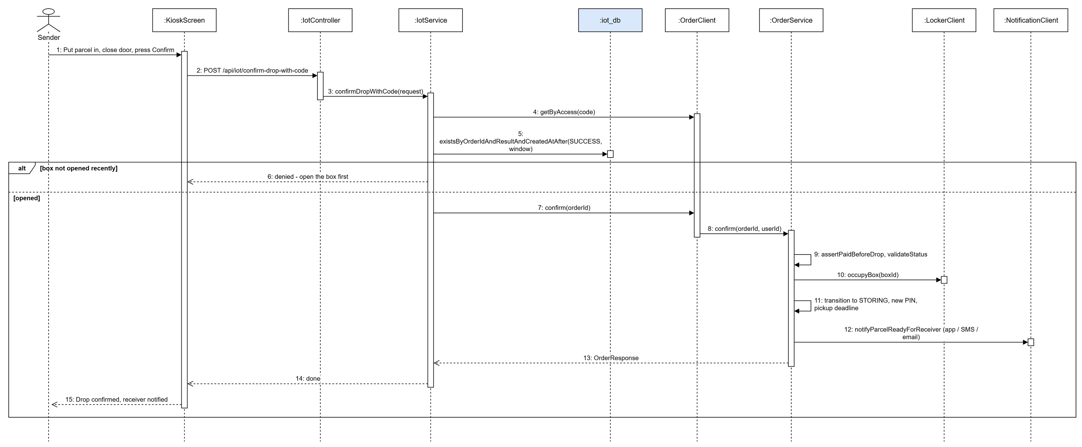
Figure 3.8.3: Sequence diagram - Confirm Parcel Drop

3.8.4 Class Specification
3.8.4.a IotController
Table 3.8.4.a: IotController description
No | Method | Description
01 | verifyAccess(request: VerifyAccessRequest): ApiResponse<VerifyPinResponse> | Checks a PIN / QR code for a box (public kiosk route).
02 | unlockWithCode(request: UnlockWithCodeRequest): ApiResponse<Map> | Opens the box of the order identified by the code.
03 | confirmDropWithCode(request: UnlockWithCodeRequest): ApiResponse<Map> | Confirms the parcel was dropped after the door was opened.
04 | endRentalWithCode(request: UnlockWithCodeRequest): ApiResponse<Map> | Ends a rental after the customer took the items.

3.8.4.b IotService
Table 3.8.4.b: IotService description
No | Method | Description
01 | unlockWithCode(request: UnlockWithCodeRequest): Map | Looks up the order by access code, verifies the box and code, sends the unlock command and records the access.
02 | verifyAccess(boxId: Long, code: String): VerifyPinResponse | Checks the code, payment rules and the wrong-attempt lockout (AccessAttempt).
03 | confirmDropWithCode(request: UnlockWithCodeRequest): Map | Requires a recent successful open, then confirms the order in order-service.
04 | endRentalWithCode(request: UnlockWithCodeRequest): Map | Requires a recent open, then calls pickupStorage to end the rental.

3.8.4.c LockerMqttService
Table 3.8.4.c: LockerMqttService description
No | Method | Description
01 | sendUnlockCommandAsync(lockerId: Long, boxId: Long): CompletableFuture<JsonNode> | Publishes cabinet/{lockerId}/command/open and completes when /result arrives.
02 | messageArrived(topic: String, msg: MqttMessage): void | Handles results, heartbeats and door status from the Pi.

3.9 Rent Locker, Extend and End Rental
A customer rents a box for a number of hours (price by cell type and hours from business settings), extends the rental from the app and ends it at the kiosk or on the phone. Overtime is assessed before the box can be opened again.

3.9.1 Class Diagram
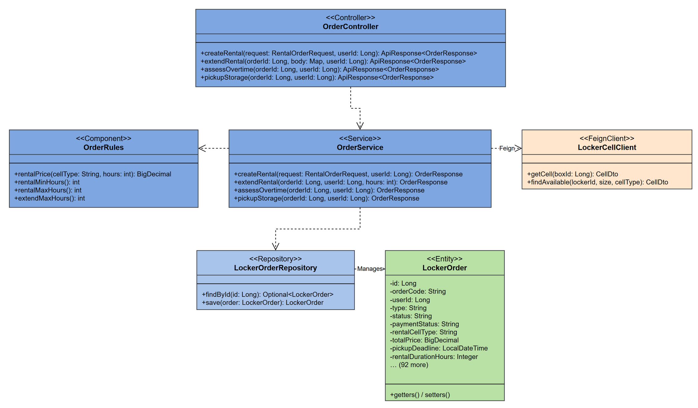
Figure 3.9.1: Class diagram - Rent Locker, Extend and End Rental

3.9.2 Create Rental Order
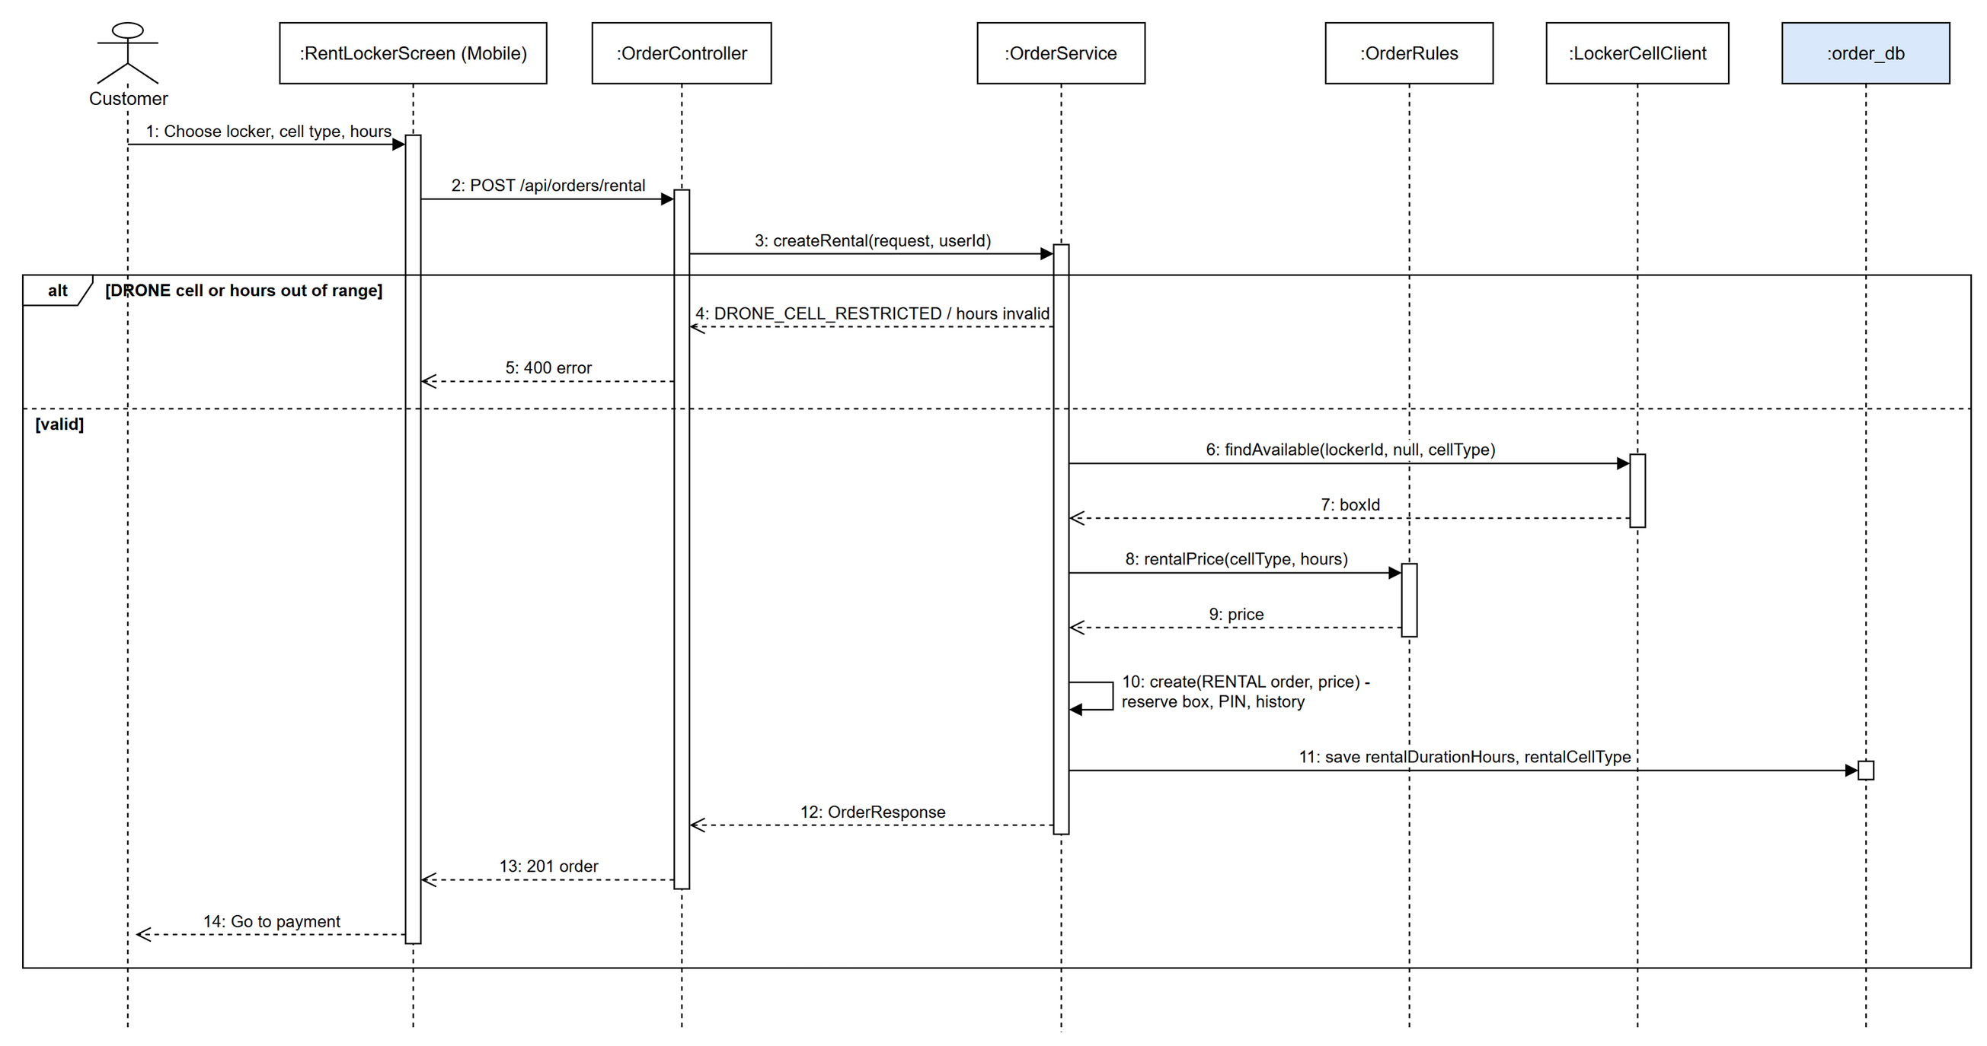
Figure 3.9.2: Sequence diagram - Create Rental Order

3.9.3 Extend Rental
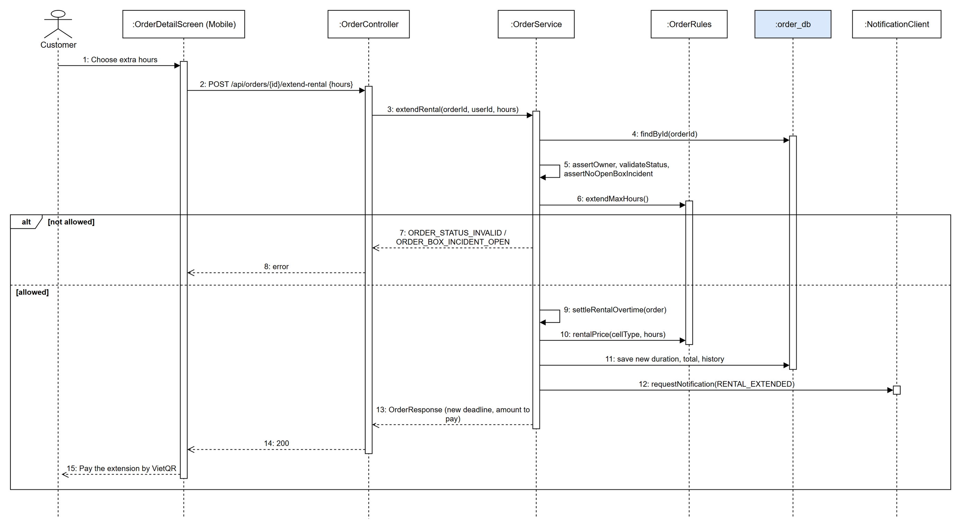
Figure 3.9.3: Sequence diagram - Extend Rental

3.9.4 End Rental at the Kiosk
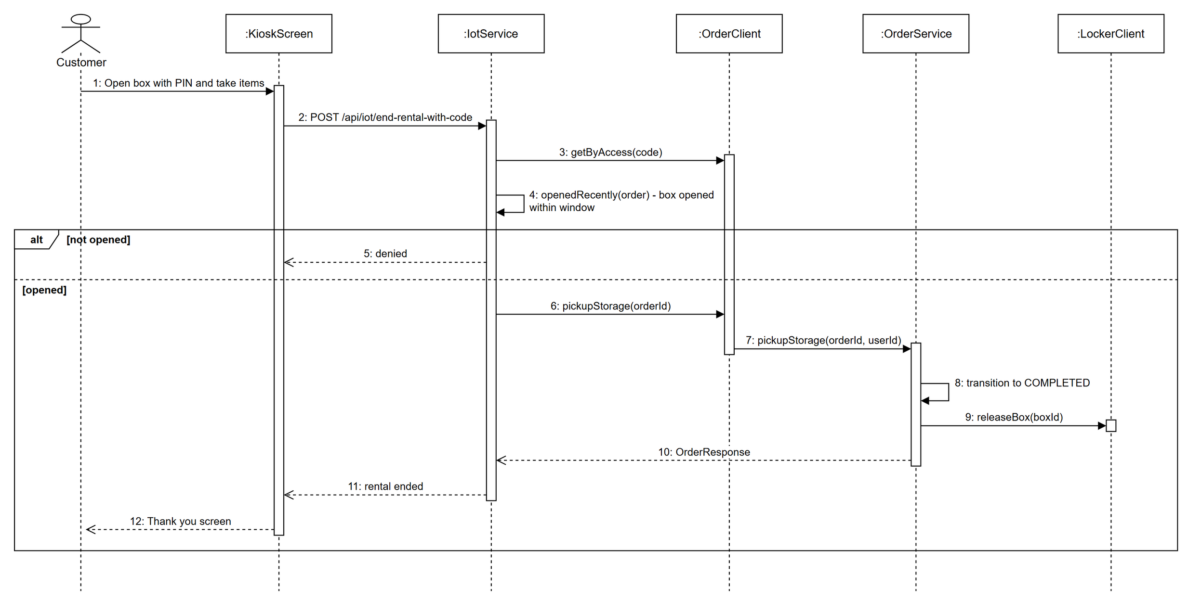
Figure 3.9.4: Sequence diagram - End Rental at the Kiosk

3.9.5 Class Specification
3.9.5.a OrderController
Table 3.9.5.a: OrderController description
No | Method | Description
01 | createRental(request: RentalOrderRequest, userId: Long): ApiResponse<OrderResponse> | Creates a RENTAL order.
02 | extendRental(orderId: Long, body: Map, userId: Long): ApiResponse<OrderResponse> | Adds hours to an active rental.
03 | assessOvertime(orderId: Long, userId: Long): ApiResponse<OrderResponse> | Computes overtime fee before reopening.
04 | pickupStorage(orderId: Long, userId: Long): ApiResponse<OrderResponse> | Ends the rental after the items are taken.

3.9.5.b OrderService
Table 3.9.5.b: OrderService description
No | Method | Description
01 | createRental(request: RentalOrderRequest, userId: Long): OrderResponse | Rejects DRONE cells, checks min / max hours, prices by cell type and hours and creates the order.
02 | extendRental(orderId: Long, userId: Long, hours: int): OrderResponse | Checks owner, status, open incidents and max hours, settles overtime and adds the extension price.
03 | assessOvertime(orderId: Long, userId: Long): OrderResponse | Adds the overtime fee that must be paid before unlocking.
04 | pickupStorage(orderId: Long, userId: Long): OrderResponse | Completes the rental and releases the box.

3.10 Delegate Pickup and Reset PIN
The owner of an order may hand the pickup over to another person (phone, name, note) or request a new PIN. A new PIN is generated, the old one stops working, and the delegate is notified when the phone belongs to an account.

3.10.1 Class Diagram
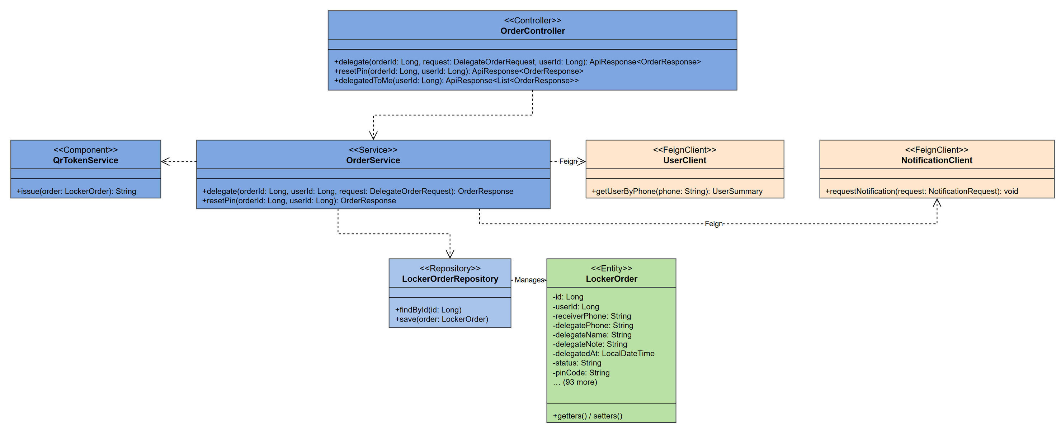
Figure 3.10.1: Class diagram - Delegate Pickup and Reset PIN

3.10.2 Delegate Pickup
Figure 3.10.2: Sequence diagram - Delegate Pickup

3.10.3 Reset PIN
Figure 3.10.3: Sequence diagram - Reset PIN

3.10.4 Class Specification
3.10.4.a OrderController
Table 3.10.4.a: OrderController description
No | Method | Description
01 | delegate(orderId: Long, request: DelegateOrderRequest, userId: Long): ApiResponse<OrderResponse> | Delegates pickup to another person.
02 | resetPin(orderId: Long, userId: Long): ApiResponse<OrderResponse> | Issues a new PIN for the order.
03 | delegatedToMe(userId: Long): ApiResponse<List<OrderResponse>> | Orders delegated to the current user.

3.10.4.b OrderService
Table 3.10.4.b: OrderService description
No | Method | Description
01 | delegate(orderId: Long, userId: Long, request: DelegateOrderRequest): OrderResponse | Checks owner and status, stores delegate data, generates a new PIN, writes history and notifies both sides.
02 | resetPin(orderId: Long, userId: Long): OrderResponse | Checks owner and status and generates a new PIN.

3.10.4.c QrTokenService
Table 3.10.4.c: QrTokenService description
No | Method | Description
01 | issue(order: LockerOrder): String | Signs the QR token that encodes the order access.

3.11 Rate Order, Complaint and Feedback Handling
After an order is completed the customer rates it (1-5 stars, comment) or files a complaint. Administrators read the feedback, see satisfaction analytics and reply; the customer is notified of the reply.

3.11.1 Class Diagram
Figure 3.11.1: Class diagram - Rate Order, Complaint and Feedback Handling

3.11.2 Rate an Order
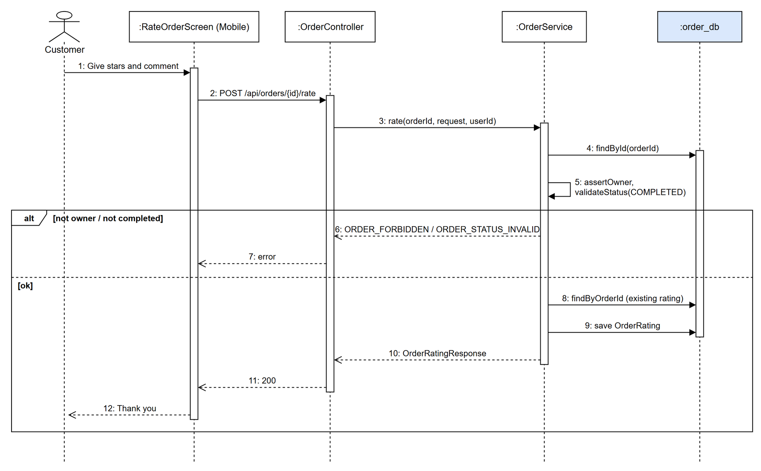
Figure 3.11.2: Sequence diagram - Rate an Order

3.11.3 Administrator Replies to Feedback
Figure 3.11.3: Sequence diagram - Administrator Replies to Feedback

3.11.4 Class Specification
3.11.4.a OrderController
Table 3.11.4.a: OrderController description
No | Method | Description
01 | rate(orderId: Long, request: OrderRatingRequest, userId: Long): ApiResponse<OrderRatingResponse> | Customer rates a completed order.
02 | complaint(orderId: Long, request: OrderComplaintRequest, userId: Long): ApiResponse<OrderComplaintResponse> | Customer files a complaint.

3.11.4.b AdminFeedbackController
Table 3.11.4.b: AdminFeedbackController description
No | Method | Description
01 | list(filters): ApiResponse<PageResponse> | Admin lists ratings and complaints.
02 | reply(id: Long, body: Map, adminId: Long): ApiResponse<FeedbackDetail> | Admin replies to a rating.
03 | satisfaction(range): ApiResponse<Map> | Satisfaction analytics.

3.11.4.c OrderService
Table 3.11.4.c: OrderService description
No | Method | Description
01 | rate(orderId: Long, request: OrderRatingRequest, userId: Long): OrderRatingResponse | Checks owner and COMPLETED status, creates or updates the rating.
02 | complain(orderId: Long, request: OrderComplaintRequest, userId: Long): OrderComplaintResponse | Checks owner and saves the complaint.

3.11.4.d AdminFeedbackService
Table 3.11.4.d: AdminFeedbackService description
No | Method | Description
01 | reply(id: Long, text: String, adminId: Long): FeedbackDetail | Saves the admin reply and notifies the customer.
02 | analytics(range): Map | Counts ratings, complaint types and averages by order type.

3.12 Wallet Top-up and Withdrawal
Each customer has a Lock.R wallet with a ledger. The wallet is topped up by VietQR (SePay), used to pay orders, credited by refunds, and can be withdrawn to a saved bank account after admin approval. Only real money (top-ups and refunds) can be withdrawn.

3.12.1 Class Diagram
Figure 3.12.1: Class diagram - Wallet Top-up and Withdrawal

3.12.2 Top Up Wallet
Figure 3.12.2: Sequence diagram - Top Up Wallet

3.12.3 Withdraw to Bank and Admin Approval
Figure 3.12.3: Sequence diagram - Withdraw to Bank and Admin Approval

3.12.4 Class Specification
3.12.4.a WalletController
Table 3.12.4.a: WalletController description
No | Method | Description
01 | balance(userId: Long): ApiResponse<WalletResponse> | Wallet balance.
02 | transactions(userId: Long): ApiResponse<List<WalletTransactionResponse>> | Wallet ledger.
03 | withdraw(userId: Long, request: WithdrawRequest): ApiResponse<WithdrawResponse> | Requests a withdrawal to the bank account.
04 | processWithdrawal(id: Long, request: AdminWithdrawProcessRequest): ApiResponse<WithdrawResponse> | Admin approves / rejects a withdrawal.

3.12.4.b PaymentController
Table 3.12.4.b: PaymentController description
No | Method | Description
01 | createTopup(userId: Long, request: CreateTopupRequest): ApiResponse<TopupResponse> | Creates a VietQR top-up payment.

3.12.4.c WalletService
Table 3.12.4.c: WalletService description
No | Method | Description
01 | getBalance(userId: Long): WalletResponse | Balance and withdrawable balance.
02 | credit(userId, amount, source, ref, note): WalletTransaction | Adds money (idempotent by source + reference) and publishes wallet.updated.
03 | debit(userId, amount, source, ref, note): WalletTransaction | Removes money if the balance is enough.
04 | withdraw(userId: Long, request: WithdrawRequest): WithdrawResponse | Checks minimum and withdrawable amount, debits the wallet and saves a PENDING withdrawal.
05 | adminApproveWithdrawal(id: Long, adminId: Long): WithdrawResponse | Marks the withdrawal APPROVED after the bank transfer and notifies.
06 | adminRejectWithdrawal(id: Long, adminId: Long, reason: String): WithdrawResponse | Rejects and credits the money back.

3.13 Refund Requests
A customer asks for a refund of a paid order within the allowed days, to a saved bank account. The order is marked REFUND_PENDING; an administrator transfers the money, enters the bank transfer reference and approves (or rejects). payment.refunded lets loyalty-service take back the points earned.

3.13.1 Class Diagram
Figure 3.13.1: Class diagram - Refund Requests

3.13.2 Request and Approve a Refund
Figure 3.13.2: Sequence diagram - Request and Approve a Refund

3.13.3 Class Specification
3.13.3.a PaymentController
Table 3.13.3.a: PaymentController description
No | Method | Description
01 | requestRefund(userId: Long, request: CreateRefundRequest): ApiResponse<RefundResponse> | Customer requests a refund.
02 | myRefunds(userId: Long): ApiResponse<List<RefundResponse>> | Refunds of the customer.

3.13.3.b AdminPaymentController
Table 3.13.3.b: AdminPaymentController description
No | Method | Description
01 | approveRefund(id: Long, request: ProcessRefundRequest): ApiResponse<RefundResponse> | Admin approves a refund after the bank transfer.
02 | rejectRefund(id: Long, request: ProcessRefundRequest): ApiResponse<RefundResponse> | Admin rejects a refund with a reason.
03 | refunds(filters): ApiResponse<PageResponse<AdminRefundResponse>> | Admin lists refund requests.

3.13.3.c PaymentService
Table 3.13.3.c: PaymentService description
No | Method | Description
01 | requestRefund(userId: Long, request: CreateRefundRequest): RefundResponse | Checks the refund policy (enabled, max days, amount), bank account and duplicates, saves the refund and marks the order REFUND_PENDING.
02 | adminApproveRefund(id: Long, adminId: Long, req: ProcessRefundRequest): RefundResponse | Requires the transfer reference, completes the refund, syncs the order and publishes payment.refunded.
03 | adminRejectRefund(id: Long, adminId: Long, req: ProcessRefundRequest): RefundResponse | Rejects with a reason and restores the order payment status.

3.14 Promotions, Vouchers and Loyalty Points
Administrators define promotions (code, discount, period, limits, locker scope, point price). Customers save free vouchers or exchange loyalty points for vouchers and apply them when ordering. loyalty-service awards 10 % of the paid amount as points when order.completed is received and reverses them on refunds.

3.14.1 Class Diagram
Figure 3.14.1: Class diagram - Promotions, Vouchers and Loyalty Points

3.14.2 Exchange Points for a Voucher
Figure 3.14.2: Sequence diagram - Exchange Points for a Voucher

3.14.3 Earn Points when an Order Completes
Figure 3.14.3: Sequence diagram - Earn Points when an Order Completes

3.14.4 Class Specification
3.14.4.a OrderController
Table 3.14.4.a: OrderController description
No | Method | Description
01 | activePromotions(userId: Long): ApiResponse<List<PromotionView>> | Active promotions for the customer.
02 | claimPromotion(promotionId: Long, userId: Long): ApiResponse<Map> | Saves a free voucher.
03 | exchangeVoucher(promotionId: Long, userId: Long): ApiResponse<VoucherExchangeResult> | Exchanges points for a voucher.
04 | myVouchers(userId: Long): ApiResponse<List<Map>> | Vouchers held by the customer.

3.14.4.b VoucherExchangeService
Table 3.14.4.b: VoucherExchangeService description
No | Method | Description
01 | exchangeable(userId: Long): List<ExchangeableVoucherView> | Promotions that can be bought with points.
02 | exchange(promotionId: Long, userId: Long): VoucherExchangeResult | Locks the promotion, checks eligibility, spends points in loyalty-service and saves the claim (refunds points on rollback).

3.14.4.c LoyaltyController
Table 3.14.4.c: LoyaltyController description
No | Method | Description
01 | summary(userId: Long): ApiResponse<LoyaltyAccountResponse> | Points, lifetime points and tier.
02 | history(userId: Long): ApiResponse<List<PointTransactionResponse>> | Point transactions.
03 | exchangeForVoucher(request: VoucherExchangeRequest): ApiResponse<VoucherExchangeResponse> | Internal: spends points for a voucher.

3.14.4.d LoyaltyService
Table 3.14.4.d: LoyaltyService description
No | Method | Description
01 | awardOrderPoints(userId: Long, orderId: Long, paid: BigDecimal): Optional<LoyaltyAccountResponse> | Adds earn points once per order and updates the tier.
02 | exchangeForVoucher(request: VoucherExchangeRequest): VoucherExchangeResponse | Deducts points with a reference for idempotency.
03 | reverseOrderEarn(orderId: Long, refunded: BigDecimal, paid: BigDecimal): int | Takes back points proportionally to a refund.
04 | redeemForOrder(request: OrderRedemptionRequest): OrderRedemptionResponse | Uses points as an order discount.

3.14.4.e OrderCompletedPointsListener
Table 3.14.4.e: OrderCompletedPointsListener description
No | Method | Description
01 | onOrderCompleted(event: DomainEvent): void | Consumes order.completed / payment.refunded and calls LoyaltyService.

3.15 Drone Delivery Booking
A customer books a drone delivery between two lockers with a landing pad or from a pickup address to a locker. order-service quotes the price, checks flight availability, open-order limit, parcel weight and weather, selects the source locker, reserves a DRONE box at the destination and creates a DRONE_DELIVERY order (idempotent by key).

3.15.1 Class Diagram
Figure 3.15.1: Class diagram - Drone Delivery Booking

3.15.2 Book a Drone Delivery
Figure 3.15.2: Sequence diagram - Book a Drone Delivery

3.15.3 Class Specification
3.15.3.a OrderController
Table 3.15.3.a: OrderController description
No | Method | Description
01 | quoteDroneDelivery(request: DroneDeliveryQuoteRequest): ApiResponse<DroneDeliveryQuoteResponse> | Price, distance and ETA before booking.
02 | createDroneDelivery(request: CreateDroneDeliveryOrderRequest, userId: Long, key: String): ApiResponse<DroneDeliveryOrderResponse> | Books a drone delivery.
03 | getDroneDelivery(orderId: Long, userId: Long): ApiResponse<DroneDeliveryOrderResponse> | Booking and flight status.

3.15.3.b DroneOrderBookingService
Table 3.15.3.b: DroneOrderBookingService description
No | Method | Description
01 | quote(request: DroneDeliveryQuoteRequest): DroneDeliveryQuoteResponse | Computes distance, price and availability.
02 | create(request, userId: Long, idempotencyKey: String): DroneDeliveryOrderResponse | Validates limits, weight, parcel and weather, selects the source locker, reserves the destination box and saves the order.

3.15.3.c DroneSourceLockerSelector
Table 3.15.3.c: DroneSourceLockerSelector description
No | Method | Description
01 | select(request): SourceLocker | Chooses the source locker / station for the flight.

3.15.3.d DroneWeatherService
Table 3.15.3.d: DroneWeatherService description
No | Method | Description
01 | assessJourney(from, to): WeatherAssessment | Wind / rain check from Open-Meteo (fallback MET Norway).

3.16 Drone Home Pickup
When a drone order that starts at the customer's address is paid, a pickup is opened and offered to the nearest on-duty drone technician who is not busy. The technician accepts (or declines, then the next one is offered), meets the customer, checks the pickup code and takes a photo; the parcel is then ready to load.

3.16.1 Class Diagram
Figure 3.16.1: Class diagram - Drone Home Pickup

3.16.2 Offer, Accept and Confirm a Home Pickup
Figure 3.16.2: Sequence diagram - Offer, Accept and Confirm a Home Pickup

3.16.3 Class Specification
3.16.3.a OrderController
Table 3.16.3.a: OrderController description
No | Method | Description
01 | acceptDronePickup(orderId: Long, userId: Long): ApiResponse | Technician accepts the pickup offer.
02 | declineDronePickup(orderId: Long, userId: Long): ApiResponse | Technician declines the offer.
03 | confirmDronePickup(orderId: Long, request, userId: Long): ApiResponse | Technician confirms the parcel was collected.
04 | assignDronePickup(orderId: Long, request): ApiResponse | Admin assigns a technician manually.

3.16.3.b DronePickupService
Table 3.16.3.b: DronePickupService description
No | Method | Description
01 | startForPaidOrder(orderId: Long): void | Creates the pickup and offers it to the next free technician.
02 | accept(orderId: Long, technicianId: Long): void | Closes the offer and assigns the technician to the order.
03 | decline(orderId: Long, technicianId: Long): void | Declines and offers the pickup to the next technician.
04 | confirmPickedUp(orderId, technicianId, code, matched, note, photo): void | Checks the pickup code, verifies the photo and moves the order to the loading step.
05 | sweep(now: LocalDateTime): void | Scheduled: expires unanswered offers and re-offers.

3.17 Drone Dispatch, Loading and Launch
A drone technician accepts a paid drone order and reserves a drone that passes the pre-flight checks (status, battery, landing pad and destination box). The parcel is weighed and sealed in the loading step (surcharge when heavier than declared), then the drone is launched after a weather check. The drone status is changed in locker-service.

3.17.1 Class Diagram
Figure 3.17.1: Class diagram - Drone Dispatch, Loading and Launch

3.17.2 Accept Drone Order and Confirm Loading
Figure 3.17.2: Sequence diagram - Accept Drone Order and Confirm Loading

3.17.3 Launch the Drone
Figure 3.17.3: Sequence diagram - Launch the Drone

3.17.4 Class Specification
3.17.4.a OrderController
Table 3.17.4.a: OrderController description
No | Method | Description
01 | maintenanceDroneOrders(userId: Long): ApiResponse<List<DroneMissionResponse>> | Dispatch queue of drone orders.
02 | acceptDroneOrder(orderId: Long, request: AcceptDroneOrderRequest, userId: Long): ApiResponse<DroneMissionResponse> | Accepts an order with a drone.
03 | confirmDroneLoading(orderId: Long, request: ConfirmDroneLoadingRequest, userId: Long): ApiResponse<DroneMissionResponse> | Confirms weight, seal and checklist.
04 | launchDroneOrder(orderId: Long, userId: Long): ApiResponse<DroneMissionResponse> | Launches the flight.
05 | cancelDroneOrder(orderId: Long, request, userId: Long): ApiResponse<DroneMissionResponse> | Cancels before launch.

3.17.4.b DroneOrderMaintenanceService
Table 3.17.4.b: DroneOrderMaintenanceService description
No | Method | Description
01 | queue(role: String): List<DroneMissionResponse> | Orders waiting for dispatch / in progress.
02 | accept(orderId, userId, role, request): DroneMissionResponse | Checks paid status, parcel in hand, flights open, drone and locker pre-flight; reserves the drone and creates the mission.
03 | confirmLoading(orderId, userId, role, request): DroneMissionResponse | Checks operator and reservation, generates the seal code, applies a weight surcharge and releases the source box.
04 | launch(orderId, userId, role): DroneMissionResponse | Re-checks pre-flight and weather, sets the drone IN_FLIGHT and the mission LAUNCHED, emails / notifies.
05 | cancel(orderId, userId, request): DroneMissionResponse | Cancels the mission and frees the drone.

3.18 Drone Flight Tracking and Stage Progress
During the flight the dispatcher confirms the STANDARD stages (or the simulator advances DEMO orders) and the drone companion Pi sends HMAC-signed telemetry over MQTT. order-service updates the mission, writes the journey and broadcasts the live position to /topic/deliveries/{orderId}/position.

3.18.1 Class Diagram
Figure 3.18.1: Class diagram - Drone Flight Tracking and Stage Progress

3.18.2 Advance Flight Stage and Live Position
Figure 3.18.2: Sequence diagram - Advance Flight Stage and Live Position

3.18.3 Class Specification
3.18.3.a OrderController
Table 3.18.3.a: OrderController description
No | Method | Description
01 | advanceDroneOrder(orderId: Long, request: AdvanceDroneOrderRequest, userId: Long): ApiResponse<String> | Dispatcher confirms the next flight stage.

3.18.3.b DroneMissionProgressService
Table 3.18.3.b: DroneMissionProgressService description
No | Method | Description
01 | nextStage(current: String): String | Next stage of the STANDARD journey.
02 | advanceByOperator(orderId: Long, userId: Long, expected: String): String | Validates the expected stage and advances it.
03 | advanceToStage(order, mission, stage, actor, note): void | Saves mission / order stage and history, notifies and frees the drone at the end.

3.18.3.c DroneTelemetryMqttListener
Table 3.18.3.c: DroneTelemetryMqttListener description
No | Method | Description
01 | messageArrived(topic: String, msg: MqttMessage): void | Receives lockr/drones/+/telemetry.

3.18.3.d DroneTelemetryService
Table 3.18.3.d: DroneTelemetryService description
No | Method | Description
01 | ingest(droneCode: String, payload: JsonNode): void | Verifies the HMAC signature, stores the latest sample and forwards the position.

3.19 Drone Parcel Drop Incident
If a parcel falls during a flight the technician reports a drop incident with location, telemetry and photos. The drone is grounded, incident tickets are created, a return-to-launch is requested, a recovery technician is assigned, and the admin proposes free redelivery or compensation that the customer accepts or disputes.

3.19.1 Class Diagram
Figure 3.19.1: Class diagram - Drone Parcel Drop Incident

3.19.2 Report a Dropped Parcel
Figure 3.19.2: Sequence diagram - Report a Dropped Parcel

3.19.3 Recovery, Proposal and Customer Decision
Figure 3.19.3: Sequence diagram - Recovery, Proposal and Customer Decision

3.19.4 Class Specification
3.19.4.a DroneParcelIncidentController
Table 3.19.4.a: DroneParcelIncidentController description
No | Method | Description
01 | report(orderId: Long, request: ReportDroppedParcelRequest, userId: Long): ApiResponse | Technician reports a dropped parcel.
02 | assignRecovery(id: Long, request: AssignDroneRecoveryRequest, adminId: Long): ApiResponse | Admin assigns a recovery technician.
03 | submitRecovery(id: Long, request: DroneRecoverySubmitRequest, userId: Long): ApiResponse | Technician submits the recovery result.
04 | propose(id: Long, request: DroneIncidentProposalRequest, adminId: Long): ApiResponse | Admin proposes redelivery / compensation.
05 | customerRespond(id: Long, request, userId: Long): ApiResponse | Customer accepts or disputes the proposal.

3.19.4.b DroneParcelIncidentService
Table 3.19.4.b: DroneParcelIncidentService description
No | Method | Description
01 | report(orderId, userId, role, key, request): DroneParcelIncidentResponse | Idempotent report: stores location / evidence, marks mission and order, grounds the drone, creates tickets and requests return-to-launch.
02 | assignRecovery(id, adminId, role, request): DroneParcelIncidentResponse | Checks the technician is valid and not busy and assigns the recovery.
03 | submitRecovery(id, userId, request): DroneParcelIncidentResponse | Saves outcome, parcel condition and evidence.
04 | propose(id, adminId, request): DroneParcelIncidentResponse | Creates a versioned redelivery / compensation proposal according to the policy.
05 | customerRespond(id, userId, request): DroneParcelIncidentResponse | Accept -> create redelivery or submit compensation refund; dispute -> admin review.

3.20 Locker Incident Ticket
A customer who cannot use a box reports it from the order. The box goes to PENDING_CHECK, a ticket is created and routed to the technician responsible for the locker, and the order is paused (no overtime). The technician claims the ticket within the SLA, adds notes and before / after photos, then resolves (box returns to service) or rejects it.

3.20.1 Class Diagram
Figure 3.20.1: Class diagram - Locker Incident Ticket

3.20.2 Customer Reports a Box Fault
Figure 3.20.2: Sequence diagram - Customer Reports a Box Fault

3.20.3 Technician Claims and Resolves a Ticket
Figure 3.20.3: Sequence diagram - Technician Claims and Resolves a Ticket

3.20.4 Class Specification
3.20.4.a OrderController
Table 3.20.4.a: OrderController description
No | Method | Description
01 | reportBoxFault(orderId: Long, body: Map, userId: Long): ApiResponse<OrderResponse> | Customer reports the box of an order.

3.20.4.b LockerController
Table 3.20.4.b: LockerController description
No | Method | Description
01 | markFaultInternal(id: Long, request: BoxFaultRequest): ApiResponse<CellResponse> | Internal: opens a ticket for a box.
02 | maintenanceReports(userId: Long): ApiResponse<List<LockerReportResponse>> | Technician ticket queue.
03 | maintenanceClaim(id: Long, userId: Long): ApiResponse<LockerReportResponse> | Technician claims a ticket.
04 | maintenanceAddReportAttachments(id: Long, request, userId: Long): ApiResponse | Adds before / during / after photos.
05 | maintenanceResolve(id: Long, request: ResolveReportRequest, userId: Long): ApiResponse<LockerReportResponse> | Resolves the ticket and clears the fault.
06 | maintenanceRejectReport(id: Long, request, userId: Long): ApiResponse | Rejects a wrong report with feedback.

3.20.4.c OrderService
Table 3.20.4.c: OrderService description
No | Method | Description
01 | reportBoxFault(orderId, userId, reason, attachments): OrderResponse | Checks owner / status, calls locker-service and opens the box incident on the order (or auto-cancels).

3.20.4.d LockerService
Table 3.20.4.d: LockerService description
No | Method | Description
01 | markFault(boxId, reason, reporter, attachments, ...): CellResponse | Sets the box PENDING_CHECK, creates the LockerReport, routes it to the locker technician and publishes locker.report.routed.
02 | claimReport(reportId: Long, userId: Long): LockerReportResponse | Assigns the ticket (SLA) and publishes locker.report.claimed.
03 | resolveReport(reportId, userId, request): LockerReportResponse | Requires the after photo, closes the ticket, clears the fault and notifies the order.

3.21 Periodic Inspection
Administrators plan periodic inspections of a locker or a drone (checklist, interval, time slot, technician). A scheduler reminds the technician when an inspection is due; the technician records Pass / Fail for each item with photos, and failed items create a ticket.

3.21.1 Class Diagram
Figure 3.21.1: Class diagram - Periodic Inspection

3.21.2 Plan and Perform a Periodic Inspection
Figure 3.21.2: Sequence diagram - Plan and Perform a Periodic Inspection

3.21.3 Class Specification
3.21.3.a LockerController
Table 3.21.3.a: LockerController description
No | Method | Description
01 | adminCreateSchedule(request: MaintenanceScheduleRequest): ApiResponse<MaintenanceScheduleResponse> | Admin creates an inspection plan.
02 | assignTechnicianToSchedule(id: Long, request): ApiResponse | Admin assigns the technician.
03 | maintenanceSchedules(userId: Long): ApiResponse<List> | Technician's due inspections.
04 | maintenanceCompleteSchedule(id: Long, request: CompleteScheduleRequest, userId: Long): ApiResponse | Technician submits the inspection result.

3.21.3.b LockerService
Table 3.21.3.b: LockerService description
No | Method | Description
01 | createSchedule(request): MaintenanceScheduleResponse | Validates the target and technician role, saves the plan and notifies the technician.
02 | completeSchedule(id, userId, request): MaintenanceScheduleResponse | Saves the inspection log, moves next due date and creates a ticket for failed items.

3.21.3.c LockerScheduler
Table 3.21.3.c: LockerScheduler description
No | Method | Description
01 | remindDueSchedules(): void | Scheduled: publishes locker.schedule.due for plans that became due.

3.22 Locker Controller Provisioning and Cabinet Control
A Raspberry Pi controller announces itself over MQTT (iot/{mac}/discovery). The administrator assigns it to a locker; iot-service sends the setup with the box layout and tracks progress. Technicians and administrators open boxes, move the sliding lid and read the panel status remotely; every action is written to cabinet_control_logs.

3.22.1 Class Diagram
Figure 3.22.1: Class diagram - Locker Controller Provisioning and Cabinet Control

3.22.2 Assign a Controller to a Locker
Figure 3.22.2: Sequence diagram - Assign a Controller to a Locker

3.22.3 Remote Open Box from the Admin Web
Figure 3.22.3: Sequence diagram - Remote Open Box from the Admin Web

3.22.4 Class Specification
3.22.4.a GatewayController
Table 3.22.4.a: GatewayController description
No | Method | Description
01 | list(): ApiResponse<List<GatewayDeviceResponse>> | Controllers discovered / assigned.
02 | assign(id: Long, request: AssignGatewayRequest): ApiResponse<GatewayDeviceResponse> | Assigns a controller to a locker.
03 | unassign(id: Long): ApiResponse<GatewayDeviceResponse> | Clears the setup on the Pi.

3.22.4.b CabinetControlController
Table 3.22.4.b: CabinetControlController description
No | Method | Description
01 | openBox(lockerId: Long, boxId: Long, userId: Long): ApiResponse<Map> | Remote box open by technician / admin.
02 | lid(lockerId: Long, axis: int, action: String): ApiResponse<Map> | Moves the sliding lid of a drone box.
03 | panel(lockerId: Long): ApiResponse<Map> | Live panel status from the Pi.
04 | logs(lockerId: Long): ApiResponse<List<CabinetControlLogResponse>> | Control log of the cabinet.

3.22.4.c GatewayProvisioningService
Table 3.22.4.c: GatewayProvisioningService description
No | Method | Description
01 | onDiscovery(mac: String, payload: JsonNode): void | Creates / updates the GatewayDevice from a discovery message.
02 | assign(id: Long, request: AssignGatewayRequest): GatewayDeviceResponse | Requires the broker, checks the locker is free, validates cells and publishes iot/{mac}/command/setup after commit.
03 | onSetupResult(mac: String, payload: JsonNode): void | Stores the setup result.

3.22.4.d CabinetControlService
Table 3.22.4.d: CabinetControlService description
No | Method | Description
01 | openBox(lockerId, boxId, userId, role): Map | Logs the web action and sends the unlock command.
02 | lid(lockerId, axis, action, userId, role): Map | Sends a lid command.
03 | panel(lockerId, userId, role): Map | Queries the Pi panel.

3.23 Bluetooth Open Test
For testing offline opening, the administrator grants a customer account access to a locker. The app asks iot-service for a one-time Ed25519-signed token (valid 120 s) for one box and sends it to the Pi over Bluetooth; the Pi verifies it with the public key downloaded from /api/iot/ble/public-key.

3.23.1 Class Diagram
Figure 3.23.1: Class diagram - Bluetooth Open Test

3.23.2 Open a Box by Bluetooth
Figure 3.23.2: Sequence diagram - Open a Box by Bluetooth

3.23.3 Class Specification
3.23.3.a BleTestController
Table 3.23.3.a: BleTestController description
No | Method | Description
01 | grant(lockerId: Long, body: Map, adminId: Long): ApiResponse<BleTestGrantResponse> | Admin grants BLE test access to a user.
02 | revoke(lockerId: Long, userId: Long): ApiResponse | Admin revokes the grant.
03 | myLockers(userId: Long): ApiResponse<List<BleTestLockerResponse>> | Lockers the user may test.
04 | token(lockerId: Long, boxNumber: Integer, userId: Long): ApiResponse<BleOpenTokenResponse> | Issues a signed open token.
05 | publicKey(): ApiResponse<Map> | Public key for the Pi (public route).

3.23.3.b BleTestService
Table 3.23.3.b: BleTestService description
No | Method | Description
01 | grant(lockerId, userId, adminId): BleTestGrantResponse | Saves a grant for the locker and user.
02 | issueToken(lockerId, boxNumber, userId): BleOpenTokenResponse | Checks the grant and box, signs a 120 s token and logs it.
03 | publicKey(): Map | Returns the current verification key.

3.24 Notifications and Realtime Updates
Services publish domain events to the RabbitMQ topic exchange laundry.events or call notification-service directly. notification-service stores in-app notifications, sends FCM push to registered devices and pushes STOMP messages over /ws so that the app and admin web refresh orders, wallet, catalog and maintenance screens in real time.

3.24.1 Class Diagram
Figure 3.24.1: Class diagram - Notifications and Realtime Updates

3.24.2 Deliver a Domain Event to Users
Figure 3.24.2: Sequence diagram - Deliver a Domain Event to Users

3.24.3 Class Specification
3.24.3.a NotificationController
Table 3.24.3.a: NotificationController description
No | Method | Description
01 | getCurrentUser(userId: Long): ApiResponse<List<NotificationResponse>> | Notifications of the user.
02 | unreadCount(userId: Long): ApiResponse<Long> | Unread badge.
03 | markRead(id: Long, userId: Long): ApiResponse<NotificationResponse> | Marks one as read.
04 | createInternal(request: NotificationRequest): ApiResponse<NotificationResponse> | Internal: create and deliver a notification.
05 | adminBroadcast(request: AdminBroadcastRequest): ApiResponse<List> | Admin broadcast.

3.24.3.b NotificationEventListener
Table 3.24.3.b: NotificationEventListener description
No | Method | Description
01 | onEvent(event: DomainEvent): void | Consumes notification.events from RabbitMQ.

3.24.3.c NotificationService
Table 3.24.3.c: NotificationService description
No | Method | Description
01 | consumeDomainEvent(event: DomainEvent): void | Maps an event to realtime destinations and, when needed, to a stored notification.
02 | create(request: NotificationRequest): NotificationResponse | Saves the notification, sends FCM push and STOMP to the user.
03 | markRead(id: Long, userId: Long): NotificationResponse | Marks as read.
04 | adminBroadcast(request): List<NotificationResponse> | Creates notifications for a group of users.

3.25 AI Assistant (RAG)
Users ask questions in Vietnamese about Lock.R. assistant-service normalises the question, embeds it with Voyage AI, searches the kb_chunks vector index (pgvector, cosine) limited to documents allowed for the user's roles, adds the user's own order context when relevant and asks Claude for an answer with citations; it refuses when nothing relevant is found. Administrators upload knowledge documents that are chunked and embedded in the background.

3.25.1 Class Diagram
Figure 3.25.1: Class diagram - AI Assistant (RAG)

3.25.2 Ask the AI Assistant
Figure 3.25.2: Sequence diagram - Ask the AI Assistant

3.25.3 Upload and Index a Knowledge Document
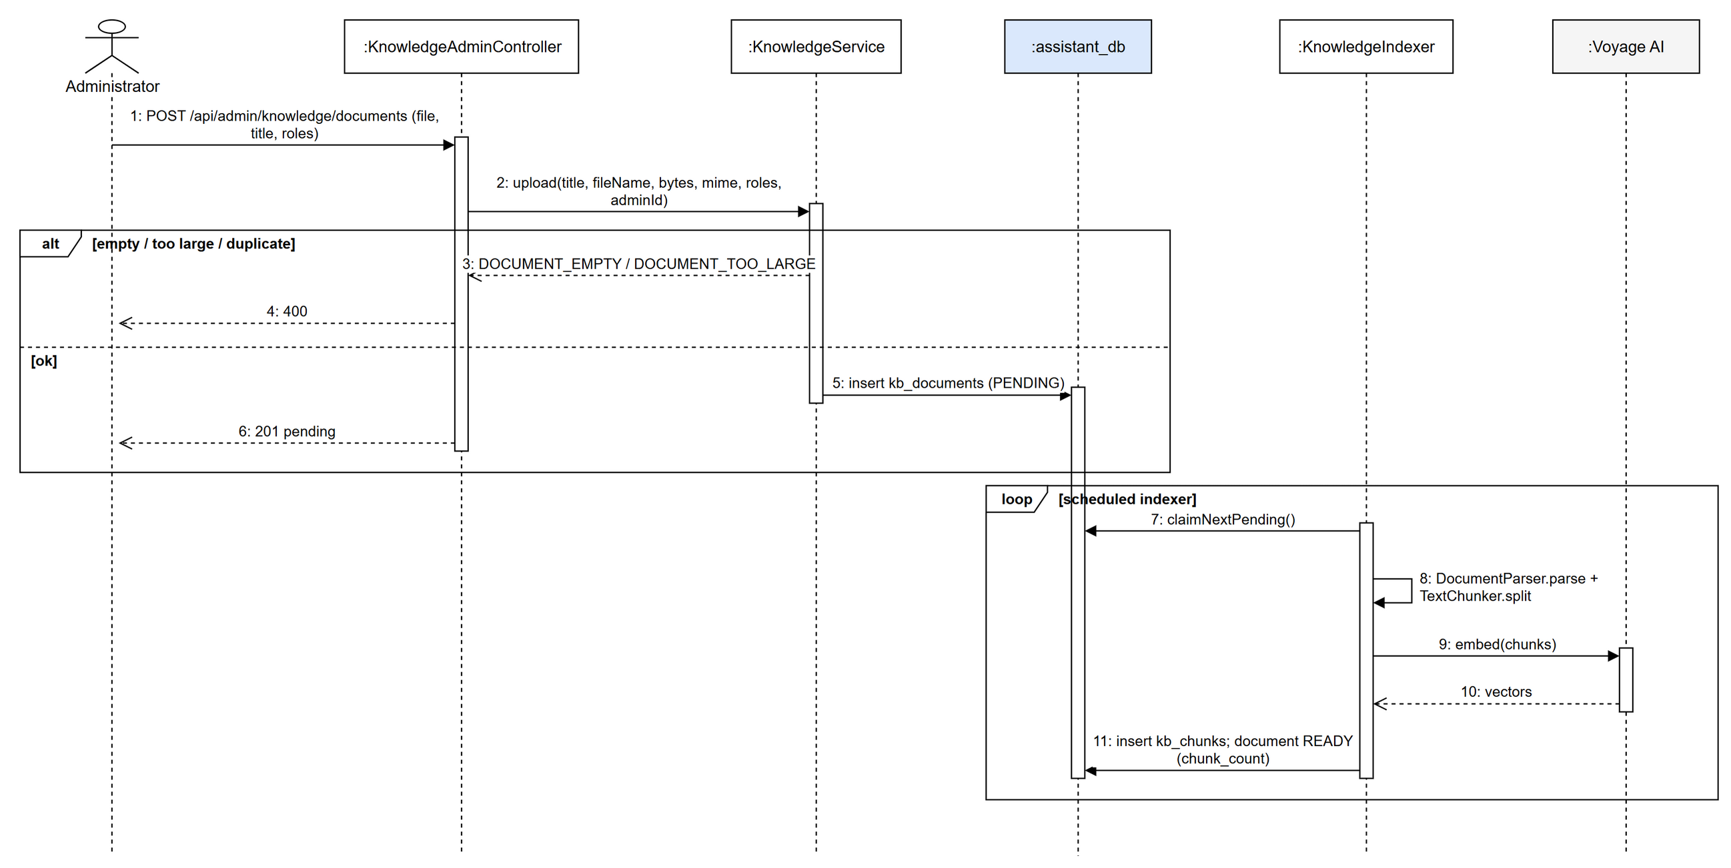
Figure 3.25.3: Sequence diagram - Upload and Index a Knowledge Document

3.25.4 Class Specification
3.25.4.a AssistantController
Table 3.25.4.a: AssistantController description
No | Method | Description
01 | ask(userId: Long, roles: List<String>, request: AskRequest): ApiResponse<AskResponse> | Asks a question in a new or existing conversation.
02 | conversations(userId: Long): ApiResponse<List<ConversationView>> | Conversations of the user.
03 | status(): ApiResponse<AssistantStatus> | Whether the providers are configured.

3.25.4.b KnowledgeAdminController
Table 3.25.4.b: KnowledgeAdminController description
No | Method | Description
01 | upload(file: MultipartFile, title: String, roles: List<String>, adminId: Long): ApiResponse<KnowledgeDocument> | Uploads a knowledge document.
02 | reindex(id: Long): ApiResponse<KnowledgeDocument> | Re-indexes a document.

3.25.4.c AssistantService
Table 3.25.4.c: AssistantService description
No | Method | Description
01 | ask(userId: long, roles: List<String>, request: AskRequest): AskResponse | Rate-limits, prepares the question, retrieves chunks, adds order context, generates the answer and stores both messages.
02 | myConversations(userId: long): List<ConversationView> | Lists conversations.

3.25.4.d KnowledgeService
Table 3.25.4.d: KnowledgeService description
No | Method | Description
01 | upload(title, fileName, bytes, mime, roles, adminId): KnowledgeDocument | Validates size / duplicates (checksum) and inserts a PENDING document.

3.25.4.e KnowledgeIndexer
Table 3.25.4.e: KnowledgeIndexer description
No | Method | Description
01 | indexPending(): void | Scheduled: claims the next PENDING document, parses, chunks, embeds and stores chunks.

3.26 Business Settings
Business rules (prices, time limits, SLA, refund policy, payment methods, loyalty rate...) are defined in a SettingsCatalog of each service and can be changed by the administrator without redeploying. Values are validated, stored in the service's system_settings table with an audit trail, and public values are readable by the app at /api/settings/{scope}/public.

3.26.1 Class Diagram
Figure 3.26.1: Class diagram - Business Settings

3.26.2 Administrator Changes a Business Rule
Figure 3.26.2: Sequence diagram - Administrator Changes a Business Rule

3.26.3 Class Specification
3.26.3.a BusinessSettingsController
Table 3.26.3.a: BusinessSettingsController description
No | Method | Description
01 | list(): ApiResponse<List<SettingView>> | All settings of the service scope.
02 | update(request: UpdateSettingsRequest, adminId: Long): ApiResponse<List<SettingView>> | Updates several settings.
03 | reset(key: String, adminId: Long): ApiResponse<List<SettingView>> | Returns a setting to its default.
04 | audits(key: String, limit: int): ApiResponse<List<SettingAuditView>> | Change history.
05 | publicValues(): ApiResponse<Map> | Public values for clients.

3.26.3.b BusinessSettings
Table 3.26.3.b: BusinessSettings description
No | Method | Description
01 | update(values: Map, actorUserId: Long): List<SettingView> | Validates every key against the catalog, normalises values, upserts changed ones, writes audits and refreshes the cache.
02 | getInt / getDecimal / getBoolean / getString(key) | Typed reads used by the *Rules classes.
03 | publicValues(): Map | Values flagged public.

3.27 Admin Dashboard and Revenue Reports
The admin dashboard shows revenue by day, service, payment method, locker, store and customer for a date range. order-service combines its orders with the money actually collected from payment-service and resolves locker, store and customer names.

3.27.1 Class Diagram
Figure 3.27.1: Class diagram - Admin Dashboard and Revenue Reports

3.27.2 View Revenue Summary
Figure 3.27.2: Sequence diagram - View Revenue Summary

3.27.3 Class Specification
3.27.3.a AdminRevenueController
Table 3.27.3.a: AdminRevenueController description
No | Method | Description
01 | summary(from: String, to: String): ApiResponse<RevenueSummaryResponse> | Totals and change vs the previous period.
02 | daily(from, to): ApiResponse<DailyRevenueResponse> | Revenue per day.
03 | byService(from, to): ApiResponse<ServiceRevenueResponse> | Revenue per order type.
04 | byLocker(from, to, storeId): ApiResponse<LockerRevenueResponse> | Revenue per locker.
05 | byCustomer(from, to, page, size, sort, q): ApiResponse<PageResponse<CustomerRevenue>> | Top customers.

3.27.3.b RevenueReportService
Table 3.27.3.b: RevenueReportService description
No | Method | Description
01 | summary(from: String, to: String): RevenueSummaryResponse | Loads orders and collected payments of the period and the previous one and computes totals and changes.
02 | daily(from, to): DailyRevenueResponse | Groups by business day.
03 | byLocker(from, to, storeId): LockerRevenueResponse | Groups by locker with names.

3.28 System Scheduled Jobs
Background jobs keep orders and boxes consistent: cancel unpaid orders, release boxes of completed orders, remind receivers before the pickup deadline, move overdue parcels to storage (EXPIRED), reconcile box states with locker-service and retry point refunds. Administrators can trigger them manually and see their status.

3.28.1 Class Diagram
Figure 3.28.1: Class diagram - System Scheduled Jobs

3.28.2 Expire Overdue Orders
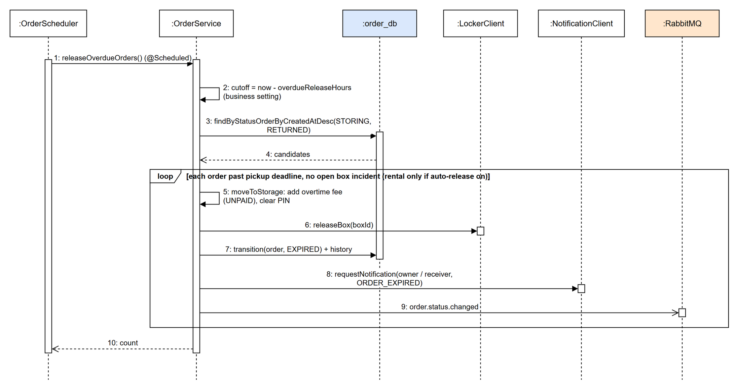
Figure 3.28.2: Sequence diagram - Expire Overdue Orders

3.28.3 Class Specification
3.28.3.a OrderScheduler
Table 3.28.3.a: OrderScheduler description
No | Method | Description
01 | sweepUnconfirmedReservations(): void | Cancels orders not paid / dropped in time and releases boxes.
02 | releaseCompletedBoxes(): void | Releases boxes of completed orders.
03 | remindOverduePickups(): void | Sends pickup reminders.
04 | releaseOverdueOrders(): void | Moves overdue parcels to storage (EXPIRED) and frees their boxes.
05 | reconcileBoxStates(): void | Aligns box states with active orders.
06 | retryPointRefunds(): void | Retries loyalty refunds that failed.

3.28.3.b OrderController
Table 3.28.3.b: OrderController description
No | Method | Description
01 | autoCancel(): ApiResponse<Map> | Admin triggers the auto-cancel job.
02 | releaseOverdue(): ApiResponse<Map> | Admin triggers overdue release.
03 | schedulerStatus(): ApiResponse<Map> | Last run of each job.

